COMMUNITIES & EDUCATION DIRECTORATE

Executive Director: Audrey Sutton
Cunninghame House, Irvine KA12 8EE
Tel: 01294 310000 www.north-ayrshire.gov.uk

Springside Primary School:
Station Road
Springside
KA11 3AZ
Tel: 01294 211651

Springside

Primary & EYC
February
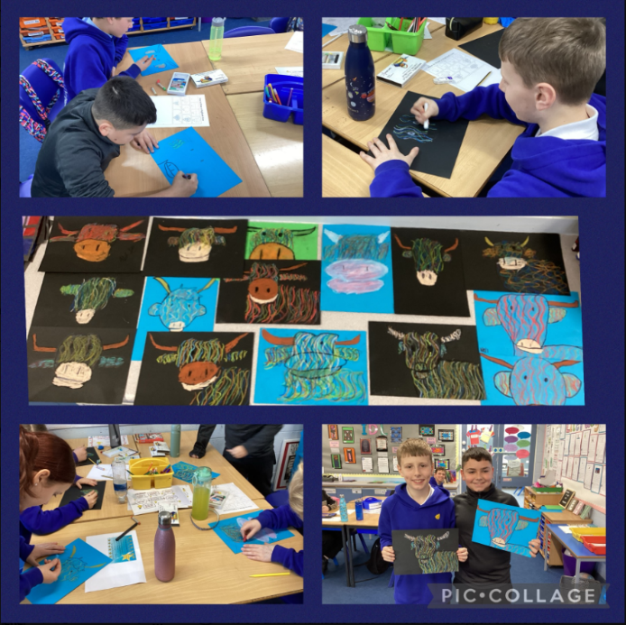
2024
Newsletter

Dear Parent/Carer,

I hope you find this newsletter informative and if there is anything you would like clarity on, please pick up the phone and ask to speak to Mr Wilson.

Winter is certainly still with us, shorter days and darker evenings. As it remains cold, wet and windy, we ask that you send children to school with layers they can remove, e.g. jumpers, cardigans and that weatherproof jackets are worn everyday as the weather changes quickly in Scotland! Please help yourself to spare uniform items from the school uniform bank or call us and we can pop items in schoolbags if your child requires any.

It’s been lovely to see families at pick up and drop off times, as well as school events such as the Parent Council meeting last week. Whether it’s coming along to the Learning Conversation/Parent’s/Carer’s Evening, or even picking up the phone to talk to us about a worry or suggestion, we appreciate the positive relationships we have with all our families. We are fortunate to have such a supportive school community!

From now on all trips that require pupils to leave the school building on transport e.g. trips, outings to sporting events will require a completed EV5 form which will be given out by the school office. Children will not be allowed to attend the trips/outings if this is not signed and returned by an adult. This ensures we are following the correct health and safety protocols set up by North Ayrshire Council. I hope you understand that keeping our pupils safe is of our utmost priority and I thank you for your support in this matter.

It has been a pleasure getting to know pupils, staff and families over the past month. I am very excited about leading Springside and know we will all continue to work well together to bring out the best results for the pupils.

Next week, we have almost all of our fabulous Primary 7’s embarking on the annual Arran Residential trip. I hope they all have a fantastic time and make memories that will last with them for years to come.

Best Wishes

Gordon Wilson
Acting Head Teacher

School Attendance

We continue to promote and support good attendance at Springside Primary. As a school community we need to work together to encourage good habits and reduce the number of unnecessary days off. Since arriving at the school I can start to see a pattern in children taking unnecessary time off school. It is essential we have pupils in the building to help them improve and develop their learning.

We understand children become unwell, e.g. sickness bug and we know there are other barriers to attendance e.g. anxiety. We have to work together to find ways to support children back to school.

We monitor and report on attendance every month. We contact families by phone and by letter to discuss concerns and offer supports.

I thank you in advance for supporting Springside on this matter and hope you all agree attendance in school is paramount.

NUT FREE SCHOOL

Another reminder is that we are a nut free school. We have several pupils with nut allergies and ask that all families help keep everyone safe.

Please ensure that you child’s play piece/snack/lunch does not contain nuts. This includes Kinder products, Snickers and hazelnut spread on sandwiches.

We thank you for your support with this.

Robert Burns

We are hosting our annual Burns Poetry competition this week.
Pupils have been learning poems and songs whilst developing their understanding of Scots language. We are excited to hear the finalists on Friday.
A huge thank you to all parents/carers for supporting their child at home by practising their poem/songs with them.

SCHOOL SPORTS CLUBS

Our Active Schools Coordinator is working on the data but it seems Springside Primary is very close to the top of the league for the number of clubs on offer to our children. A huge thanks to the Young Leaders from Greenwood Academy for helping run the clubs and our school staff for supervising the clubs. Thanks too, to Mr Baillie and Mrs Cook for planning and organising the great number of activities for our pupils. Information on dates and times of when clubs will start and who wishes to attend will be sent out soon.

Multi-Sports P5-P7 Monday (Dates to follow)

Racket Sports P5-P6 Monday (Dates to follow)

Football (Outside) P3-P4 –Tuesday (Dates to follow)

Dodgeball P6-P7 – Tuesday (Dates to follow)

Non-Sporting Clubs

Thank you to Miss Gaw/Mrs Havlin and Miss Nolan for supporting the school and giving up their own time to run non-sporting clubs for our pupils. Art Club (P1-P3) will run on Wednesdays from 31.1.24 to 21.2.24 at 3:00-3:45pm. Technology Club (P5-P7) will run on Monday 19.2.24 to 11.3.24 at 3:00-3:45pm. Children decided which clubs they wanted this term, other clubs for different stages will be voted on and put on later in the session.

How to set up Twitter/X
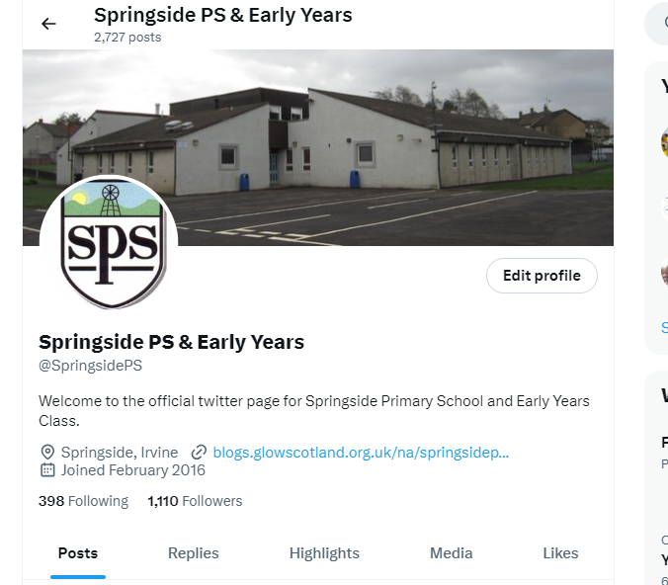
As part of promoting the wider life of the school, each class will be posting on Twitter/X on a weekly basis. This will let parents/carers see what is happening in school, what their child is learning and find out about any news/ information and any events that are happening. Please see the attached link on how to set up a Twitter/X account and then follow @SpringsidePS for all of our updates. How to Create X account 2023 - Formerly knows as Twitter (Full Guide) -Create New Account (youtube.com)

HT Awards
The House/Vice Captains worked with Mr Wilson on a new Head Teacher award system and presented this to pupils at assembly last week. Children will be given HT awards from their class teacher and be sent to Mr Wilson to show off their amazing work, being recognised for displaying great attitude or how they have shown the values of the school. Mr Wilson will track how many times children have been sent to him over their time at Springside Primary and be presented with special awards once they hit certain milestones. E.g. a Bronze Award for coming 4 times, Silver for 8 times etc. This is a great way to help pupils develop their confidence and begin to talk about their learning across the school.

Wider Achievements:
We know that our pupils do a variety of activities outside of school and we want to celebrate this too. Each Friday, during assembly pupils are encouraged to bring in trophies, certificates etc and celebrate these with the whole school. The House/Vice Captains will then record this in our ‘Wider Achievement Floorbook’. You will also be able to check these wider achievements out on Twitter/X page. Remember a wider achievement doesn’t need to be a trophy, it can be anything including learning to tie your shoe laces. We recognise that all achievements are vital to help pupils develop and we want to celebrate this.

Reporting to Parents/Carers
Learning Conversations(Parent’s/Carer’s Night)
March 2024

To finish this session there will be a written report and one Learning Conversation (Parent’s/Carer’s Night) with you, your child and the Class Teacher. I want to encourage pupils to take part in these conversations as they are at the heart of the discussion. Please bring your child along to listen and share their views during these meetings.

This Learning Conversation/(Parent’s/Carer’s Night) will be held on Thursday 21st March 2024 between 3:15pm and 8:45pm. Information and parent slips will be sent out in due course.

Remember, if you are worried about your child’s wellbeing or learning at any time please make an appointment to talk to their Class Teacher or myself.

Annual Parent/Carers Survey:

Thank you to all parents who completed the Annual Parent/Carer Survey. We had 32 families that completed this and the results will be sent out to parents. We will also make a school display with the results and action any points made by you. We always take on board your thoughts and views to help us improve the experiences for our pupils. Some of the initial responses are very strong including 90% of pupils enjoy being at this school, 97% of you state children feel safe and 97 % feel your child is encouraged by the school to be healthy and take regular exercise. We will look closely at the results and action the next steps to improve our service to the community.

Supporting Children
Please look out for the Parent/Carer Staged Intervention info guide coming your way this term. This guide gives information about what Staged Intervention is, why is could be needed, the difference between certain levels and the new processes that are in place for Springside Primary. New Staged Intervention Paperwork for pupils on Stage 1 and Stage 2 will be sent out later this month. Please read the letter that accompanies the paperwork and if you have any questions, please email ( gordonwilson@ea365.n-ayrshire.sch.uk )or call the office to speak to Mr Wilson.

Staffing updates:

Our raising attainment teacher Mrs Findlay is moving on from Springside this week to a new post at Elderbank PS. She has been a great addition to the staff, her dedication to the pupils and staff at Springside was clear to see by everyone across the school. We will all miss her greatly but wish her well in this new chapter of her career.

Mrs McFadzean (PT) is also leaving us as she is relocating to the north of Scotland. Mrs McFadzean has been a fantastic teacher and Principal Teacher at Springside. Her enthusiasm and passion for the school has been infectious. The love she has for the school and pupils is clear for all to see and she has given 24 years of her life to Springside which we can’t thank her enough for. She will be missed by the whole community but we wish her the best of luck on this new endeavour and I’m sure she will be very successful in her new post. I will keep you all updated on her replacement in due course, who will hopefully be in place after the Easter break.

Finally

Please find dates attached from now until the end of term and get in touch if there is anything you wish to discuss.

Thank you for your continued support.

Mr. Wilson

Acting Head Teacher

Springside Primary School

Diary Dates

Thursday 1st February | Children to recite Burns Poetry
Monday 5th February | P7 Arran Residential (3 Nights)
Thursday 8th February | Fluoride Varnish EYC, P1, P2, P3 & P4
Friday 9th, Monday 12th and Tuesday 13th February | School Holiday
Wednesday 14th February | Greenwood Maths Dept to visit P7
Wednesday 14th February | Football Team Game (Info to follow)
Friday 16th February | P7 Transition Visit to Greenwood
Thursday 22nd February | World Thinking Day – Brownies, Guides, Beavers, Cubs & Scouts. If your child attends either of these organisations including Sunbeams, Rainbows, Boys’ Brigade etc they can all wear their uniforms on this special day.
Monday 4th March | Parent Council meeting at Springside 3:15pm (all welcome)
Tuesday 5th March | Tempest School & EYC Photographs
Thursday 7th March | P6 Euro Quiz (4 pupils)
Thursday 7th March | World Book Day 2024 (info to follow)
Thursday 7th March | P1 and P2 Pupils to 4 aside football tournament (8 pupils)
Friday 15th March | Red Nose Day (Info to follow)
Friday 15th March | P7 Rotary Quiz (4 pupils)
Wednesday 20th March | P7 Transition Family Learning, Time to Talk for Parent’s/Carer’s – Greenwood. Info to follow from Greenwood
Thursday 21st March | Learning Conversations (Parent’s/Carer’s Night) 3:15pm – 8:45pm
Monday 25th March | Pupil Survey
Wednesday 27th March | P7 Transition Visit to Greenwood
Thursday 28th March | School stops at 2.30pm
Friday 29th March to Friday 12th April | School Easter Holidays
Monday 15th April | Pupils and Staff return to School

