Our School

Skelmorlie Primary is a small rural school in the village of Skelmorlie on the North Ayrshire coast. Our school has a particularly warm and friendly ethos and a nurturing environment for learning. We aim to provide opportunities for all children to attain and achieve their full potential, and children are encouraged to develop positive attitudes towards their learning and a caring attitude towards themselves, others, and our local and global environment. Our values of respect, co-operation, friendship, honesty, responsibility, and effort are embedded within our school. Our school is at the heart of the local community and we take great pride in supporting community events.

Our Vision, Values and Aims

At Skelmorlie Primary School and Early Years Class we will provide our children with the highest quality education within a nurturing and safe environment. We will provide a positive culture where everyone has ownership of their learnings, show respect for each other and value one another as individuals.

OUR VALUES
- RESPECT
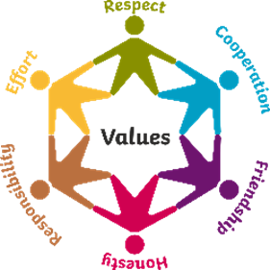
- HONESTY
- RESPONSIBILITY
- EFFORT
- CO-OPERATION
- FRIENDSHIP

Skelmorlie Primary School
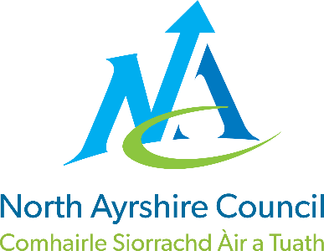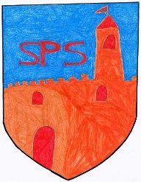
Standards & Quality Report
June 2026

This report will inform you of the school’s progress and achievements in the last session and let you know about our plans for 2026-2027.
I hope that you find it helpful and informative.

Lynne Cathcart
Head Teacher

Attainment & Achievement

Throughout the year we gather lots of information on how our children are progressing in their learning. To monitor their progress we watch children working through tasks, listen to what they say, ask important questions, set challenges and use a variety of standardised assessments. We gather as a team and analyse our collection of data and observations to plan targeted learning activities for children to ensure they are making appropriate progress.

North Ayrshire Council and The Scottish Government also ask us to summarise our children’s progress in Reading, Writing, Listening & Talking and Numeracy. We are required to make professional judgements regarding children’s progress towards the Early, First and Second Levels: P1, P4 and P7. We come to these judgements using a variety of evidence such as performance in lessons, progress in class work and results from standardised assessments.

In the Early Years most children achieved their expected preschool milestones. In Primary 1, most children achieved their expected levels in Literacy and Numeracy. In Primary 4, the majority of children achieved first level in Literacy and most children achieved first level in Numeracy. In Primary 7, almost all children achieved second level in Literacy and most children achieved second level in Numeracy.

We are very proud of each and every child and the progress they have made over the past year! The successes are due to high quality learning and teaching experiences across our school.

Our attendance overall is higher than the North Ayrshire average. We have had no exclusions.

Wider Achievement

- Supporting our community - Harvest Collection for North Ayrshire Foodbank
- School Christmas nativity in the local church showcasing our expressive arts skills
- Effective communication with our learning community i.e. Parent Welcome Sessions, Learning Conversations with Parents/Carers and Pupils, SeeSaw
- Children improved their Health and Wellbeing by participating in myHappymind
- We secured funding for two bikes and four helmets to support delivery of iCycle, basic cyclist training programme
- P4/5 represented the school by participating in the Day of Dance
- Celebrating Scottish culture through our whole-school Scottish concert – singing, dancing and Scots/Burns poem recitals
- Links were continued with Largs Cronies & The Poosenancies for our Scots and Burns poem recitals competition
- P7 pupils had the opportunity to learn a woodwind instrument and P5 received Ukulele instruction – both delivered by North Ayrshire Council Music Service
- Primary 6 learned a song on the Glockenspiel with Mr Morton this term which they’ll perform at the end of term celebration
- 5 children represented Skelmorlie Primary at North Ayrshire Swimming Gala and all did brilliantly
- A child from P4 sailed at his first full racing event representing Skelmorlie in the Scottish Schools Sailing Event at Loch Earn
- P3/4 learned how to play various songs on the recorder and performed at The Harvest Assembly, Christmas Service, and End of Year Service
- A range of Staff Professional Development i.e. Moderation, Neurodiversity & Maths/Numeracy
- Primary 6 pupils enjoyed the experience of being Buddies to Early Years children after applying and interviewing for their roles
- Two P6 pupils Primary 6 children got to the regional final of the K’Nex Creating Engineers competition in Glasgow Clyde College
- A Primary 7 child won the James Fairlie McGill Tam O'Shanter Quaich for being the overall Burns Competition winner out of 134 pupils from several schools
- 2 Commonwealth ambassadors in Primary 7 attended training events and lead a range of sporting events for the whole school
- All classes enjoyed input from outside agencies including sound bath and pound during mental health week to support children and staff Health & Wellbeing
- P7 Residential Transition Trip to Dumfries House with Cumbrae and Fairlie Primary Schools enabling the children to develop relationships with their new peers
- Skelmorlie 50th Celebration performance showcasing the fantastic performance skills of children from across our school
- All staff and classes have benefitted from Outdoor Learning experiences within our school grounds this year, developing a variety of skills
- Celebration of successes at our Early Years Class Graduation Ceremony & End of Year Service celebrating our P7 children
- Our charity event, raised £102.16 for Children in Need
- The whole school took part in World Book Day activities, celebrating a love of reading
- P5/6 & 7 developed their entrepreneurial skills through a Virgin Money project and we secured a grant of £2000 towards digital technologies
- Strong relationships with our wonderful Parent Council who have supported the school and Early Years Class throughout the session

How Successful Have We Been in Improving Our Establishment?

Our School Improvement Plan is a document which sets out the activities we will be undertaking as a school over the coming session. When writing this document we take into account a number of factors –
- National Improvement Framework
- Local priorities set by North Ayrshire Council
- The development needs of our own school
This session our priorities were:-
- To raise attainment in literacy and numeracy by developing approaches to planning, tracking and monitoring across the curriculum, ensuring that learning builds on what is already known and is appropriately challenging
- To increase attainment in children’s health and wellbeing and develop skills for life, learning and work
- To ensure pupil rights at the forefront and providing children with opportunities to lead change within school and community

Quality Indicators

‘How Good is Our School’ is a document we use to monitor school improvement. We measure ourselves against quality indicators outlined within this document. We have given ourselves the following grades –
1.3 – Leadership of Change - Good
2.3 – Learning, Teaching and Assessment – Good
3.1 – Ensuring Well Being, Equality & Inclusion – Very Good
3.2 – Raising Attainment and Achievement – Good

Pupil Equity Funding
Pupil Equity Funding has been used to employ an additional Classroom Assistant for 11 hours. This staff member has supported classes across the school enabling 1:1 and small group sessions with Pupil Support Assistants to support interventions and additional support to help raise attainment

Improvement Plan Priorities
2026-2027

Priority 1 –
Improving Attainment and Progression in Literacy and Numeracy

Priority 2 –
Supporting needs, wellbeing, equality and inclusion

Priority 3 –
Developing High-Quality STEAM (Science, Technology, Engineering, Arts & Maths) Learning and Teaching Across the School

Priority 4 –
Strengthening High-Quality Early Level Planning, Tracking and Support Approaches in our Early Years Class

