

Education Service
Skelmorlie Primary School & EYC
Improvement Plan
2026-2027
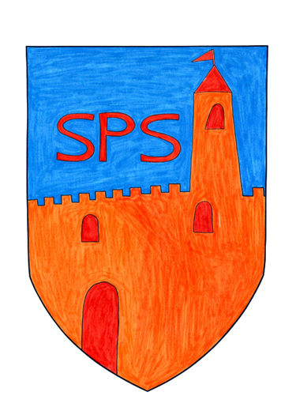

Vision, Values and Aims
At Skelmorlie Primary School and Early Years Class, we will provide our children with the highest quality education within a nurturing and safe environment. We will provide a positive culture where everyone has ownership of their learning, show respect for each other and value one another as individuals.
We will do this by –
- Providing stimulating, creative and relevant learning experiences showing continuity, progression and challenge for all learners.
- Promoting high standards and expectations to ensure all pupils achieve their potential.
- Working with the local, national and global initiatives in order to strengthen our awareness and responsibility to the wider world.
- Creating opportunities for staff and pupils to lead learning and take on responsibility.
- Promoting social inclusion and diversity in an environment where everyone is made to feel safe and welcome.
- Ensure appropriate leadership and management skills are in place for the school to operate effectively, making the best use of accommodation and resources.

Underpinning our values and aims are our school values –
- Respect
- Honesty
- Responsibility
- Effort
- Cooperation
- Friendship

EDUCATION SERVICE: IMPROVEMENT PLAN SUMMARY 2026/7 – 2028/9

The Education Service Improvement Plan is organised under three main priorities. Individual establishments should create their own plan under these three priority areas, based on rigorous self-evaluation and analysis of performance evidence. Stakeholders should be fully engaged in the development of the plan. In the diagram below, the light blue show the thematic areas under each priority which the service intends to focus on in the year ahead.
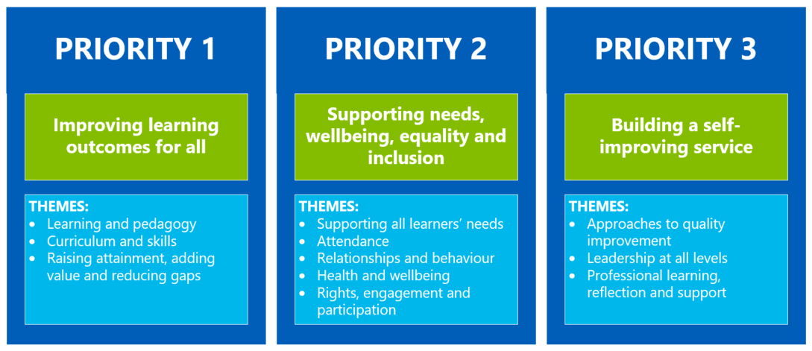

PRIORITY 1: Improving Attainment and Progression in Literacy and Numeracy
Strategic Objective:
What do you we want to specifically achieve across your school/department/EY centre?

To raise attainment in writing by developing consistent, high-quality writing pedagogies, assessment approaches and engaging learning experiences across the school.
To improve attainment, confidence and progression in numeracy through consistent, high-quality learning, teaching, assessment and moderation approaches across Early, First and Second Level.
Select the KEY drivers for this improvement priority
National Improvement Framework  Please select the relevant NIF priority | NIF Drivers of Improvement  Please select up to three NIF drivers | How Good Is Our School 4  Please select up to three quality indicators for this priority | Quality Improvement Framework for ELC settings  Please select up to three quality indicators for this priority
1. Improvement in attainment, particularly literacy and numeracy  Choose an item. | 4. Curriculum and assessment  2. Teaching and practitioner professionalism  1. School & ELC leadership | 3.2 Raising attainment and achievement  2.3 Learning, teaching and assessment  2.4 Personalised support | Choose an item.  Choose an item.  Choose an item.
Rationale for Change
What did our analysis of data tell us? What self-evaluation information supports this change? Provide details of the gaps or barriers you wish to address. State clearly if this is related to PEF spend.
Analysis of SNSA, PTE, PTM and NGRT data shows that, while most learners are achieving expected levels, there is a need to improve consistency and progress across writing and numeracy. Writing attainment is less consistent than reading, and numeracy data highlights gaps in confidence and progression for some learners particularly in P3 & P6. Self-evaluation activities, including learning visits, moderation and professional dialogue, identified inconsistency in learning, teaching, assessment and moderation approaches across stages.
To address these gaps, we will develop a more consistent whole-school approach to writing and numeracy through high-quality learning, teaching, assessment and moderation practices. PEF staffing allocation will support targeted interventions, small-group teaching and increased learner support to improve attainment, confidence and progression in writing and numeracy, particularly for learners affected by the poverty-related attainment gap.

PRIORITY 1: Action Plan
Pupil Outcomes | Implementation Plan | Timescales/  Responsibility | Measurement of Impact | Analysis & Evaluation of Progress | Cost  (PEF)
Specifically, what will change for our learners? | How will we achieve this?  What do we plan to do? | What are our timescales? Who will lead? | How will we know the change is an improvement? Can you quantify this?  What data will be collated and analysed to demonstrate progress? Consider baseline data. | How do we know that the experiences & outcomes for learners have improved? What does the data tell us which demonstrates impact? | Please enter the cost to the nearest £
Learners will demonstrate improved writing skills, increased motivation and greater independence through consistent, high-quality writing pedagogies across the school. | Continue to engage and embed the NAC Learning, Teaching and Assessment policy and use the PLA Literacy Framework (Writing section) to support consistent, high-quality writing pedagogy and progression across the school.  Develop staff confidence in using PM Writing and the PLA Framework through professional learning, moderation and professional dialogue.  Writing leads to develop PM writing supporting consistent assessment, moderation and teaching approaches in writing.  Provide opportunities for staff to observe effective writing practice and share high-quality pedagogies, resources and assessment approaches.  Use PLA Frameworks, assessment evidence and moderation materials to support professional judgement and progression in writing.  Promote collaborative professional dialogue through staff meetings, moderation activities and working parties.  Strengthen links between reading and writing to support vocabulary development, creativity and writing skills.  Introduce Clicker to support inclusive writing approaches, learner independence and engagement.  Continue to provide engaging and purposeful writing opportunities across the curriculum.  Continue targeted interventions which support improved writing attainment, confidence and engagement.  Inclusive approaches and digital supports, including Clicker, will improve learner participation, accessibility and independence within writing tasks.  Establish a pupil-led School Media Team, facilitated by PT, to provide meaningful and purposeful contexts for writing for a real audience across the school community.  Develop children’s skills in investigative reporting, inquiry-based questioning, fact checking and paraphrasing through collaborative media activities. | HT/PT/CT  Aug 26 - June 27  PT/CT  Aug 26 - June 27  PT/CT  Aug 26 - June 27  PT/CT Aug 26 - June 27  CT Aug 26 - June 27  HT/PT/CT/PSA/PS Aug 26 - June 27  PT/CT Aug 26 - June 27  PT/CT/PS Aug 26 - June 27  PT Aug 26 - June 27  PT Aug 26 - June 27 | Classroom observations, learning walks and moderation activities will evidence increased consistency in writing pedagogy, assessment and feedback approaches across the school in line with the NAC Learning, Teaching and Assessment policy.  Staff self-evaluation and professional dialogue will demonstrate increased confidence in using PM Writing and the PLA Literacy Framework (Writing) to support progression and professional judgement.  Moderation activities, jotter monitoring and assessment evidence will demonstrate improved progression, consistency and attainment in writing across stages.  Learner conversations, pupil voice and classroom observations will evidence increased confidence, motivation, independence and engagement in writing.  Tracking data, ACEL and school-based assessments will demonstrate improved attainment and progress in writing across the school.  Learner voice, writing samples and observations will demonstrate increased motivation, engagement and confidence in writing.  Children will demonstrate improved writing, communication and inquiry skills through participation in School Media Team activities and publications for the wider school community.
Learners will demonstrate increased confidence, attainment and progression in numeracy through consistent use of the PLA Mathematics Planners and Frameworks, alongside high-quality learning, teaching, assessment and moderation approaches across Early, First and Second Level. | Explore and implement the PLA Mathematics Planners and Frameworks across Early, First and Second Level to support consistent progression, learning, teaching and assessment in numeracy.  Use cluster moderation activities to strengthen professional dialogue, consistency in professional judgement and understanding of achievement within a level.  Develop staff confidence in using the PLA Frameworks to assess learner progress, identify next steps and support differentiation.  Facilitate collaborative moderation opportunities within school and across the cluster to share effective pedagogies, assessment evidence and numeracy resources.  Continue to embed practical, play-based and differentiated numeracy approaches to increase learner engagement, participation and attainment.  Use assessment evidence, pupil voice and professional dialogue to inform planning, targeted interventions and learner next steps. | HT/PT/CT Aug 26 - June 27  HT/PT/CT Aug 26 - June 27  CT Aug 26 - June 27  HT/PT/CT Aug 26 - June 27  CT Aug 26 - June 27  CT/PS Aug 26 - June 27 | Classroom observations, learning walks and moderation activities will evidence increased consistency in numeracy learning, teaching and assessment across the school.  Pre and post self-evaluation activities will demonstrate increased staff confidence in using the PLA Mathematics Planners and Frameworks to support assessment and progression.  Moderation discussions and assessment evidence will demonstrate increased consistency in professional judgement and understanding of achievement within a level across Early, First and Second Level.  Staff feedback and professional dialogue will evidence increased confidence in numeracy pedagogy, assessment and differentiation.  Learner conversations, pupil voice and observations will demonstrate increased confidence, engagement and participation in numeracy experiences.  Tracking data, ACEL and school-based assessments will demonstrate improved attainment and progression in numeracy across the school.  Assessment evidence and moderation activities will demonstrate clearer identification of learner next steps and progression pathways within numeracy.

PRIORITY 2: Supporting needs, wellbeing, equality and inclusion
Strategic Objective:
What do you we want to specifically achieve across your school/department/EY centre?

To improve attendance across the school from 93.75% to 94.75% and late coming through consistent nurturing approaches, targeted interventions and strengthened partnership working with families.
Select the KEY drivers for this improvement priority
National Improvement Framework  Please select the relevant NIF priority | NIF Drivers of Improvement  Please select up to three NIF drivers | How Good Is Our School 4  Please select up to three quality indicators for this priority | Quality Improvement Framework for ELC settings  Please select up to three quality indicators for this priority
1. Improvement in attainment, particularly literacy and numeracy  4. Improvement in children and young people's health and wellbeing | 3. Parent/carer involvement and engagement  1. School & ELC leadership  5. School & ELC improvement | 2.4 Personalised support  2.7 Partnerships  3.1 Ensuring wellbeing, equality and inclusion | 4.3 Children's progress  Choose an item.  Choose an item.
Rationale for Change
What did our analysis of data tell us? What self-evaluation information supports this change? Provide details of the gaps or barriers you wish to address. State clearly if this is related to PEF spend.
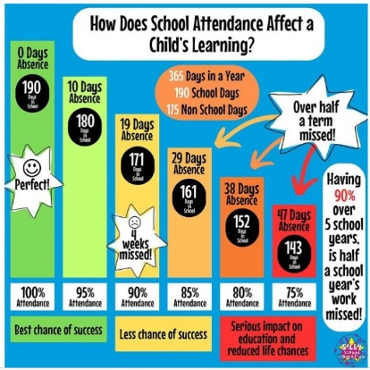
From Included, Engaged, Involved Part 1
Poor attendance has been linked to lower levels of attainment; peer relationships; emotional and behavioural difficulties and poorer employment opportunities.
Low levels of attendance can also be linked to how connected children and young people feel to their school community. Lack of school connectedness has been linked to a range of poorer outcomes including attainment, wellbeing and involvement in offending behaviours. Attendance and participation with school can also be considered as protective factors for children and young people experiencing adversity or trauma and can support early intervention.
Identified children are showing emerging signs of school avoidance, resulting in reduced attendance and missed opportunities to engage with targeted support. This is contributing to increasing gaps in learning and progress and is having a negative impact emotionally and socially.

PRIORITY 2: Action Plan
Pupil Outcomes | Implementation Plan | Timescales/  Responsibility | Measurement of Impact | Analysis & Evaluation of Progress | Cost  (PEF)
Specifically, what will change for our learners? | How will we achieve this?  What do we plan to do? | What are our timescales? Who will lead? | How will we know the change is an improvement? Can you quantify this?  What data will be collated and analysed to demonstrate progress? Consider baseline data. | How do we know that the experiences & outcomes for learners have improved? What does the data tell us which demonstrates impact? | Please enter the cost to the nearest £
Learners will demonstrate improved attendance, engagement and wellbeing through nurturing approaches, targeted support and positive partnerships between home and school. | Promote nurturing, relationship-based approaches across the school to support attendance, wellbeing and engagement.  Monitor attendance regularly and implement targeted interventions and support for identified children and families.  Strengthen partnership working with families through regular communication, attendance meetings and awareness raising around the impact of attendance and late coming on attainment and wellbeing.  Use P1 information sessions & Class Welcome Sessions, newsletters and attendance materials to promote positive attendance habits and expectations.  Continue targeted wellbeing supports and interventions for children experiencing attendance difficulties or emotionally based school avoidance.  Use Seesaw and home learning approaches to support continuity of learning during periods of absence.  Implementation of New Authority Training across the school through the BPR programme, supporting adults to understand the concepts of Resist, Persist, Unite and Repair | HT/PT/CT/PSA Aug 26 - June 27  HT/PT/TS/CT Aug 26 - June 27  HT/PT/TS/CT Aug 26 - June 27  HT/PT/TS/CT Aug 26 - June 27  HT/PT/TS Aug 26 - June 27  PS/TS/CT Aug 26 - June 27  PT/CT Aug 26 - June 27 | Attendance data will demonstrate an increase in overall attendance to 94.75%.  Tracking and monitoring processes will evidence reduced late coming and improved attendance for targeted learners.  Attendance meetings, professional dialogue and wellbeing tracking will evidence earlier identification and support for children experiencing attendance difficulties.  Learner conversations, family feedback and observations will demonstrate improved engagement, wellbeing and positive relationships with school. Tracking Engagement with SeeSaw.  Increased attendance and engagement will support improved attainment and participation across literacy, numeracy and health and wellbeing.  School data and targeted interventions will evidence positive outcomes for children previously experiencing emotionally based school avoidance or attendance barriers. Including AIW Impact of Interventions  Increased pupil and staff confidence and feelings of empowerment, evidenced in questionnaires and professional dialogue. A consistent approach across the school aligned across the Authority.

PRIORITY 3: Developing High-Quality STEAM Learning and Teaching Across the School
Strategic Objective:
What do you we want to specifically achieve across your school/department/EY centre?

To develop high-quality STEAM learning experiences across the school which increase learner skills, creativity and problem-solving while building staff confidence in delivering STEAM approaches.
Select the KEY drivers for this improvement priority
National Improvement Framework  Please select the relevant NIF priority | NIF Drivers of Improvement  Please select up to three NIF drivers | How Good Is Our School 4  Please select up to three quality indicators for this priority | Quality Improvement Framework for ELC settings  Please select up to three quality indicators for this priority
3. Improvement in skills and sustained, positive school-leaver destinations  4. Improvement in children and young people's health and wellbeing | 2. Teaching and practitioner professionalism  4. Curriculum and assessment  1. School & ELC leadership | 1.2 Leadership of Learning  1.5 Management of resources to promote equity  3.3 Increasing creativity and employability | Choose an item.  Choose an item.  Choose an item.
Rationale for Change
What did our analysis of data tell us? What self-evaluation information supports this change? Provide details of the gaps or barriers you wish to address. State clearly if this is related to PEF spend.

Analysis of attainment data shows that learners are achieving well across literacy and numeracy; however, there is limited evidence of a progressive, whole-school progressive approach to STEAM learning. Self-evaluation activities, including learning visits, professional dialogue and curriculum review, identified variation in the range and frequency of STEAM experiences offered across classes, as well as differing levels of staff confidence in delivering STEAM-based learning.
To address these gaps, we will develop high-quality, progressive STEAM learning experiences across the school that promote creativity, critical thinking, problem-solving, collaboration and digital skills. This will ensure greater consistency of learner experiences while building staff confidence, knowledge and pedagogy in STEAM approaches. By strengthening interdisciplinary learning opportunities and real-world problem-solving, we aim to enhance learner engagement, skills development and readiness for future learning and employment.
PEF Spend: This priority is not directly linked to PEF spend. However, where PEF-funded staffing supports targeted STEAM experiences or interventions for identified learners, this will contribute to reducing barriers to participation and achievement.

PRIORITY 3: Action Plan
Pupil Outcomes | Implementation Plan | Timescales/  Responsibility | Measurement of Impact | Analysis & Evaluation of Progress | Cost  (PEF)
Specifically, what will change for our learners? | How will we achieve this?  What do we plan to do? | What are our timescales? Who will lead? | How will we know the change is an improvement? Can you quantify this?  What data will be collated and analysed to demonstrate progress? Consider baseline data. | How do we know that the experiences & outcomes for learners have improved? What does the data tell us which demonstrates impact? | Please enter the cost to the nearest £
Learners will develop increased confidence, creativity, collaboration and problem-solving skills through engaging, high-quality STEAM learning experiences across the school. | Develop high-quality STEAM experiences across the curriculum through practical, creative and problem-solving approaches which are accessed by all children in P1-P7 on a weekly basis.  Develop the STEAM learning environment and resources to support creativity, collaboration and application of learning.  Use team teaching and collaborative planning opportunities to build staff confidence and consistency in delivering STEAM learning experiences and the creation of a progressive planner.  Provide professional learning opportunities and share effective STEAM pedagogies, resources and approaches across the school.  Continue to embed outdoor learning, digital technologies and practical learning experiences to support learner engagement and skills development.  Promote learner curiosity, creativity, critical thinking and problem-solving through purposeful and relevant STEAM contexts. | HT/PT/CT Aug 26 - June 27  PT/CT Aug 26 - June 27  PT/CT Aug 26 - June 27  PT/CT Aug 26 - June 27  CT Aug 26 - June 27  CT Aug 26 - June 27 | Classroom observations, learning walks and learner conversations will evidence increased use of high-quality STEAM approaches across the school.  Staff self-evaluation and professional dialogue will demonstrate increased confidence in planning and delivering STEAM learning experiences.  Learner voice, observations and participation levels will evidence increased engagement, creativity, collaboration and problem-solving skills.  STEAM floorbooks, planning evidence and pupil work will demonstrate increased opportunities for application of learning across the curriculum.  Increased use of practical, outdoor and digital learning approaches will support learner engagement and participation.  Quality assurance activities will evidence improved consistency in STEAM experiences and progression of skills across the school.

PRIORITY 4: Strengthening High-Quality Early Level Planning, Tracking and Support Approaches
Strategic Objective:
What do you we want to specifically achieve across your school/department/EY centre?

To explore and embed high-quality Early Level planning and tracking systems which support effective learning experiences, early identification of need and targeted support for all learners.
Select the KEY drivers for this improvement priority
National Improvement Framework  Please select the relevant NIF priority | NIF Drivers of Improvement  Please select up to three NIF drivers | How Good Is Our School 4  Please select up to three quality indicators for this priority | Quality Improvement Framework for ELC settings  Please select up to three quality indicators for this priority
1. Improvement in attainment, particularly literacy and numeracy  Choose an item. | 5. School & ELC improvement  Choose an item.  Choose an item. | 2.3 Learning, teaching and assessment  Choose an item.  Choose an item. | 1.3 Leadership of continuous improvement  3.3 Learning, teaching and assessment  4.3 Children's progress
Rationale for Change
What did our analysis of data tell us? What self-evaluation information supports this change? Provide details of the gaps or barriers you wish to address. State clearly if this is related to PEF spend.
Our analysis of tracking, assessment and observational data identified the need to strengthen consistency in planning, assessment and progression within the Early Years Class. Self-evaluation activities highlighted the need to further develop staff confidence in using planning and tracking approaches and to ensure learning experiences are consistently responsive to children’s interests and developmental needs.
This improvement priority will address gaps in tracking and monitoring, early identification of support needs and consistency of practice. Through embedding North Ayrshire Early Level planners, strengthening professional dialogue and moderation, and using assessment evidence to inform next steps, we will enhance learner progression and outcomes. We will continue to provide high-quality play-based literacy, numeracy and outdoor learning experiences while strengthening partnerships with families and external agencies to support wellbeing, development and learning.

PRIORITY 4: Action Plan
Pupil Outcomes | Implementation Plan | Timescales/  Responsibility | Measurement of Impact | Analysis & Evaluation of Progress | Cost  (PEF)
Specifically, what will change for our learners? | How will we achieve this?  What do we plan to do? | What are our timescales? Who will lead? | How will we know the change is an improvement? Can you quantify this?  What data will be collated and analysed to demonstrate progress? Consider baseline data. | How do we know that the experiences & outcomes for learners have improved? What does the data tell us which demonstrates impact? | Please enter the cost to the nearest £
Children will demonstrate increased engagement, independence and progression through consistent planning, tracking and targeted support approaches within the Early Years Class. | Embed North Ayrshire Early Level planners and tracking approaches within the Early Years Class to support consistent planning, assessment and progression.  Use Curriculum for Excellence Early Level planning guidance to support high-quality learning experiences responsive to children’s interests and developmental needs.  Continue to strengthen tracking and monitoring approaches to support early identification of support needs and targeted interventions.  Develop staff confidence in using planning and tracking approaches through professional dialogue, moderation and collaborative working.  Continue to provide rich, play-based, literacy, numeracy and outdoor learning experiences which support engagement and progression.  Strengthen partnership working with families and external agencies to support children’s wellbeing, development and learning needs.  Use observations, trackers, learner conversations and assessment evidence to inform next steps in learning and planning. | HT/PT/SEYP/EYP Aug 26 - June 27  HT/PT/SEYP/EYP Aug 26 - June 27  HT/PT/SEYP/EYP Aug 26 - June 27  HT/PT/SEYP Aug 26 - June 27  SEYP/EYP Aug 26 - June 27  HT/PT/SEYP/EYP Aug 26 - June 27  HT/PT/SEYP/EYP Aug 26 - June 27 | Planning, tracking and assessment evidence will demonstrate increased consistency in Early Level learning experiences and progression pathways.  Staff professional dialogue and self-evaluation will evidence increased confidence in using Early Level planners and tracking approaches.  Observations, learner conversations and SeeSaw will demonstrate increased engagement, independence and participation in learning.  Tracking and monitoring processes will evidence earlier identification of support needs and targeted interventions for identified children.  Learning walks and quality assurance activities will evidence high-quality, responsive and play-based Early Level experiences across the setting.  Family feedback and partnership working will demonstrate improved communication, engagement and support for children’s learning and wellbeing.  Assessment evidence and observations will demonstrate improved progress and outcomes across Early Level learning experiences.

This should only be completed for aspects of your PEF spend not included within your Improvement Plan priorities.

PEF contact - HT or DHT with responsibility for the plan: |  |  | Lynne Cathcart
Carry forward: | £1162 | Total Allocation: | £8575 | Total: | £9737
PEF Action Plan
Poverty Related Gap | Pupil Outcomes | Implementation Plan | Timescales/  Responsibility | Detail of Spend | Measures of Impact | Analysis & Evaluation of Progress
Provide details of the gap or barrier you wish to address. | Specifically, what will change for our learners? | What do we plan to do to achieve this outcome? | What are our timescales?  Who will lead? | Record cost & provide concise detail of what this entails. | How will we know the change is an improvement? Can you quantify this? What data will be collated and analysed to demonstrate progress? Consider baseline data. | What does the data tell us? How well is evidence from self-evaluation analysed to improve pupil outcomes? How is the spend contributing to narrowing our attainment gap?
Attendance data for targeted learners will show improvement from baseline. PASS data will evidence improved attitudes to self and school. ACEL, writing assessment evidence and teacher professional judgement will demonstrate improved progress for identified learners. Intervention records will show regular support and reviewed impact. | Learners will feel supported, attend more regularly and engage more fully in literacy, numeracy and health and wellbeing experiences, leading to increased confidence, improved attainment in writing and better overall outcomes. | Pupil Support Assistant providing support to CT provide interventions supporting literacy, numeracy & HWB | August – March PT/CT/PSA | £9737  PEF allocation 2026-2027 | Improved Attendance Data Improved PASS results & ACEL data of targeted group

