Our School

Skelmorlie Primary is a small rural school in the village of Skelmorlie on the North Ayrshire coast. Our school has a particularly warm and friendly ethos and a nurturing environment for learning. We aim to provide opportunities for all children to attain and achieve their full potential, and children are encouraged to develop positive attitudes towards their learning and a caring attitude towards themselves, others, and our local and global environment. Our values of respect, co-operation, friendship, honesty, responsibility, effort are embedded within our school. Our school is at the heart of the local community and we take great pride in supporting community events.

**Our Vision, Values and Aims**

At Skelmorlie Primary School and Early Years Class we will provide our children with the highest quality education within a nurturing and safe environment. We will provide a positive culture where everyone has ownership of their learnings, show respect for each other and value one another as individuals.

**OUR VALUES**

* RESPECT
* 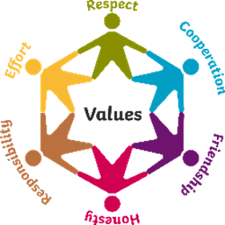HONESTY
* RESPONSIBILITY
* EFFORT
* CO-OPERATION
* FRIENDSHIP

**Skelmorlie Primary School**

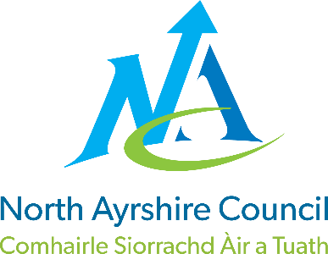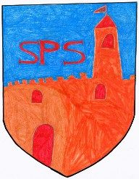

**Standards & Quality Report**

**June 2025**

This report will inform you of the school’s progress and achievements in the last session and let you know about our plans for 2025-2026.

I hope that you find it helpful and informative.

Lynne Cathcart

Head Teacher

**Attainment & Achievement**

Throughout the year we gather lots of information on how our children are progressing in their learning. To monitor their progress we watch children working through tasks, listen to what they say, ask important questions, set challenges and use a variety of standardised assessments. We gather as a team and analyse our collection of data and observations to plan targeted learning activities for children to ensure they are making appropriate progress.

North Ayrshire Council and The Scottish Government also ask us to summarise our children’s progress in Reading, Writing, Listening & Talking and Numeracy. We are required to make professional judgements regarding children’s progress towards the Early, First and Second Levels: P1, P4 and P7. We come to these judgements using a variety of evidence such as performance in lessons, progress in class work and results from standardised assessments.

In the Early Years most children achieved their expected preschool milestones. In Primary 1, most children achieved their expected levels in Literacy and Numeracy. In Primary 4, the majority of children achieved first level in Literacy and the majority achieved first level in Numeracy. In Primary 7, most children achieved second level in Literacy and Numeracy.

We are very proud of each and every child and the progress they have made over the past year! The successes are due to high quality learning and teaching experiences across our school.

Wider Achievement

* Produce planted and tended by the pupils in our allotments was entered into Largs Flower Show and won 2nd place
* Supporting our community - Harvest Collection for North Ayrshire Foodbank
* School Christmas nativity in the local church showcasing our expressive arts skills
* Effective communication with our learning community i.e. Parent Welcome Sessions, Learning Conversations with Parents/Carersand Pupils, SeeSaw
* Children improved their Health and Wellbeing by participating in ‘Beat the Street’ achieving 3rd overall within the schools category
* P4/5 represented the school by participating in the Day of Dance
* Celebrating Scottish culture through our whole-school Scottish concert – singing, dancing and Scots/Burns poem recitals
* P6/7 hosted an incredible Burns Supper celebrating the life of Robert Burns
* Links were continued with Largs Cronies & The Poosenancies for our Scots and Burns poem recitals competition
* P6/7 pupils had the opportunity to learn a woodwind instrument and P5 received Ukulele instruction – both NAC Music Service
* P3/4 learned how to accompany a song on tuned and un-tuned percussion
* A range of Staff Professional Development i.e. Learning for Sustainability, Active Play, Moderation, Neurodiversity & Maths/Numeracy
* Primary 6 pupils enjoyed the experience of being Buddies to Early Years children after applying and interviewing for their roles
* Paired reading and board games have been enjoyed by P3/4 and P6/7 pupils when they come together weekly
* P7 Residential Transition Trip to Dumfries House with Cumbrae and Fairlie Primary Schools enabling the children to develop relationships with their new peers
* Panto Pandemonium performance showcasing the fantastic performance skills of children from across our school
* All staff and classes have benefitted from Outdoor Learning experiences within our school grounds this year, developing a variety of skills
* Celebration of successes at our EYC Graduation Ceremony & End of Year Service celebrating our P7 children
* Our school Dance-a-thon promoted exercise and fun and raised a whopping £1,102.80 for our school fund
* Our charity event, “Wheels Day”, raised £126.20 for Children in Need
* The whole school took part in World Book Day activities, celebrating a love of reading. All classes participated in a Live Author Event where we received tuition from an illustrator
* Links were made to the Wider World of Work when P6/7 were visited by a Procurator Fiscal who explained what life was like working as a lawyer and what her job entailed when working for the Scottish Government

**How Successful Have We Been in Improving Our Establishment?**

Our School Improvement Plan is a document which sets out the activities we will be undertaking as a school over the coming session. When writing this document we take into account a number of factors –

* National Improvement Framework
* Local priorities set by North Ayrshire Council
* The development needs of our own school

This session our priorities were:-

* To raise attainment in literacy and numeracy by developing approaches to planning, tracking and monitoring across the curriculum, ensuring that learning builds on what is already known and is appropriately challenging
* To increase attainment in children’s health and wellbeing and develop skills for life, learning and work
* To ensure pupil rights at the forefront and providing children with opportunities to lead change within school and community

**Quality Indicators**

‘How Good is Our School’ is a document we use to monitor school improvement. We measure ourselves against quality indicators outlined within this document. We have given ourselves the following grades –

1.3 – Leadership of Change - Good

2.3 – Learning, Teaching and Assessment – Good

3.1 – Ensuring Well Being, Equality & Inclusion – Very Good

3.2 – Raising Attainment and Achievement – Good

**Pupil Equity Funding**

PEF funding has been used to employ an additional Classroom Assistant for 11 hours. This staff member has supported classes across the school enabling 1:1 and small group sessions with PSA to support interventions and additional support to help raise attainment.

**Improvement Plan Priorities**

**2025-2026**

Priority 1 & 2 -

To raise attainment in Literacy and Numeracy by improving teaching and learning pedagogies

Priority 3 –

Improvement in children’s mental health and wellbeing

Priority 3 –

To raise attainment across the curriculum through rich engaging learning opportunities and environments. To effectively plan and track learning and achievement.