P7 Reading for Information
Hobbies/the weekend
You see a sign for a keep-fit centre.
Fill out the grid in English of the classes available each day.
central
Día | Actividad
lunes | la gimnasia
martes | el atletismo
miércoles | patin de ruedas
jueves | el baile
viernes | el judo

Version A Can you translate the timetable into English?
Version B Look at the timetable and answer the questions in English
- What day can you go dancing?
- What activity is on a Friday?
- When can you go roller skating?
- What day can you do gymnastics?
- What sport is on a Tuesday?

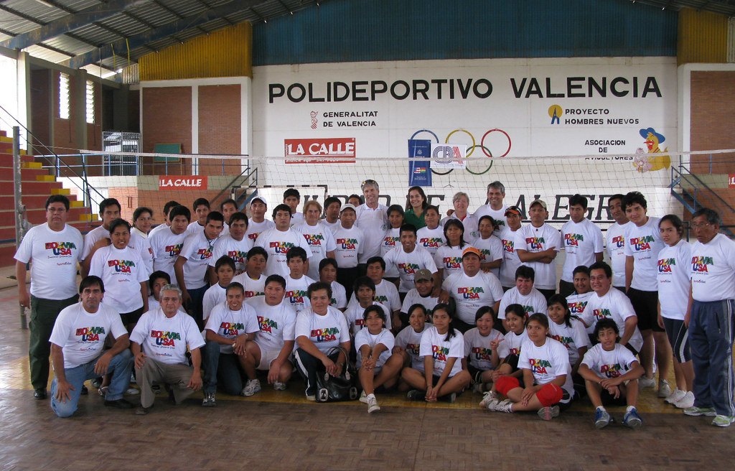

P7: Places in Town and Directions
Version A
Translate the place in town and the directions you must use.
¿La piscina? Gira a la izquierda.

¿El correos? Gira a la derecha.
¿La iglesia? Sigue todo recto.

Version B
Three directions to places in town are given below.
¿La iglesia? Sigue todo recto.
A
¿El correos? Gira a la derecha.
¿La piscina? Gira a la izquierda.

B C

Choose from the three direction arrows and right the correct number

1 3
2

What arrow do I need to go to the swimming pool?
What arrow do I need to go to the post office?
What arrow do I need to go to church?

P7 - Places in town
Version A You see some signs in French.
Version A You see some signs in Spanish. Write the correct letter for:
- Quieres practicar la natación.
- Tienes la pierna rota.
- Quieres ver un partido de fútbol.
- Quieres coger el tren.
- Quieres leer un libro.
- Quieres comprar pan.
rota - broken
A El estadio esestadioade

P7 - Places in town
C la estación de trenes
F el hospital
E la panadería
D la biblioteca
B la piscina
Version B You see some signs in Spanish. Write the correct letter for:
- You want to go swimming
- You have broken your leg
- You want to see a football match
- You want to catch a train
- You want to read a book
- You want to buy some bread
A El estadio esestadioade
C la estación de trenes
F el hospital
E la panadería
D la biblioteca
B la piscina
P7 Parts of the Body/Feeling ill
The following pupils are trying to get out of sports day.
Version A
Write what is wrong with each of them? Match the name to the correct letter.
Jorge: Tengo dolor en mi brazo.
Valería: Tengo dolor de estómago.
Juan: Tengo dolor de la garganta.
Camila: Tengo dolor de mis dientes.
Tomás: Tengo dolor en mi pierna.
A B C 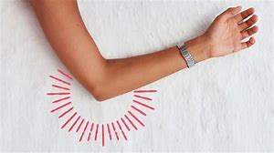 D E

Version B – Write the correct sentence beside the picture.
A _______________________________________________________________

B ________________________________________________________________

C _______________________________________________________________

D ____________________________________________________________

E _____________________________________________________________

