****P2 FrenchActivities

5 a Day Disco in French

[**https://tinyurl.com/h8aklub**](https://tinyurl.com/h8aklub)

Clear some space, **Levez-vous, et Dansez-vous!**

We are learning to how to describe the weather in French.

We are learning to say the months of the year in French and about Birthdays in France. 

We are learning to say numbers between 0 and 20 in French.

We are learning some animals.

We are learning family members.

|  |  |  |
| --- | --- | --- |
| **Animals**  Practise handwashing singing about some animals to the tune of ‘Twinkle, Twinkle, Little Star’  Lyrics are:  Tortue, tortue, araignée, araignée,  serpent, serpent, girafe, girafe.  Vocabulary:  Tortue (turtle), araignée = spider, serpent = snake,  girafe = giraffe.  <https://www.youtube.com/watch?v=KL9wwjPSuNU>  Good actions but can you spot their spelling mistake? | **French Numbers** with [‘French-Games.Net’](https://tinyurl.com/twsgo8l)  <https://www.french-games.net/frenchtopics>   1. Under categories, choose **NUMBERS.** 2. Select **‘Numbers - 1 to 10’** 3. To review the numbers before you play, select **‘Full Tutorial – All activities’** or you can click **‘No tutorial Thanks – GO TO THE GAMES’** 4. If you are going through the full tutorial, after you go through all of the activities, you can then click **‘Play the Games’** 5. Try **‘Sow Grow’** – make sure you volume is turned up – and click on the correct numbered pot. 6. When you are ready, start over, but this time select **‘Numbers – 11 to 20’**   **C:\Users\Angela\AppData\Local\Microsoft\Windows\Temporary Internet Files\Content.IE5\VOH5B11P\DJI_SeptDoodlers_123_c[1].jpgBonne chance!** Guid luck!  **Rip it Bingo** <https://tinyurl.com/y9nk5h8t> | **Weather in France**  Listen to this song and practise the weather.  <https://www.youtube.com/watch?v=eBvJVOuBPXI> **Your key vocabulary is:**  Quel temps fait-il (aujourd’hui) ? What’s the weather like today ?  Il y a du soleil. / Il fait soleil. It’s sunny.  Il y a des nuages. It’s cloudy.  Il pleut. It’s raining.  Il fait du vent. /Il y a du vent. It’s windy.  Il fait beau. It’s lovely.  Il fait mauvais. It’s awful !  Il fait froid. It’s cold !  Il fait chaud. It’s hot ! |
| **Months of the Year**  Practise the months of the year.    <https://www.youtube.com/watch?v=XZhY8frvDTA> | **Family**   |  |  |  |  | | --- | --- | --- | --- | | Mother  Mum  Father  Dad  Brother  Sister  Grandmother  Granny  Grandfather  Grandad | mère  maman  père  papa  frère  sœur  grand-mère  mamy  grand-père  papy | Video Links  Family Song <https://tinyurl.com/odsjs9y>  Peppa Pig <https://tinyurl.com/wot3p7u>  Online Story <https://tinyurl.com/y7rce6rz> | | |  |  | |  | | **Weather Race Dice Game**  Be the first to reach your holiday destination. Roll the die (ask Siri or Alexa or use an online die) and move towards your holiday destination.  Say the weather that you land on and then move forward or backwards the number of spaces next to the weather on which you land |
| **Birthdays** | **Games**  **Peppa Pig PAF Games**  Practise numbers and words for the family with this exciting dice game!  **C:\Users\Angela\AppData\Local\Microsoft\Windows\Temporary Internet Files\Content.IE5\6BNCU3VR\French_flag[1].jpg**  You’ll need additional words:  ma tante - my aunt ma cousine - my cousin (girl)  mon oncle - my uncle mon cousin - my cousin (boy) | **Exercise in French**  **French Yoga -** <https://tinyurl.com/y8znsa4k>  **Hopscotch** - Use chalk to draw grid on the pavement and play with your family. Watch this video for how to play. <https://tinyurl.com/quc7jz6> |

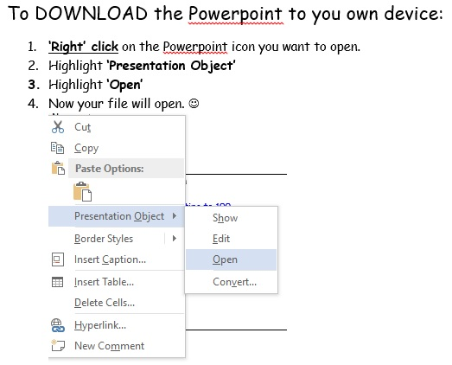

Contact Angela Noble at [gw14nobleangela@ea.n-ayrshire.sch.uk](mailto:gw14nobleangela@ea.n-ayrshire.sch.uk) if you have any questions.