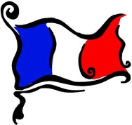**P1 French Activities**

5 a Day Disco in French

[**https://tinyurl.com/h8aklub**](https://tinyurl.com/h8aklub)

Clear some space, **Levez-vous, et Dansez-vous!**

We are learning to say our colours in French.

We are learning to say numbers between 0 and 10.

We are learning to say the days of the week in French.

We are learning some animals.

|  |  |  |
| --- | --- | --- |
| **Animals**  Practise handwashing singing about some animals to the tune of ‘Twinkle, Twinkle, Little Star’  Lyrics are:  Tortue, tortue, araignée, araignée,  serpent, serpent, girafe, girafe.  Vocabulary:  Tortue (turtle), araignée = spider, serpent = snake,  girafe = giraffe.  <https://www.youtube.com/watch?v=KL9wwjPSuNU>  Good actions but can you spot their spelling mistake? | French Numbers with ‘French-Games.Net’  <https://www.french-games.net/frenchtopics>   1. Under categories, choose **NUMBERS.** 2. Select **‘Numbers - 1 to 10’** 3. To review the numbers before you play, select **‘Full Tutorial – All activities’** or you can click **‘No tutorial Thanks – GO TO THE GAMES’** 4. If you are going through the full tutorial, after you go through all of the activities, you can then click **‘Play the Games’** 5. Try **‘Sow Grow’** – make sure you volume is turned up – and click on the correct numbered pot. | Basic Number Recognition   1. Go to <http://www.crickweb.co.uk/ks2french.html> 2. Make sure your volume is turned up to play the game. 3. Click on **Basic Number Recognition** 4. Listen to the number and click the correct number.   When reading an English story book, ask the number/count the objects in French.   * Draw a number; child guesses your number in French. |
| Greetings    Songs to enjoy together:  First in English –>  <https://www.youtube.com/watch?v=eECBSFwNtp0>  Now, in French -> <https://www.youtube.com/watch?v=atNkI6QFZ50> | French Days of the Week  lundi  mardi  mercredi  jeudi  vendredi  samedi  dimanche  <https://www.youtube.com/watch?v=QF9lUh5XPxo> | Days of the Week  Watch The Very Hungry Caterpillar in French.  <https://www.youtube.com/watch?v=xBpHkMgWld8>  Activities:   1. Adults to write days of the week on a piece of blank paper and children can make their own snack chart by drawing in what they have for snack each day. 2. Draw in what the Hungry Caterpillar had each day/cut and stick/discuss. You choose which option suits. |
| Colours & Games    **Traffic Light Game**  **red/rouge = freeze**  **yellow/jaune = get ready by running on the spot (courrez)**  **blue/bleu = spin around (hands on head) saying nee-naw, nee-naw (tournez)**  **green/vert = run (courrez)** | Colours Walk/Hunt  Take a walk outside or search your bedroom and living room for different colours. Draw some items you find for the colours:   * rouge (red) * vert (green) * bleu (blue) * jaune (yellow)   Colour Hunt: Hide objects around the house/outdoors. Winners are those who collect the most objects and can count and tell us the colour in French. | Colours songs and stories  **Arc en Ciel’ by Alain Le Lait**  <https://tinyurl.com/kh2todt>  **J’aime les voitures by Alain Le Lait**  <https://www.youtube.com/watch?v=IaaSprb0IXk>  Read a book of your choosing e.g. **The Rainbow Fish by Marcus Pfister** or **Brown Bear, Brown Bear** by Eric Carle  Discuss the colours in French. |
|  |  |  |

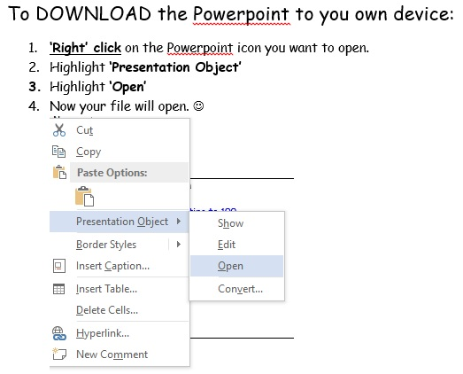

Contact Angela Noble at [gw14nobleangela@ea.n-ayrshire.sch.uk](mailto:gw14nobleangela@ea.n-ayrshire.sch.uk) if you have any questions.