
P2 FrenchActivities
5 a Day Disco in French
https://tinyurl.com/h8aklub
Clear some space, Levez-vous, et Dansez-vous!

We are learning to how to describe the weather in French.
We are learning to say the months of the year in French and about Birthdays in France.
We are learning to say numbers between 0 and 20 in French.
We are learning some animals.
We are learning family members.
Animals  Practise handwashing singing about some animals to the tune of ‘Twinkle, Twinkle, Little Star’  Lyrics are:  Tortue, tortue, araignée, araignée,  serpent, serpent, girafe, girafe.  Vocabulary:  Tortue (turtle), araignée = spider, serpent = snake,  girafe = giraffe.  https://www.youtube.com/watch?v=KL9wwjPSuNU  Good actions but can you spot their spelling mistake? | French Numbers with ‘French-Games.Net’  https://www.french-games.net/frenchtopics  - Under categories, choose NUMBERS.  - Select ‘Numbers - 1 to 10’  - To review the numbers before you play, select ‘Full Tutorial – All activities’ or you can click ‘No tutorial Thanks – GO TO THE GAMES’  - If you are going through the full tutorial, after you go through all of the activities, you can then click ‘Play the Games’  - Try ‘Sow Grow’ – make sure you volume is turned up – and click on the correct numbered pot.  - When you are ready, start over, but this time select ‘Numbers – 11 to 20’    Bonne chance! Guid luck!  Rip it Bingo https://tinyurl.com/y9nk5h8t | Weather in France  Listen to this song and practise the weather.  https://www.youtube.com/watch?v=eBvJVOuBPXI Your key vocabulary is:  Quel temps fait-il (aujourd’hui) ? What’s the weather like today ?  Il y a du soleil. / Il fait soleil. It’s sunny.  Il y a des nuages. It’s cloudy.  Il pleut. It’s raining.  Il fait du vent. /Il y a du vent. It’s windy.  Il fait beau. It’s lovely.  Il fait mauvais. It’s awful !  Il fait froid. It’s cold !  Il fait chaud. It’s hot !
Months of the Year  Practise the months of the year.  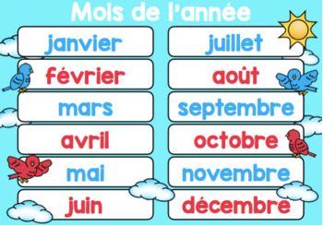  https://www.youtube.com/watch?v=XZhY8frvDTA | Family | Weather Race Dice Game  Be the first to reach your holiday destination. Roll the die (ask Siri or Alexa or use an online die) and move towards your holiday destination.  Say the weather that you land on and then move forward or backwards the number of spaces next to the weather on which you land
  Mother  Mum  Father  Dad  Brother  Sister  Grandmother  Granny  Grandfather  Grandad | mère  maman  père  papa  frère  sœur  grand-mère  mamy  grand-père  papy | Video Links  Family Song https://tinyurl.com/odsjs9y  Peppa Pig https://tinyurl.com/wot3p7u  Online Story https://tinyurl.com/y7rce6rz
Birthdays | Games  Peppa Pig PAF Games  Practise numbers and words for the family with this exciting dice game!  You’ll need additional words:  ma tante - my aunt ma cousine - my cousin (girl)  mon oncle - my uncle mon cousin - my cousin (boy) | Exercise in French  French Yoga - https://tinyurl.com/y8znsa4k  Hopscotch - Use chalk to draw grid on the pavement and play with your family. Watch this video for how to play. https://tinyurl.com/quc7jz6
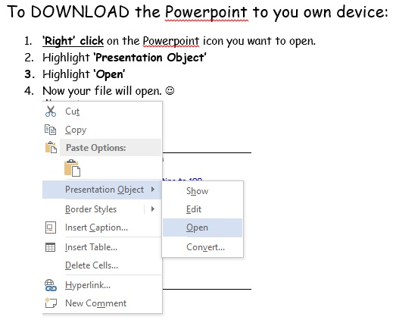

Contact Angela Noble at gw14nobleangela@ea.n-ayrshire.sch.uk if you have any questions.

