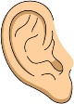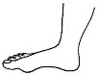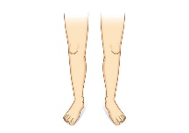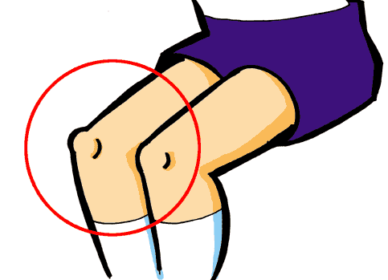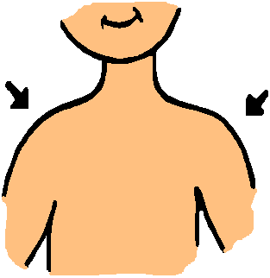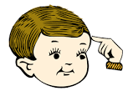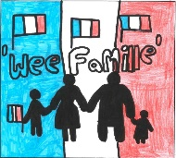

**Les Salutations**

Salut! Hello!

Au Revoir! Goodbye!

Ça va? How are you?

Ça va bien. I’m well/good.

Comme ci, comme ça So so.

Ça va mal. I’m not good.

S’il vous plaît. Please.

Merci. Thank you.

Merci beaucoup. Thank you very much Comment tu t’appelles? What is your name?

Je m’appelle ___. My name is __.

Bonne journée. Have a good day!

À la semaine prochaine. See you next week.

High Five Tope-là!

Oui. Yes.

Non. No.

**Video Links**

**Greetings Vocabulary** <https://tinyurl.com/zvjjsmq>

**Introducing Yourself** <https://tinyurl.com/wvvq93z>

**Greetings Song** <https://tinyurl.com/w2xypsu>

<https://tinyurl.com/tj56r6q>

<https://tinyurl.com/whd4nch>

**Les Couleurs**

Ma couleur préférée est My favourite colour is

J’aime I like

Je n’aime pas I don’t like

rouge red

bleu blue

jaune yellow

vert green

orange orange

violet purple

gris grey

rose pink

noir black

blanc white

marron brown

**Video Links**

**Colours Song** <https://tinyurl.com/ydxbj4o8>

**Listen to pronunciation** <https://tinyurl.com/y97s5dyg>

**Colours Matching Games** <https://tinyurl.com/s4gu7na>

<https://tinyurl.com/upbzmrh>

**Games**

**Fortune Teller** Choose numbers and colours to practise what you’ve learned with your family so far and follow the instructions on the action card.

**Ma Famille**

J’aime.. I love...

ma mère /maman my mother/mum

mon père/papa my father/dad

mon frère my brother

ma sœur my sister

ma grand-mère my grandmother

mon grand-père my grandfather

ma tante my aunt

mon oncle my uncle

ma cousine my cousin (girl)

mon cousin my cousin (boy)

**Video Links**

**Family Song** <https://tinyurl.com/odsjs9y>

**Peppa Pig** <https://tinyurl.com/wot3p7u>

**Online Story** <https://tinyurl.com/y7rce6rz>

**Games**

**Peppa Pig PAF Games** Practise numbers and words for the family with this exciting dice game!

**Les Parties du Corps**

la tête the head

les épaules the shoulders

les genoux the knees

les pieds the feet

les yeux the eyes

les oreilles the ears

la bouche the mouth

le nez the nose

les jambes the legs

**Video Links**

**Body Parts Songs** <https://tinyurl.com/yd4bjwbl>

<https://tinyurl.com/osgqwu2>

**5-a-Day Exercise** <https://tinyurl.com/h8aklub>

**French Yoga** <https://tinyurl.com/y8znsa4k>

**Online Story** <https://tinyurl.com/ve3nopu>

**Video Links**

**Food & Drink Song** <https://tinyurl.com/p5oa72d>

**Listen to pronunciation** <https://tinyurl.com/ja3z5qq>

**Food/Drink Matching Game** <https://tinyurl.com/s97xu39>

<https://tinyurl.com/uw3uqxt>

**Games**

Table Setting Game - Play this game like Beetle Drive to set your place at the table first!

Je mange.. ‘TIC TAC TOE’ - Best of 3 is the winner!

Je mange... I am eating.

une pomme an apple

une banane a banana

une orange an orange

du raisin some grapes

la pizza the pizza

les pâtes the pasta

les frites the chips

les chips the crisps

le chocolat the chocolate

le sandwich the sandwich

un couteau a knife

une fourchette a fork

une cuillère a spoon

une assiette a plate

une serviette a napkin

une tasse a cup

à droite on the right

à gauche on the left

**La Nourriture**

**French Facts**

French is an official language in 29 countries.

French is a ‘Romance’ language.

French is the native language for almost 76 million people in the world!

’Crêpes’ are very thin French pancakes with either a savoury or sweet filling.

A ‘baguette’ is a word for long bread stick.

Dogs don’t say “woof, woof” in France. In French they say, “Ouaf! Ouaf!”.

It depends where you live as to how many times you kiss when you meet. In Paris, they kiss twice - once on each cheek, in the north and in Brittany it’s three times and in the south, FOUR times - left right left right!

‘Wee Famille’

by

Jordan Young

**Mon Passeport**

**‘Wee Famille’**

**Les Nombres**

0 - zero

1 - un

2- deux

3- trois

4- quatre

5- cinq

6- six

7- sept

8- huit

9- neuf

10- dix

**Video Links**

**Listen to pronunciation** [https://tinyurl.com/ybofujrh](https://tinyurl.com/ybofujrh%20)

**Numbers Games** <https://tinyurl.com/w5porx5>

<https://tinyurl.com/vvrom5a>

**Numbers Song** <https://tinyurl.com/ybxr4esr>

**Games**

**Hopscotch** Use chalk to draw grid on the pavement and play with your family. Watch this video for how to play. https://tinyurl.com/quc7jz6

**Rip it Bingo** <https://tinyurl.com/y9nk5h8t>