Quiz | Socks | Garden/House Orienteering | Natural Noughts and Crosses
Create a quiz night for your family. Design posters to advertise it and think about how the quiz will work: Who will host it? How will people win points? Are there different rounds? Will there be a slide show? You could also visit Kahoot and see if you could create your quiz on there. If you do, share the link with the class so they can have a go too. | One of the worst things about camp is having to put those really long socks on under your boots or taking off your wet socks after a day in the water! I thought we could have a go at trying to break the world record for the number of socks put on one foot in 30 seconds, which is currently 28!!  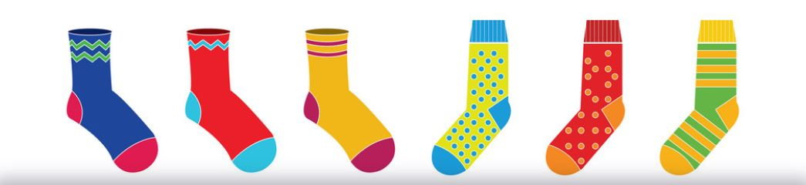 | 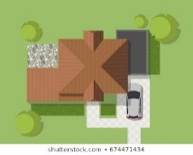  Draw a bird’s eye map of your garden and/or your house. Ask someone in your family to hide a few small objects and mark them with an X on the map. Can you find the objects? | 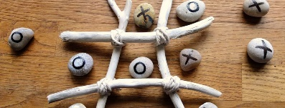  Create a noughts and crosses board and pieces out of natural materials and ask someone to play with you. One idea is using painted stones and sticks.
Marble/Tennis Ball Run | Campfire/BBQ | Treasure Hunt | Build a Shelter/Den for an Animal
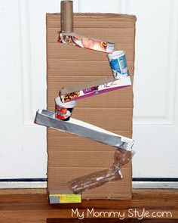  Using any materials you can find, make a track or a run for either a marble or a tennis ball to travel along. Your run must have at least 2 different heights, change direction at least once and the marble must roll all the way to the end. | 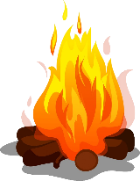  Have a camp fire or a BBQ in the garden with your family. Toast some marshmallows or have a midnight feast. Share your ghost stories and maybe sing a couple of your favourite campfire songs! | 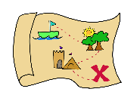  Can you create a treasure hunt for someone in your family to complete? You could create a trail that includes clues/riddles that will lead them around the house or garden to a final prize or destination. Or, you could create a treasure map with numbered places, compass points and an “X” to mark the mark the spot. | In the woods or your garden, can you make a home for a woodland creature of your choice? (mouse, rabbit, bird…)  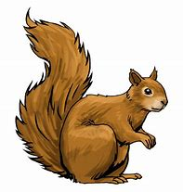  Use natural materials you can find and some string. Can you make it waterproof? Can you add any furniture?
Pitch a Tent in the Garden | Planting/Gardening | Go for a Cycle/Scooter Ride or Hike | Star Gazing
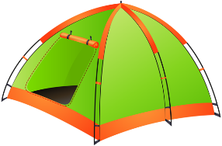  Pitch a tent in your garden and spend a bit of time in it. You could even sleep in it if the weather allows! When you’re finished, you’ll need to take it down and pack it away too. If you don’t have a tent, build a den in your house instead! | 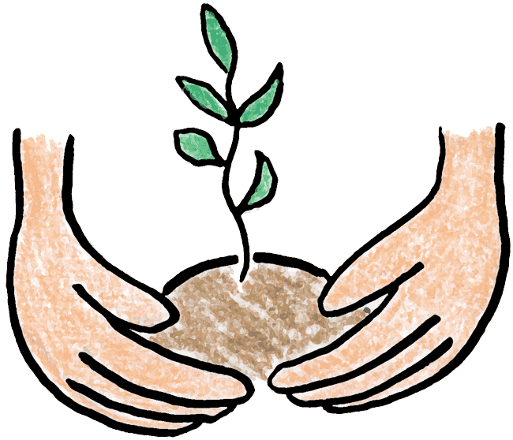  This is the perfect time of year to do some planting in the garden. Get some seeds or bulbs and find a patch of soil to plant them. Or you could plant them in plant pots. You could also do some weeding! | Go for a long cycle or scooter ride with a member of your family or take a long nature hike. You could even prepare a picnic to take with you.  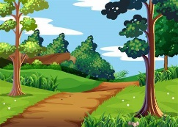  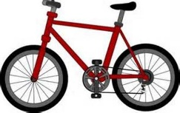 | 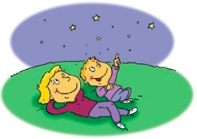  If it’s a clear night, go outside and look up at the sky. See if you can spot any constellations, planets or satellites. You can download the app Sky View and use it to help you find anything interesting in the sky. Even if it’s cloudy the app will still show you what’s hidden behind the clouds!
Tallest Natural Structure | Natural Art Picture | Make and Fly a Kite | Make a Bird Feeder
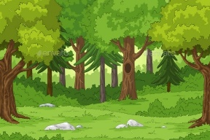  Go to the woods and try to make the tallest standing structure you can, using only natural materials you find and some string. | 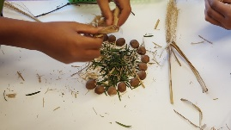  Collect some natural materials from the garden or while you are out on a walk. Use them to create a piece of artwork. | Design and make your own kite using any materials you like! Can you make it fly on a windy day?  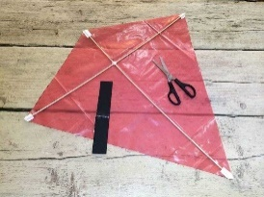 | 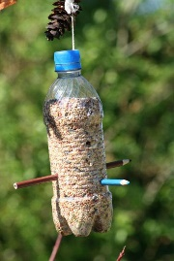  Design and make your own bird feeder. Some ideas are using a hollowed out orange or a plastic bottle. You’ll find lots of designs on the internet.  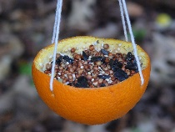
Make A Bird House | Blindfold Obstacle Course | Minibeast Hunt | Make A Mini Raft
Make and decorate a bird house from wood or cardboard (or any other materials you want to use). Remember cardboard won’t be waterproof so don’t leave it out in the rain!  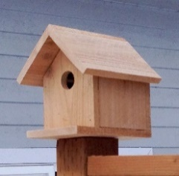 | 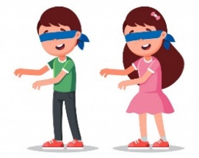  Create an obstacle course in your house or garden. Put on a blindfold and ask a member of your family to guide you around the obstacle course then swap over. Alternatively, you could put a bucket somewhere and ask someone to guide you to the bucket to put a ball inside. | 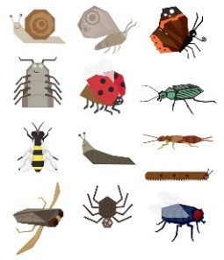  Go on a nature walk and try to find and identify different types of minibeasts. Good places to look are under large rocks or tree stumps, because minibeasts like damp, dark spaces.  Take pictures or  draw them. | 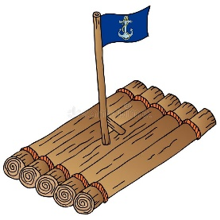  Make a mini raft for one of your toys using any materials you like. (Sticks and string would be a good example). Test it in the sink/bath/bucket of water. Does it float? Does it take the weight of the toy? (Choose a toy you don’t mind getting a bit wet!)
Ghost Stories | Time a Bed Change | Movie Night | Disco
No camp is complete without some spooky stories! Can you make up your own scary story that you think will have everyone shaking in their shoes?! If you can, record your story and share it with the class. You could think about adding scary effects, such as a torch lighting up your face, spooky background music or a door creaking behind you! | 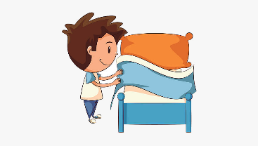  One of the important things you have to do at school camp is make your own bed! Your challenge today is to TIME how long it takes you to change your bedsheets. This includes sheet, pillow cases and duvet cover! Try to do it as quickly as possible, but it also has to be NEAT. | 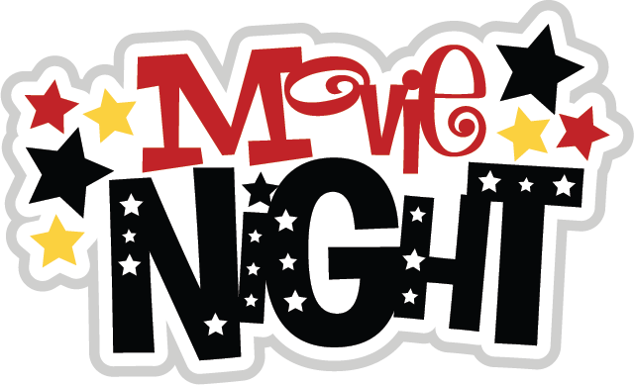  Design and plan a movie night to have with your family, or connect with friends on Zoom/FaceTime, etc and watch together virtually from your different houses. Create a poster with details such as time and location and make some snacks - there are lots of great popcorn recipes online that you could make! | Thursday is usually disco night so you could plan a disco for your family by making a playlist, organising games and making snacks. Or, you could organise a virtual Just Dance party with your friends. I miss seeing you all so I’d love to see some videos! Remember to put on your best party outfit too!

