Numeracy  - Create a picture of a butterfly making sure that the wings are symmetrical. | Out and About  - Go on a sensory walk with an adult. What can you see? What can you smell? | Literacy  - Write an acrostic poem about a springtime word of your choice.
Working with Others  - Ask your family and friends to tell you what their favourite thing about spring is. Make a list of their answers. | 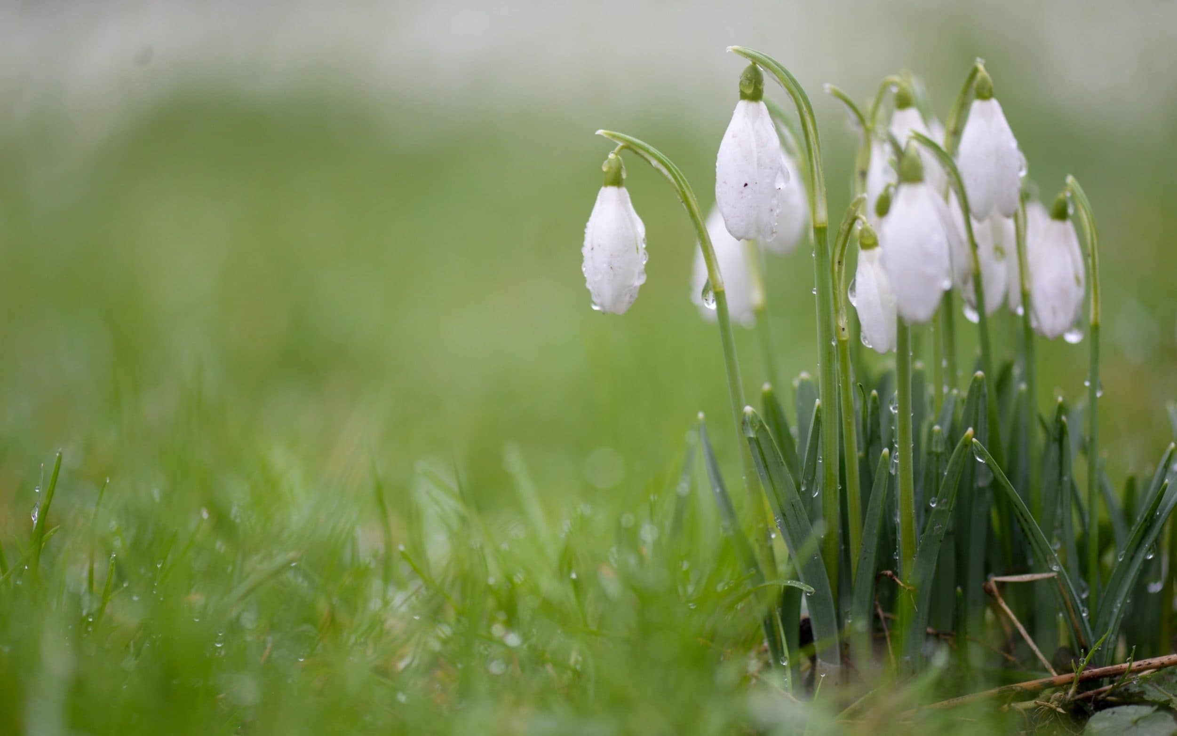  Primary 6  Spring  Activity Grid | Expressive Arts  - Create a picture of blooming spring flowers using a range of media.
Let’s Get Technical  - Make your own bird feeder and record some of the birds that use it. | Social Studies  - Write a fact file about an animal or bird that you are likely to see in spring. | Health and Wellbeing  - Create a recipe using vegetables and fruits that are in season during spring.

