Create a brand new front cover for your favourite book! | Create a supervillain! Create wanted posters and newspaper articles describing what makes them evil! | Extreme Reading Photo Challenge – Have someone take a photo of you reading in extreme/very strange places. | Choose a topic that interests you, it can be anything at all. Can you create a comic with your topic’s theme? | On a small piece of paper or index card, Write a little about a book that has meant the world to you and why.
2 person activity. Take turns describing a character – either one who already exists or you make one up – visualise and draw what your partner is describing. | Create a PowerPoint trying to convince someone to read your favourite book. Include pictures, quotes and facts to help persuade someone. | 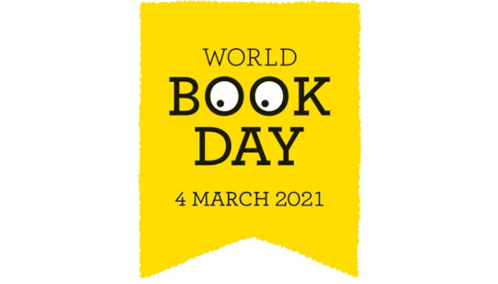 | Top 5’s  List your top 5…  -favourite books  -favourite authors  - favourite characters  - favourite quotes | We have all used Lego to build something. Can you use books to build/create a wonderful piece of art?
Create a cosy reading den/corner for you to relax and enjoy a great story | Potato Character  Use a potato to design and make your own character! Write a short description about them. It can be a familiar character or one you’ve made up yourself. | Choose an author and create a fact poster all about them. Where are they from? When did they start writing stories? What was their first book? How many books have they sold? When did they become an author? | Listening to music whilst you read can be extremely relaxing and enjoyable. Try and find some music you would like to listen to whilst you read. | Book Scavenger Hunt  Find a book with…  -an animal main character  -a dragon in it  -more than 150 pages  - rhyming words  -a girl as the main character  -a 5 word title.

