Numeracy  - Draw a space scene using only 2D shape.  - Work out the distance of each planet from the sun in kilometres and meters. | Out and About  - Observe the night sky and note any constellations you see.  - Write down three facts about you favourite constellation. | 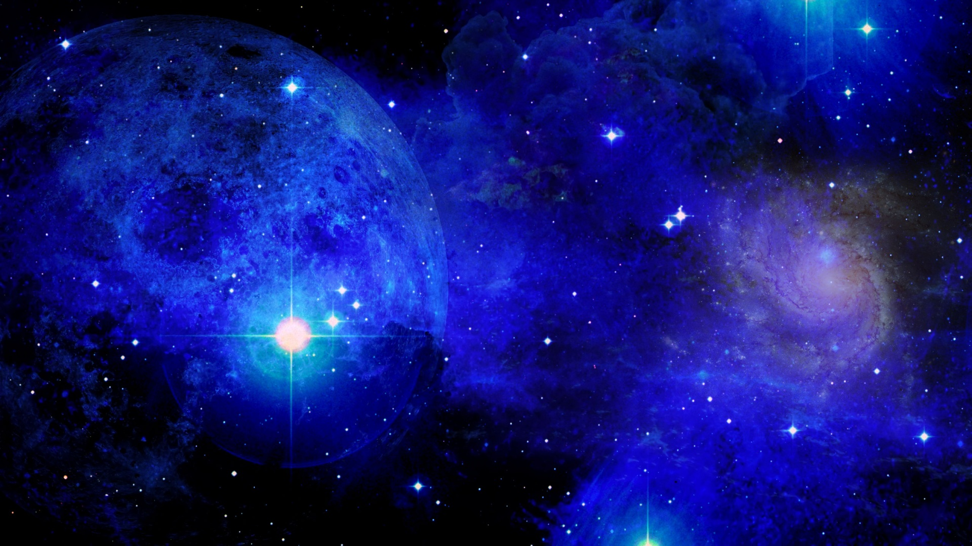  Literacy  - Write an acrostic poem for one of the planets.  - Create your own word search using words relating to space.
Working with Others  - Create a mnemonic to help family members remember the order of the planets.  - Make a space quiz for your family to do. | Primary 6  Space  Activity Grid | Expressive Arts  - Create a list of song titles that have spaced themed words.  - Create a picture of a space scene using materials of your choice.
Let’s Get Technical  - Find out 10 amazing facts about space travel.  - Make a rocket with a parachute to aid re-entry. | Social Studies  - Write a fact file about a famous astronaut.  - Create a timeline of space travel and exploration events. | Health and Wellbeing  - Find and make a space themed recipe.  - Create a workout for an astronaut living on the International Space Station.

