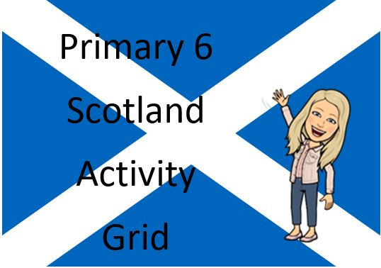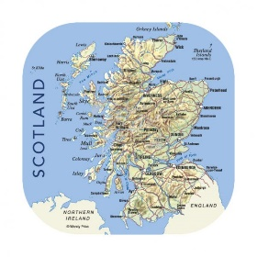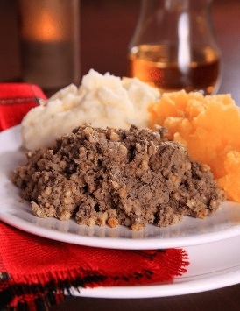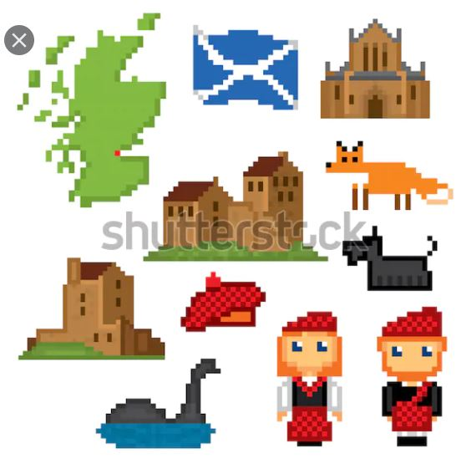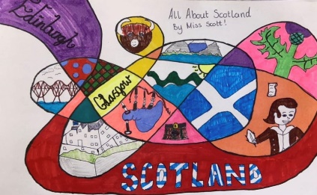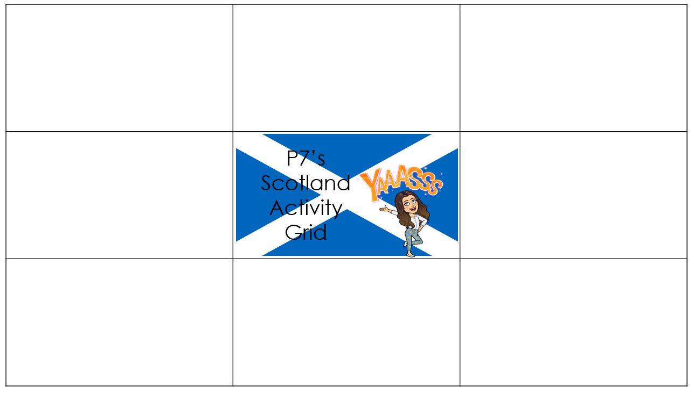

Scots Poems

Choose one of the poems below and have a go at learning as much of the poem as possible. Perform it to your family or, even better, get someone to film you reciting it and post it on Teams! Look on youtube to get some ideas.  
[Willie Wastle Poem.pdf](Willie%20Wastle%20Poem.pdf)

[The Ballad of Janitor MacKay Poem.pdf](The%20Ballad%20of%20Janitor%20MacKay%20Poem.pdf)

Scottish Landmarks

Have a look through the [All About Scotland's Landscape PowerPoint.ppt](All%20About%20Scotlands%20Landscape%20PowerPoint.ppt)

Complete the 4 activities   
at the end of the   
PowerPoint

Virtual Tours

* [Tour of Burns Birthplace Museum & Cottage](https://www.youtube.com/watch?v=7wnu5sVpNAg&safe=active)
* [Story of Robert Burns](https://www.youtube.com/watch?v=qMxIBqpryG0&safe=active)

Task: create an advert for the Burns Museum and Cottage. Think about why people would want to visit this landmark. Remember to use persuasive language.

Scottish Art Task

Take your pencil for a walk on a piece of paper. Fill each space you have created with Scotland related pictures.

Example:

Scottish Pixel Art

I know you all really enjoyed creating some Pixel art   
last week, so this   
week I’d like you   
to create some   
Scottish themed   
pixel art.

[Draw here](https://www.pixilart.com/draw)

Find your Tartan

* Read through [What is Tartan Powerpoint.ppt](What%20is%20Tartan%20Powerpoint.ppt)
* What Clan are you a part of?   
  [Find your Family Tartan here](https://clan.com/families)
* How is tartan made?  
  [Weaving Tartan](https://www.youtube.com/watch?v=2W9UBVjx_QQ&safe=active)

Design your own family tartan.  
Top Tip: think of the colours you are using, they should complement each other.

Burns Supper

Read through the [Invitation to a Burns Supper.ppt](Invitation%20to%20a%20Burns%20Supper.ppt)PowerPoint.

Design a Selkirk Grace   
table mat

Complete the Burns Word   
search

Scottish Kahoot! Quiz

Click on the link to try a Kahoot! Quiz which will test your knowledge of our bonnie country! [Scotland Kahoot Quiz](mailto:https://create.kahoot.it/details/scotland/609d6aa2-ec38-4b6f-bd80-c92cfaa751f2)

Post your scores on Teams!