IDS ACTIVITY GRID
HWB – 2021 Vision Board  A vision board is a fun way to create and record future big dreams and goals. It can be used as an overview of what you want in your life.  I’d like you to create your own Vision Board, this can include short term and long term goals.  Prompt Question for Vision Board  How to Make a Vision Board  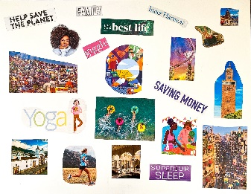 | Technology – Pixel Art  Pixel art is a form of digital art, created through the use of software. Click on the link and have a go at designing and drawing your very own piece of pixel art. Experiment using the tools and enjoy!  https://www.pixilart.com/draw  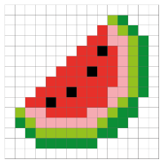 | Science – The Water Cycle  I have created a folder on SharePoint with an information PowerPoint about the Water Cycle and other useful resources.  Here are some other websites for more information:  What is the Water Cycle?  The Water Cycle  Met Office - The Water Cycle  I’d like you to create your own poster describing each step of the water cycle.  Please share your finished product on Teams. | Music – Mrs McDougall  Mrs McDougall will be posting new music activities every week for you to complete on the blog.  Please make sure that you complete any tasks that she sets you.  Have fun! | Art – Scottish Artwork  Gillian Kyle is a Scottish Artist. She designs unique prints, taking inspiration from Scottish favourites such as Irn-Bru, thistles and Tunnock’s teacakes.  Look at Kyle’s artwork and search her art further online if you can then create your own Scottish Tunnock’s teacake drawing.  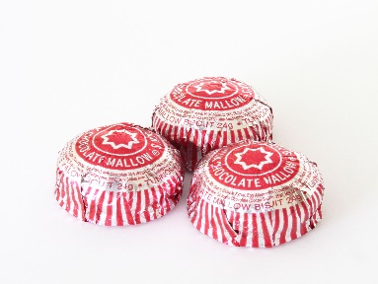
HWB – Healthy Eating  Can you help create a healthy lunch or dinner for your family?  Make a menu, listing the ingredients in each dish.  Have a look at food labels to find out if you are making healthy choices.  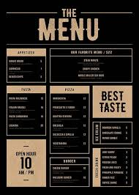 | Technology –  Research Fact File  Choose an inspirational Scot to research. Ask a family member about them, read newspapers, magazines or books, use an online search engine or watch a TV programme or movie, if appropriate, to find more information about this person.  You can make your fact file on paper, on a word document or on PowerPoint.  Some potential Scots to research:  Robert Burns, John Logie Baird, Andy Murray, Alexander Graham Bell, Billy Connelly | Listening & Talking – Soul  There are 4 placemats to choose from. I haven’t had a chance to watch Soul yet but I’ve heard lots of good things about it. You can let me know what you think.  Enjoy  Pixar Film Placemats  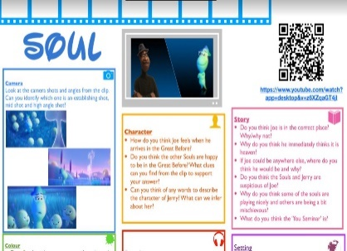 | I see... I think… I wonder…  Look at the image below. Write your notes on paper.  What do you see? Try to use ambitious vocabulary!  What do you think is happening?  What do you wonder about the environment/  person in this picture? | Burns Supper/Music  As I am sure you’ll already know, Primary 7 usually host the Burns Supper. I am hopeful that we will still be able to do this virtually, or at least be able to provide a video showcasing our talent as a cohort.  Have a listen to these songs performed by Scottish Artists; which one is your favourite? Why? Please share your opinions on Teams.  Caledonia  Loch Lomond  Auld Lang Syne  Dignity  I'm Gonna Be (500 Miles)  I'm On My Way  Walk of Life  Mr Rock & Roll
I thought some of you might enjoy this challenge. Please feel free to share your creations with us all on Teams
