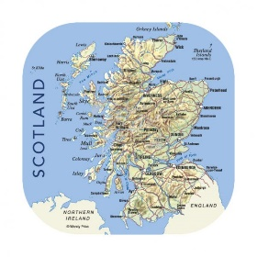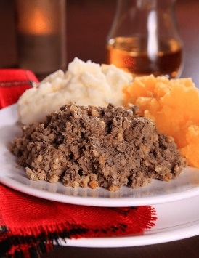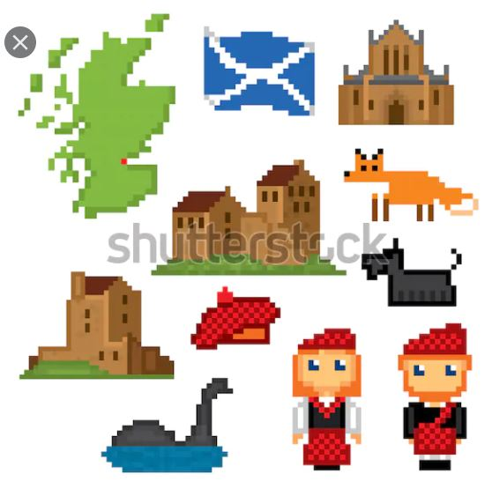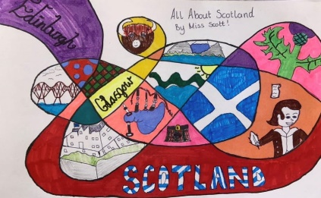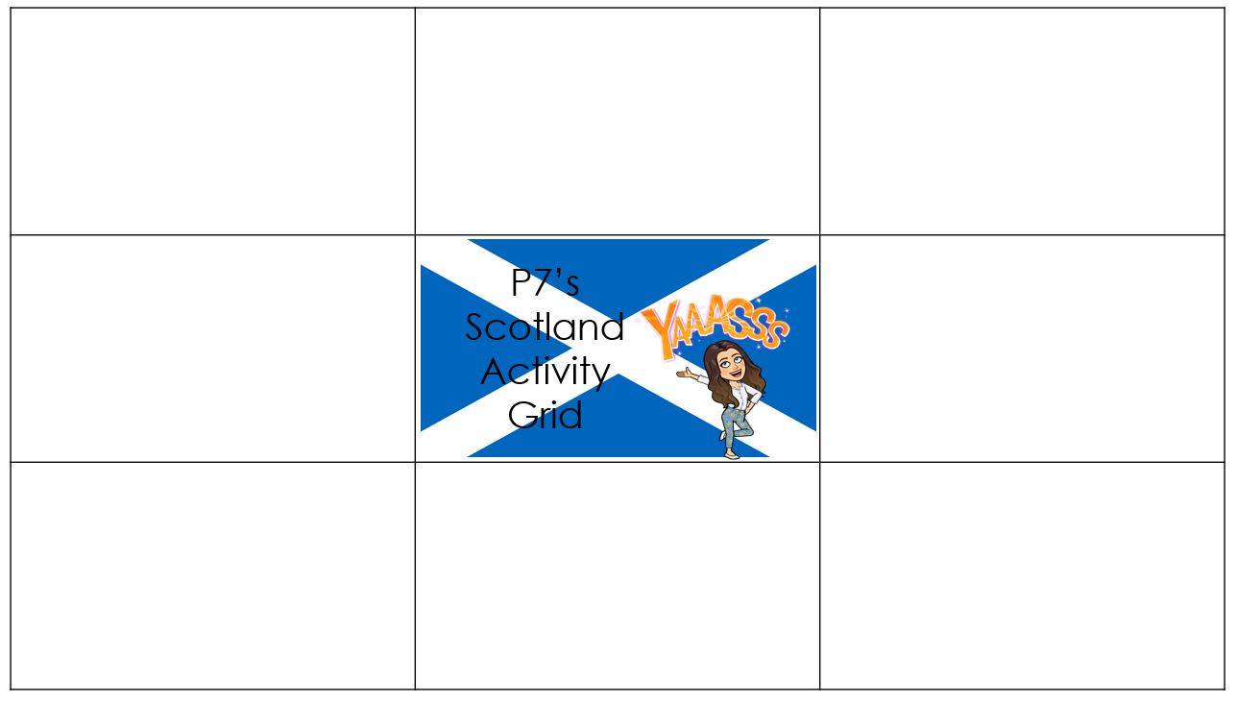

Scottish Landmarks

Have a look through the *All About Scotland’s Landscapes* ppnt.

Complete the 4 activities   
at the end of the   
PowerPoint

Virtual Tours

* [Tour of Burns Birthplace Museum & Cottage](https://www.youtube.com/watch?v=7wnu5sVpNAg&safe=active)
* [Story of Robert Burns](https://www.youtube.com/watch?v=qMxIBqpryG0&safe=active)

Task: create an advert for the Burns Museum and Cottage. Think about why people would want to visit this landmark. Remember to use persuasive language.

Scots Poems

Listen to the poem *‘A Man’s a Man for a’ That’*

[*A Man's a Man... Youtube*](https://www.youtube.com/watch?v=yPLMni0-P1U&safe=active)

Have a go at learning as much of the poem as possible. Perform it to your family, it would be even better if someone could film you reciting it!  
[A Man's a Man... Poem](https://www.scottishpoetrylibrary.org.uk/poem/mans-man-0/)

Scottish Art Task

Take your pencil for a walk on a piece of paper. Fill each space you have created with Scotland related pictures.

Example:

Scottish Pixel Art

I know you all really enjoyed creating some Pixel art   
last week, so this   
week I’d like you   
to create some   
Scottish themed   
pixel art.

[Draw here](https://www.pixilart.com/draw)

Find your Tartan

* Read through *What is Tartan*? Ppnt
* What Clan are you a part of?   
  [Find your Family Tartan here](https://clan.com/families)
* How is tartan made?  
  [Weaving Tartan](https://www.youtube.com/watch?v=2W9UBVjx_QQ&safe=active)

Design your own family tartan.  
Top Tip: think of the colours you are using, they should complement each other.

Burns Supper

Read through the *An Invitation to a Burns Supper* PowerPoint.

Design a Selkirk Grace   
table mat

Complete the Burns Word   
search

Scotland Quiz

Join our VSCENE meeting at 1:30pm on Friday to take part in Mr. Anderson’s Scotland Quiz.

I will put your knowledge to the test so try and brush up on your knowledge of Scotland!