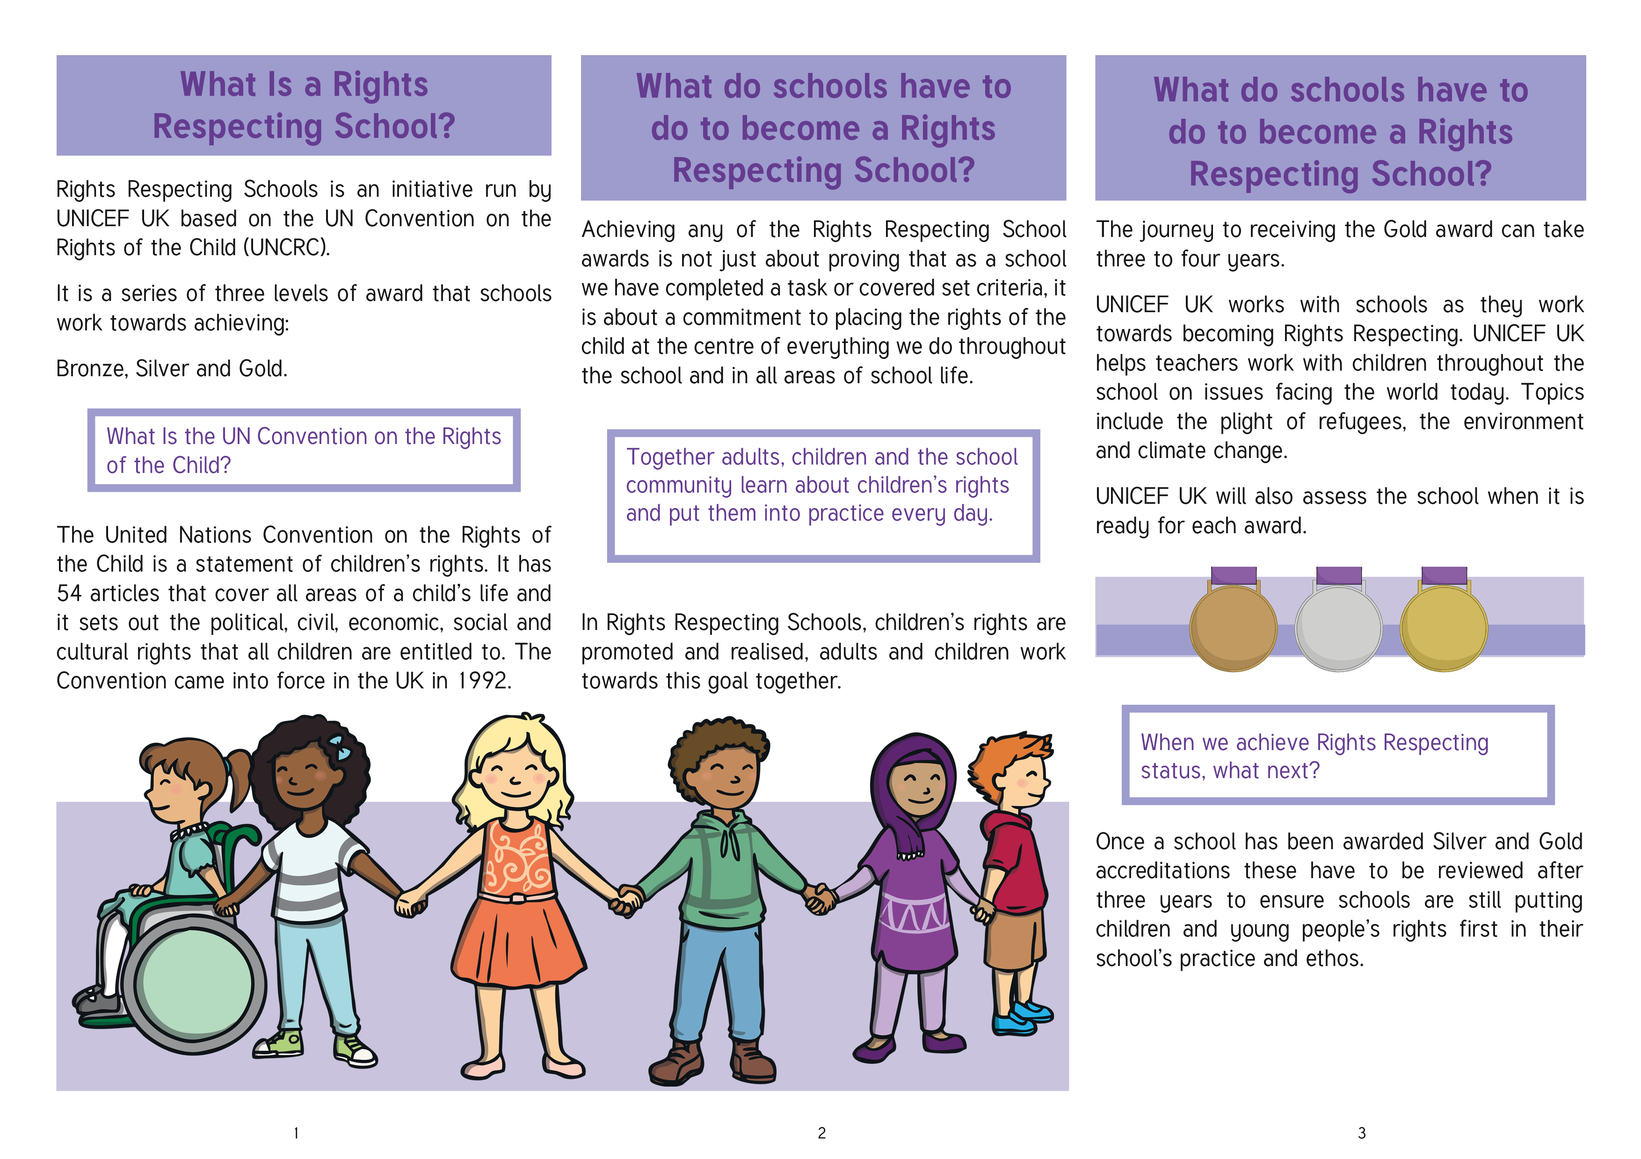
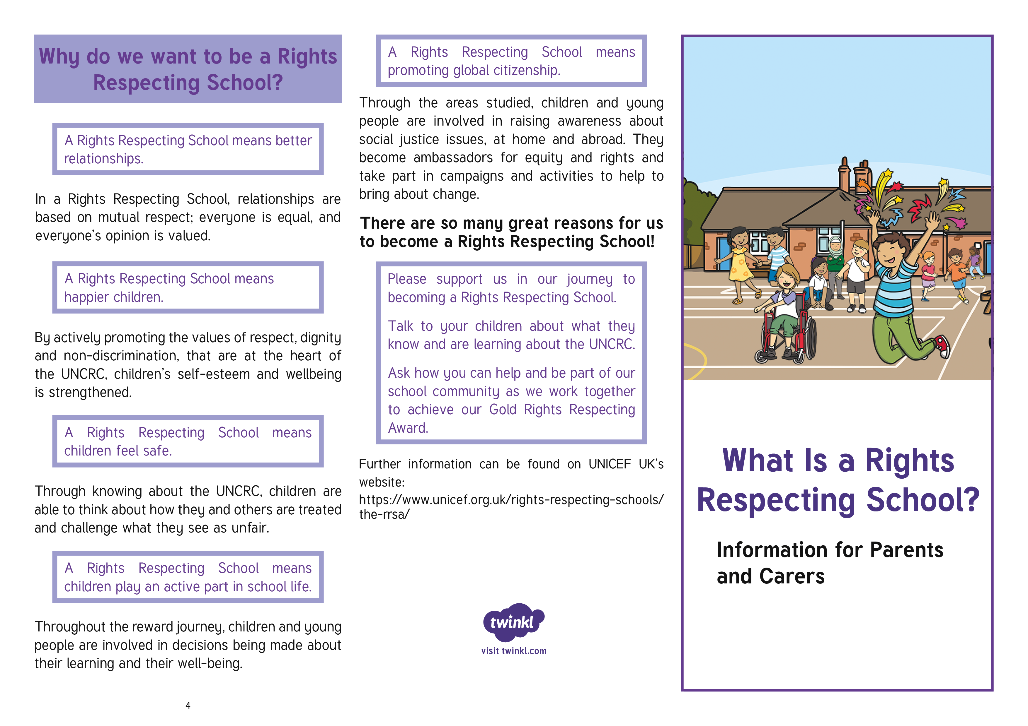
Contact Information: Please insert the Head Teacher’s contact information for your school e.g. name, address, phone number and email address or Local Authority point of contact and logo. Please remember to delete this text before printing!

