Get Cooking!  - Follow a recipe and weigh each ingredient using scales. Add the cooking time to the current time to work out when it will be ready. Bon appétit! | Data Handling  - Create a questionnaire and gather data about the perfect night in from your family and/or friends. Consider the entertainment, the dinner, snacks and drinks. Present the data in graph form. | Fun Friday Night TV  - Create a viewing schedule for 5 hours of television.  - Include the names of the shows, their duration and their start times | Shape Challenge  - Find a 2D shape in your home. Measure it and calculate the perimeter and area of the shape. For a challenge, find a 3D shape in your home and calculate its volume.
Saturday Chores  - You have the following chores to complete between 9am-12pm  - Complete homework (45 mins)  - Walk the dog (30 mins)  - Visit gran (1 hour)  - Clean the car (30 mins)  - Empty the dishwasher (15 mins)  - Make a timetable of your morning showing when you start and finish each chore.  - Can you make another timetable, this time showing 5 different ways you’d prefer to spend those 3 hours? | Count Down  Play this game with another person. One person writes down a 3-digit ‘total’ number. The other person writes down four numbers between 1 and 10 as well as three numbers which are multiples of 10, up to 100. e.g. Total: 437 Numbers: 4, 7, 9, 3, 20, 70, 50 Set a two-minute timer and work out the total number by using the other numbers and any operations, e.g. +, -, ÷ and ×. The person closest to the total number wins |  | Times Tables Tennis  - Select a times table. With another person, alternatively say each station of the table. If you make an error, start the times table again. Try to complete every times table from 2 to 10 with your partner.  Sale  - Go to a shop with an adult. Create a 25% off sale. For each item the adult buys, work out the new price of the item if there was a 25% off sale in the shop. Remember: 25% = ¼.  - Challenge yourself by discounting different %
Numeracy Home Learning Challenges (Second Level)
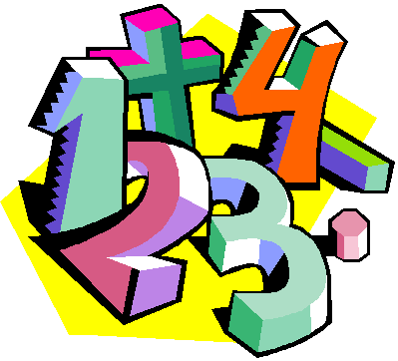
NName: _________________________

Class: ________________________
Talking Numbers
Ask an adult or friend to write a number down. You have one minute to tell the person as many facts about that number as possible. It could be: sums that total this number; whether the number is odd or even; how many digits it has; numbers which are more or less; where this number is seen in real life, etc. Then write down a new number and create number facts for the new number.
Other Curricular Area Challenges | Art – Symmetrical Patterns  - Head outside to create a picture using symmetrical patters.  - Use natural resources (e.g. leaves, twigs, petals, etc) to make your patterns. | Technology  - Log into Scratch and create a game for a friend or relative to play | HWB – Fit 15  - Create a 15 minute HIIT workout including a variety of different exercises and rest time in between.

