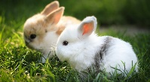  Kits | 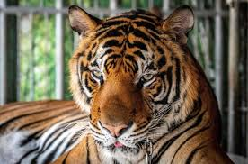  Tigers | 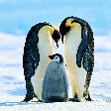  Penguins | 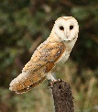  Owls | 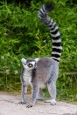  Lemurs
swam | pipe | renew | angel | puncture
swell | wise | screw | digest | signature
swim | bite | stew | emergency | temperature
swop | kite | threw | energy | vulture
twig | size | her | engineer | action
twin | inside | after | imagine | addition
twist | slide | paper | intelligent | addiction
clap | smile | water | legend | ambition
click | stile | herb | magic | attention
cling | while | verb | register | competition
clip | chime | term | stranger | condition
club | crime | stern | tragic | devotion
 | slime | verse

