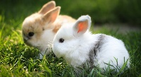  Kits | 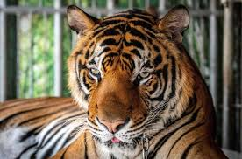  Tigers | 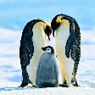  Penguins | 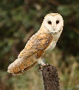  Owls | 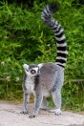  Lemurs
snot | tide | awkward | giant | behaviour
snug | wide | awful | ginger | saviour
spam | bike | blew | giraffe | adventure
span | hike | chew | general | capture
spat | like | crew | genius | creature
spell | time | dew | gentle | figure
spill | fine | drew | geometry | furniture
spin | line | few | gesture | future
spit | mine | flew | gymnasium | manufacture
spot | pine | grew | gypsy | mixture
spun | wine | Jew | damage | nature
 |  | new | danger | picture
 |  |  |  | premature

