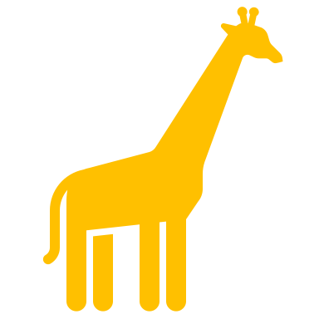
How to save the rainforest

- Support the grassroots .
- Teach others about the environment .
- We need the rainforest to protect and produce oxygen .
- We need to save the rainforest to help us breathe and carbon cycle.
- The rainforest is important for something called lungs .
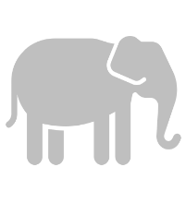
- Plant more trees .
- Establish parks to protect rainforest and wildlife

Where Animals live

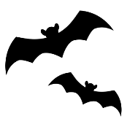
Emergent layer
- Butterflies
- Bats
- Birds
- Harpy eagles

Canopy layer

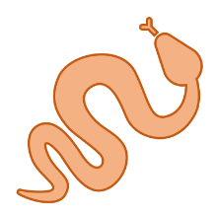
- Sloths
- Bats
- Tree frogs
- Hummingbird
- Snakes

Understory
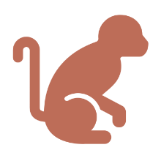
- Bats
- Monkeys
- Lizards
- Jaguars
- Insects

The forest floor
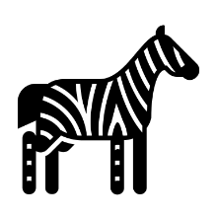
- Elephant
- Jaguars
- Tapir
- Mongoose
- Southern cassowary
- Okapi
- Armadillos
- Gorilla
- Tiger
- Leprechaun
- Leopard
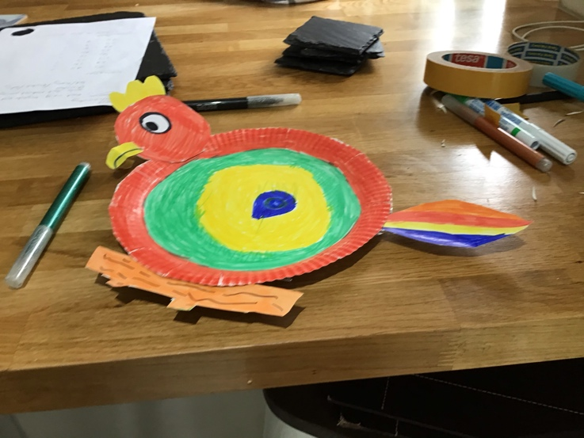
- Toucans
- Wolves
- Foxes
- Kola
- Monkeys
- Frogs
- Raccoon
- Zebras
- Snakes
- Butterfly
- Insects.

Tribes

- There are 77 types of tribes.
- Brazil claims to have most of world’s unconnected people estimating as many as 77 tribes.
- The Cherokee Indians are 200 years old .
- A tribe is short for tribal.

Temperature

The temperature in the rainforest is 32 degrees C.

Task 2 - Glossary

Emergent layer | The emergent layer is where all the birds live.
Canopy | The canopy is very dark because the trees are blocking the sun light.
Forest floor | The forest floor is where the zoo animals live.
Understory | This is where the monkeys live.
Tiger | Tigers are orange with black stripes.
Elephant | Elephants  are nearly extinct.
Brazil nut tree | A Brazil nut tree is very tall
Kola | Kolas are grey with a very long fluffy tail
Monkey | Monkeys are brown with long tails they are like lemlur .
Toucan | A toucan is a type of bird.
Jaguars | Jaguars are like tigers.
Wolf | Wolves are big scary animals
Frog | Frogs are green they live in ponds they sit on water Lille’s .

Flowers

Emergent layer

- Kapok
- Brazil nut tree

Canopy

- None

Under story

- None

Forest floor
- Bromeliads
- Orchids
- Açai palms
- Carnauba palm
- Rattan
- Walking palm
- Water Lille’s
- Rubber tree

