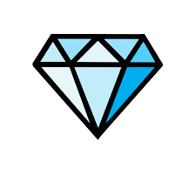  Diamonds  ou | 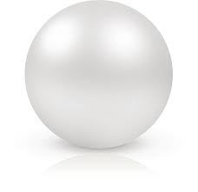  Pearls  ea | 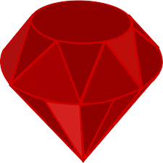  Rubies  oo | 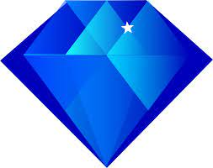  Sapphires  sl/br
pound  round  surround  wound  count  flour  hour  our  sour | real  clean  cheap  beat  eat  cheat  heat  meat  neat | pool  room  broom  spoon  moon  soon  boot  shoot | slim  slip  slot  slum  brag  brat  brick  bring

