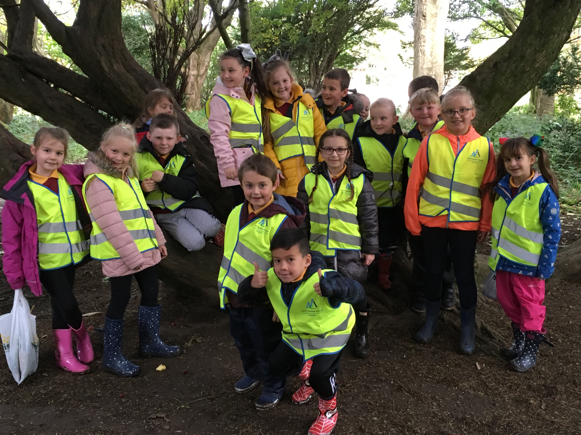
Term 3
Primary 3b - Newsletter

Happy New Year everyone and I hope you all had a lovely Christmas break! We have started Term 3 by carrying out a mini topic on Scotland. The children have had experience of using an atlas to locate places they have visited. We are listening to, and learning about Scottish poetry. Our poem for the Burn’s competition is Blethertoun Rovers by Matthew Fitt. In music Mrs McDougal is teaching the children some traditional Scottish songs.

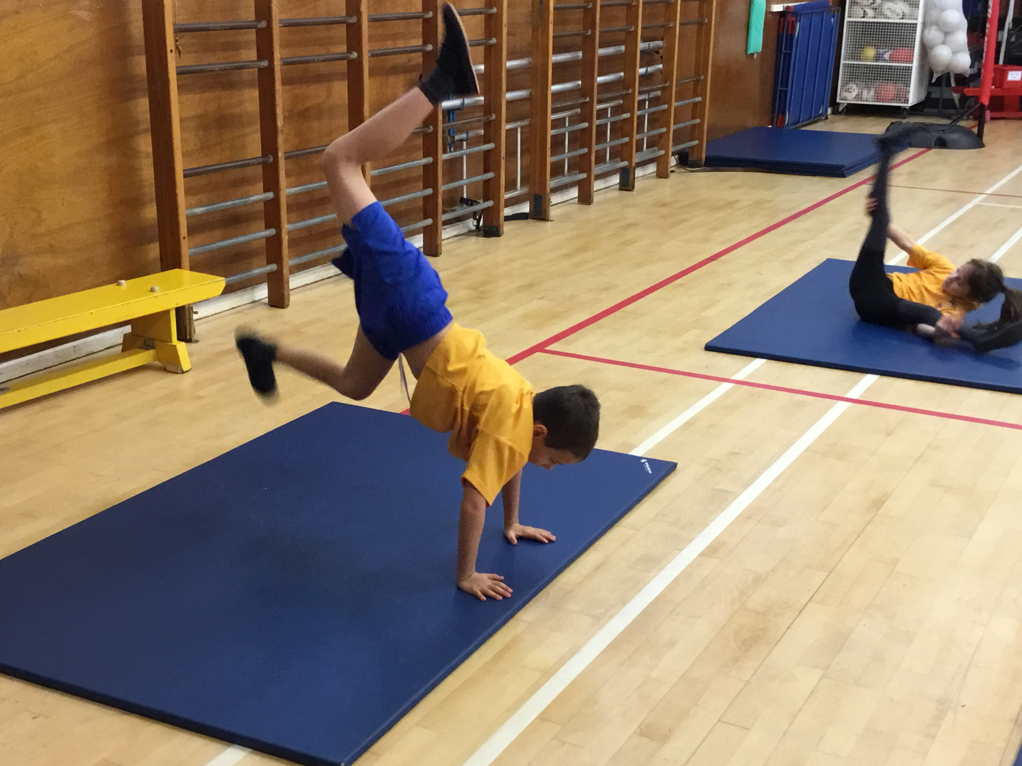
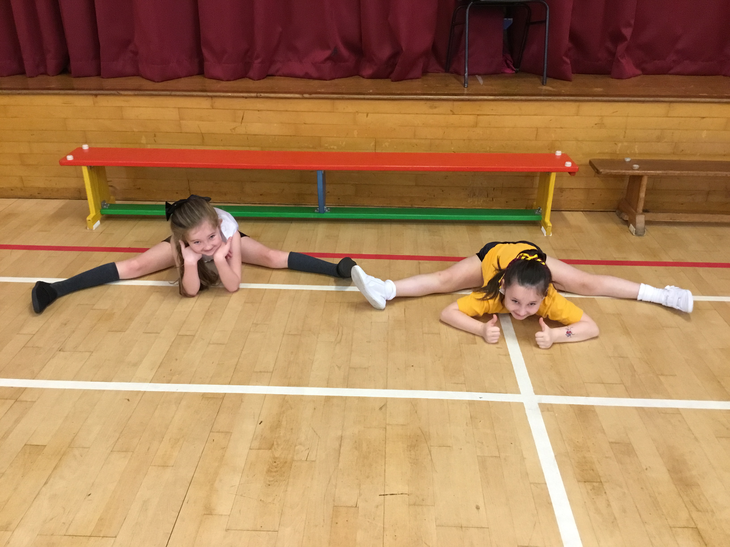
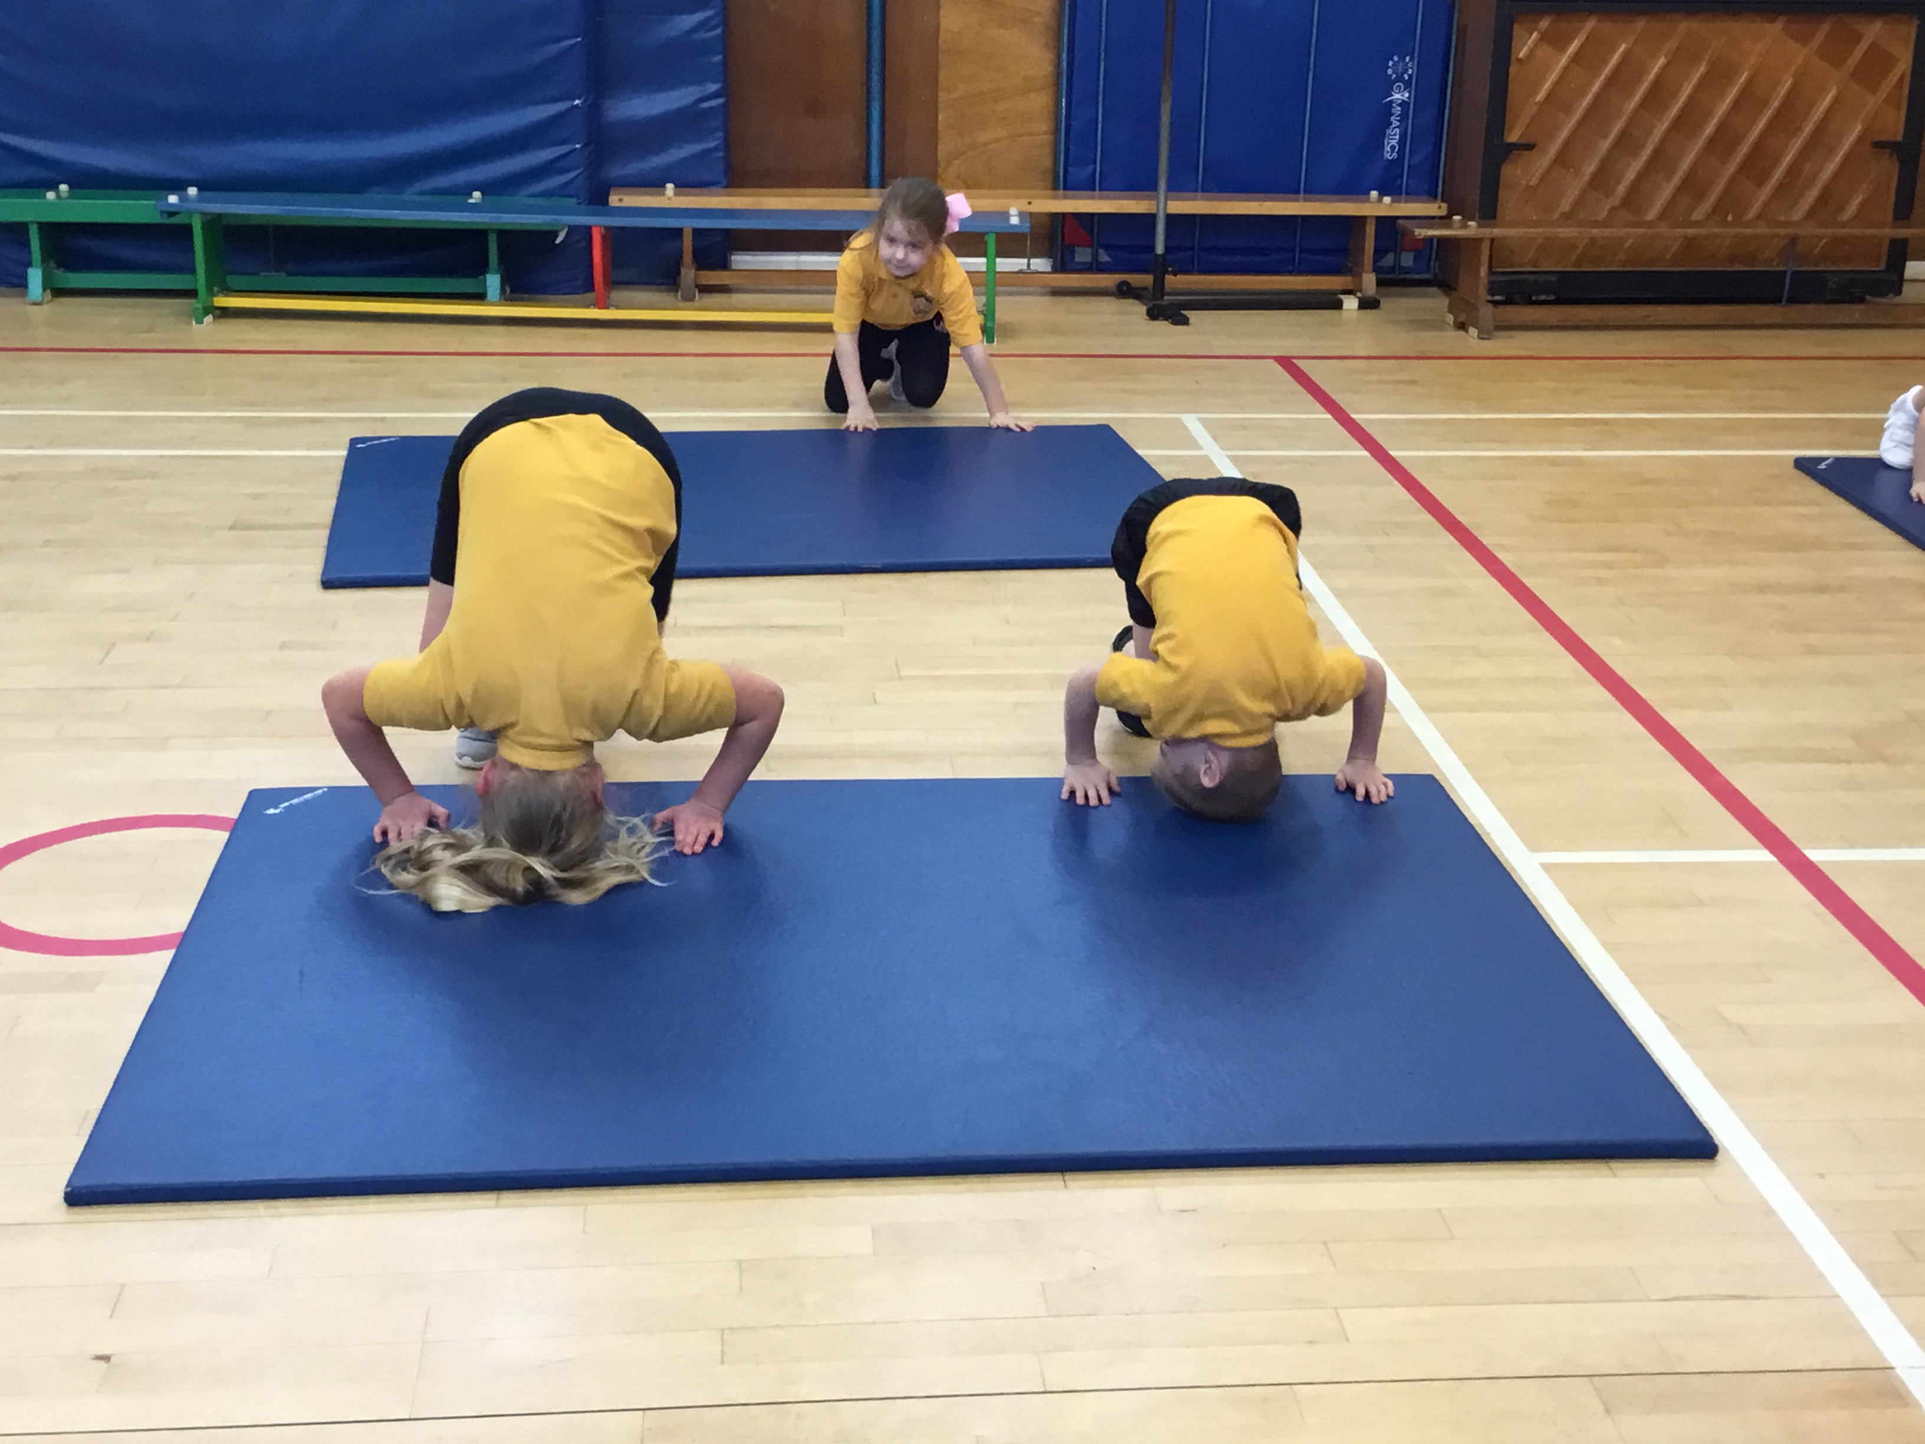

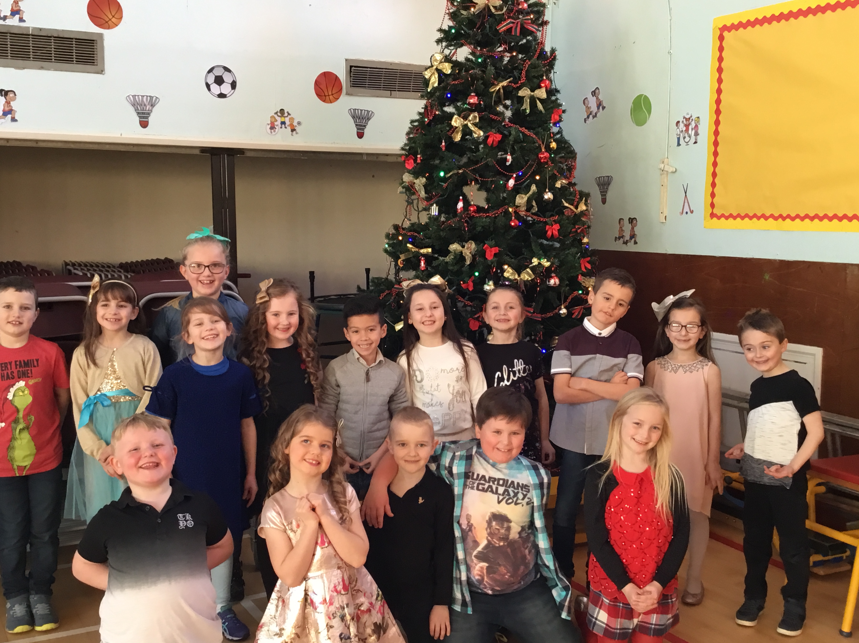
Last term was a very busy term. Please look at our class blog where you will see photographs and find out more about our learning. You can also leave a comment on the Parents Comment Page!

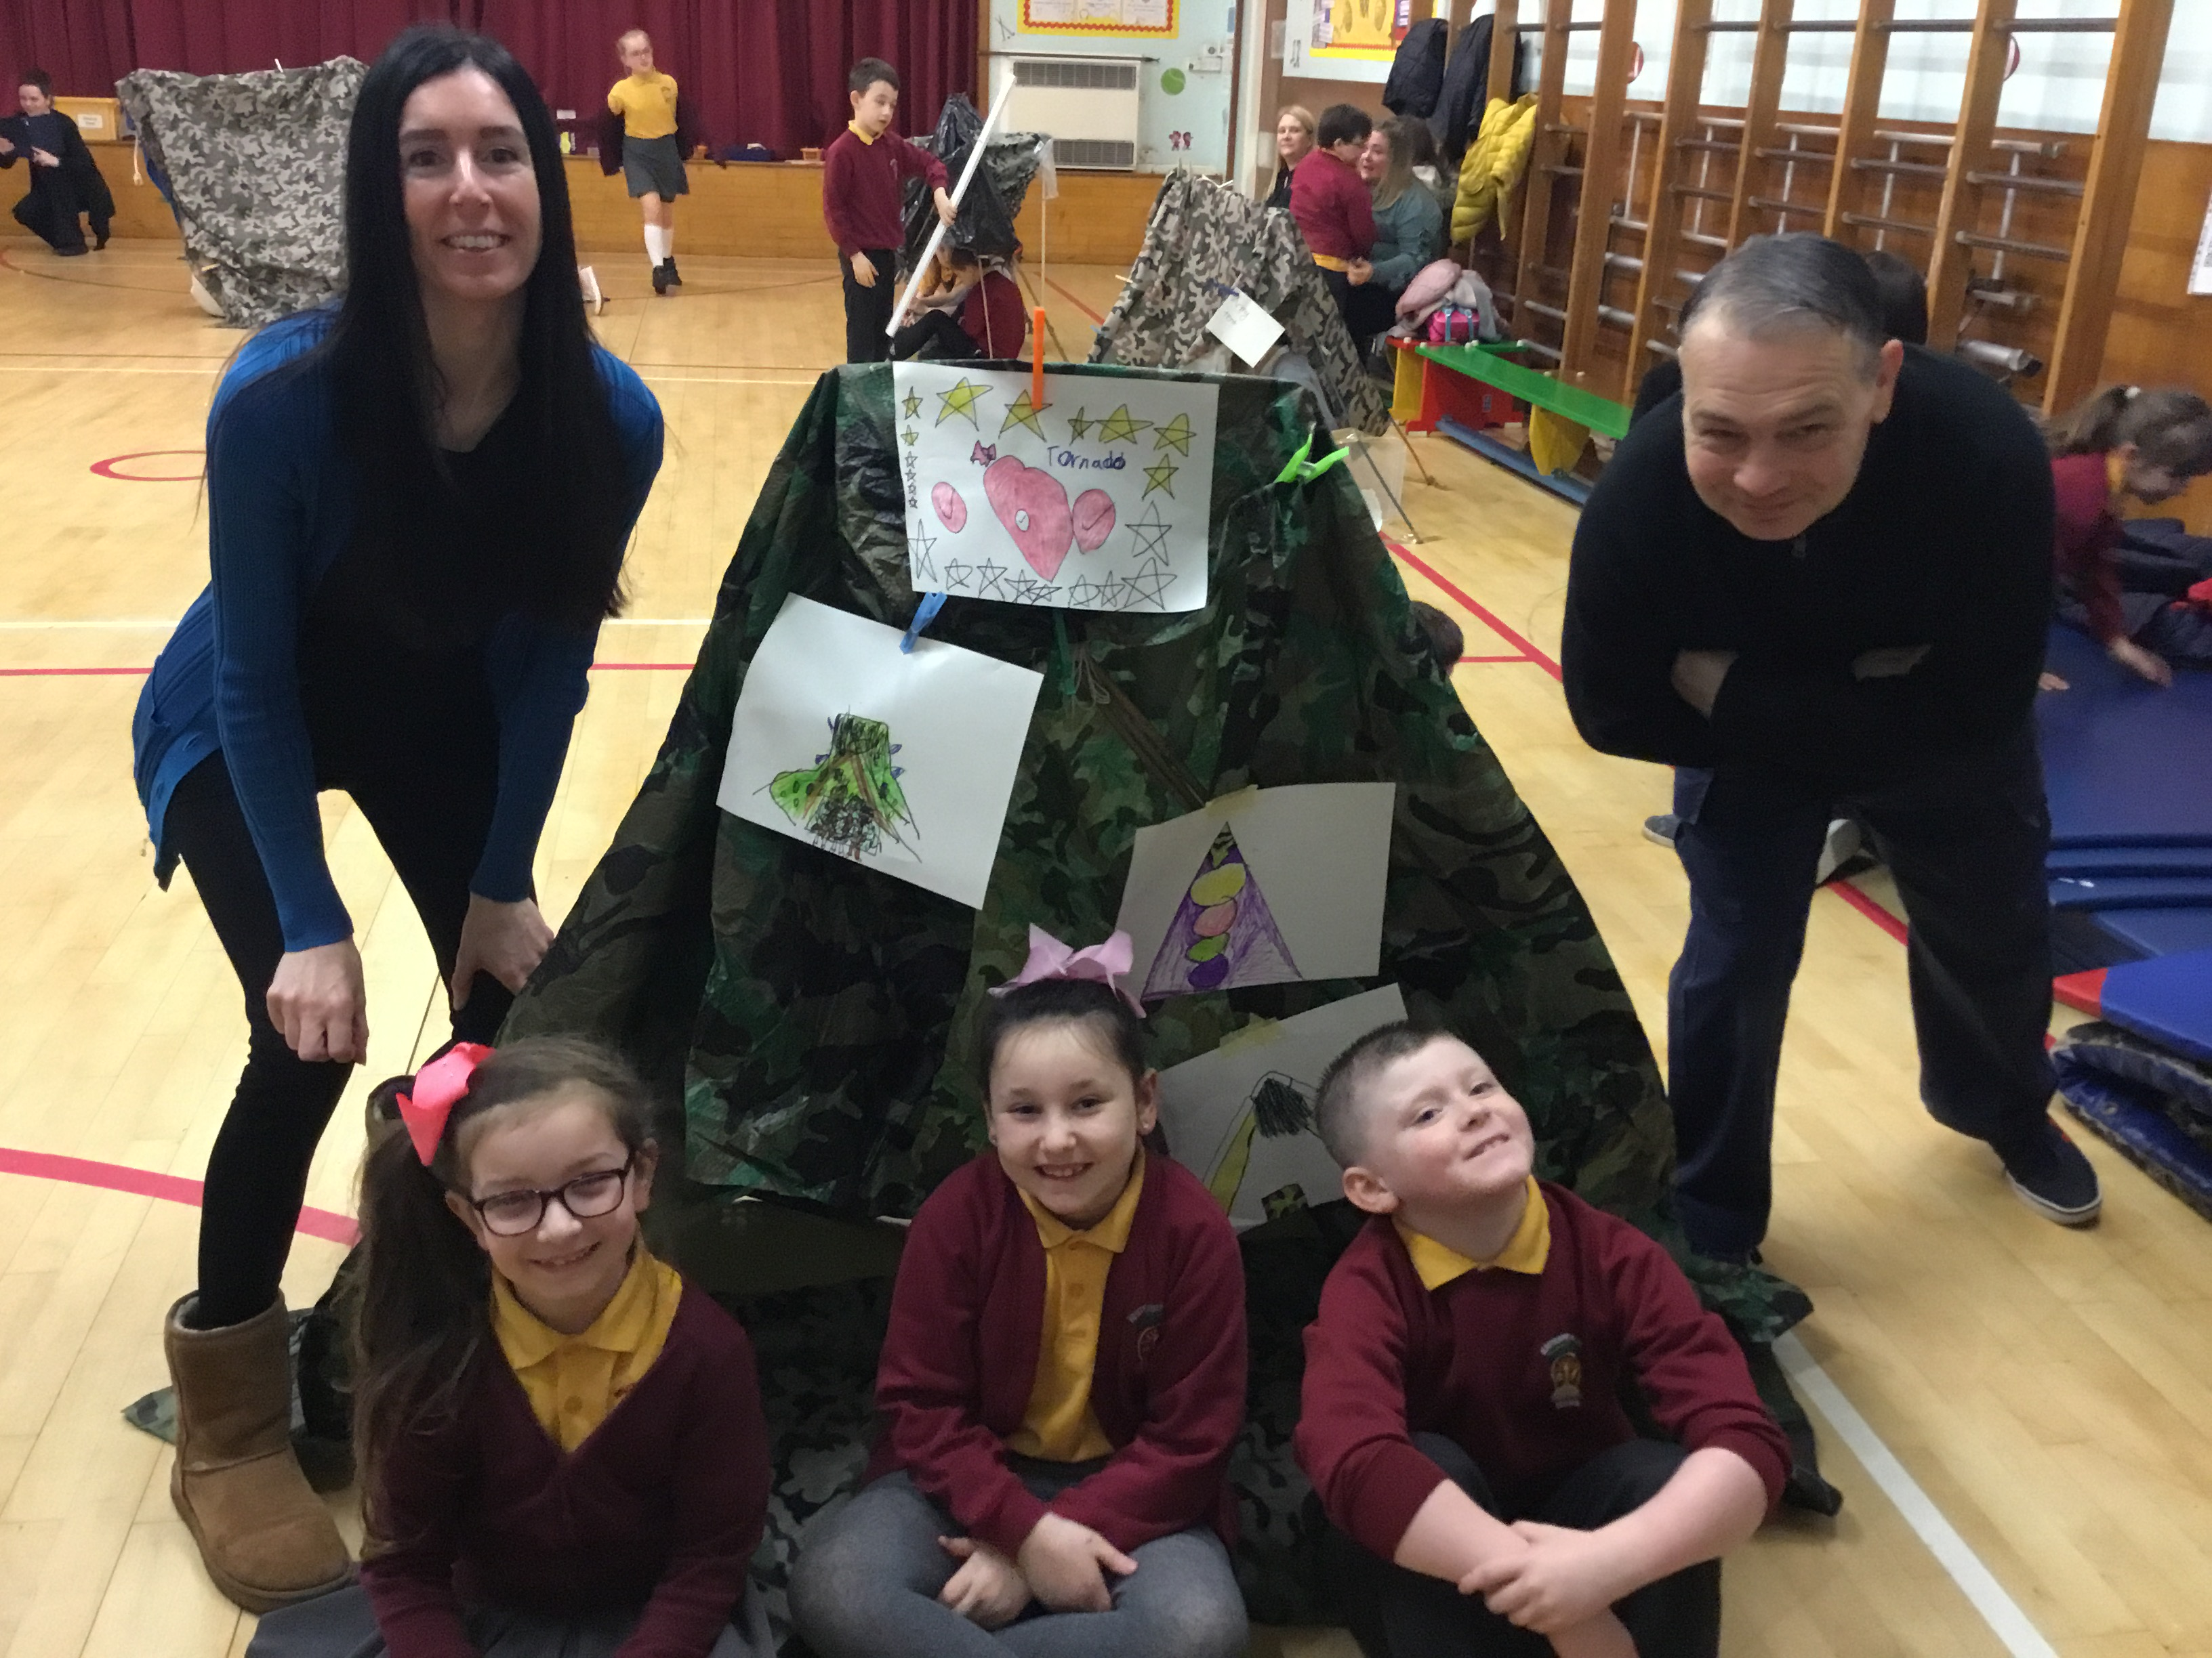
What Will We Be Learning About In Term 3?

Health and Wellbeing
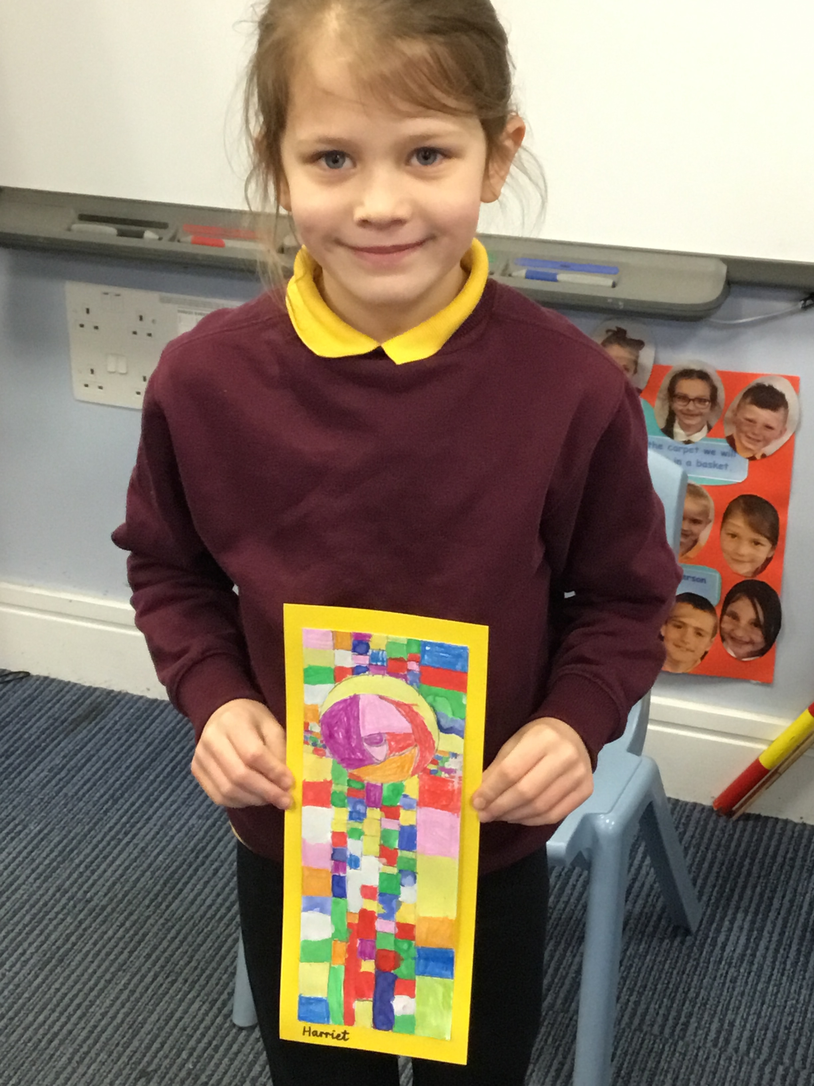
In Health and Wellbeing we will be learning about the importance of healthy eating. In our ‘PAThS’ sessions we will be learning about privacy and sharing feelings. Lastly, we will be evaluating how much we have learned since the beginning of P3 and how we can continue to progress. In PE we will be developing our creative dance skills and how to play short tennis and develop our fitness through group games and activities.

Expressive Arts
In expressive arts we will be learning all about the wonders of Scotland. We have been busy creating our own tartans and the children will also look at the work of Charles Rennie MacKintosh.

Numeracy & Mathematics

In numeracy we have been making progress with our multiplication skills by learning the 2,3,4,5 and 10 times tables. This term we will be moving on to division and fractions. We will use the language of sharing, halving and grouping. Also, we will continue to develop our mental strategies for addition and subtraction.


How you can help: Continue to spend time with your child helping them to memorise the times tables facts and discuss how these facts relate to division. Car journeys or walking to school is a great time to revise.
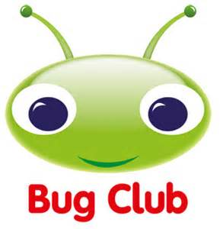

Literacy
This term we will be continuing to stretch sentences to make our stories more engaging. We will be writing newspaper articles on the sightings of the Loch Ness Monster and writing instructions and reports.
We will be reading a range of Scottish poems and dialogue and investigating the meaning of Scottish words through making our own Scottish dictionaries.
We will continue to develop our joined cursive script and develop our phonic/spelling skills.

How you can help: Encourage your child to read and listen to books. On ‘You Tube’ you can often find free audio stories by your child’s favourite authors. Also, encourage your child to make up their own stories with strange settings and detailed characters. I will regularly update Bug Club books so your child will always have the opportunity to read something new.

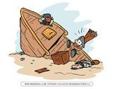
Topic
Our topic this term will be based on the Shipwrecked storyline topic. This is based around an imaginary character who has been shipwrecked. They will communicate with the children through a journal and the children will find out more about the character through active learning experiences, challenges and group work. This is a literacy based topic.

STEM

Looking ahead we are looking forward to the return of STEM Fortnight in February, where we will be taking on new challenges in Science, Technology, Engineering and Maths through a wide range of stimulating activities. Look out for further information on this later in the term.

We are looking forward to a busy term ahead and will share our learning with you on Parent’s Evening. If you have any spare time and would like to help in class please contact Mrs Elstone or the School Office.

Mrs Elstone and Primary 3b

