Happy New Year everyone and I hope you all had a wonderful Christmas break! We have begun term 3 by carrying out a mini topic on the beautiful country that we live in, as part of Scotland fortnight. Already we have begun to practice our Scottish poem ‘Captain Puggle’!

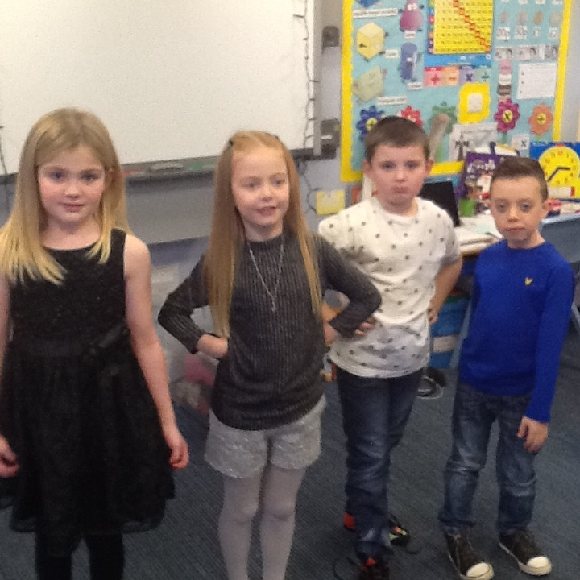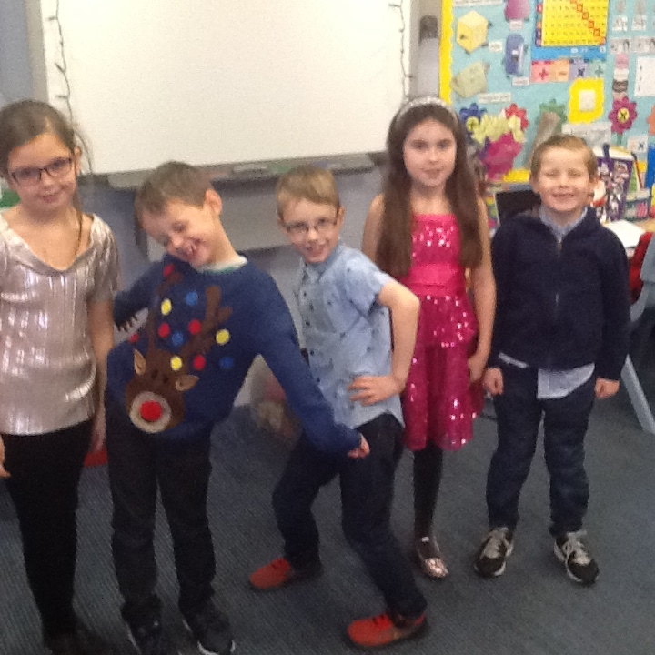

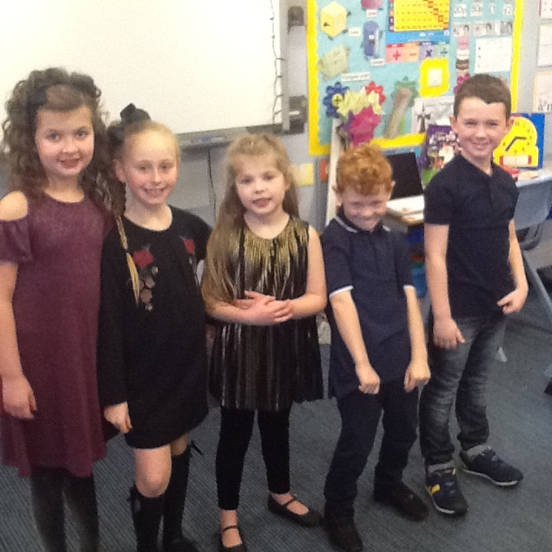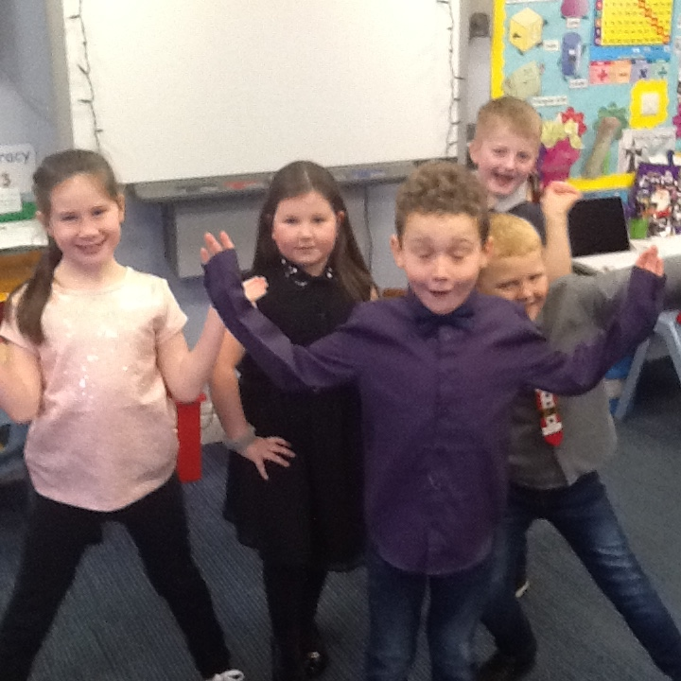

Last term was a very busy one, but I am incredibly proud of the hard work and dedication the children showed during our Christmas Fayre. They were all true role models to the rest of the school and it is evident that I have a lot of talented children in my class.

**What Will We Be Learning About In Term 3?**

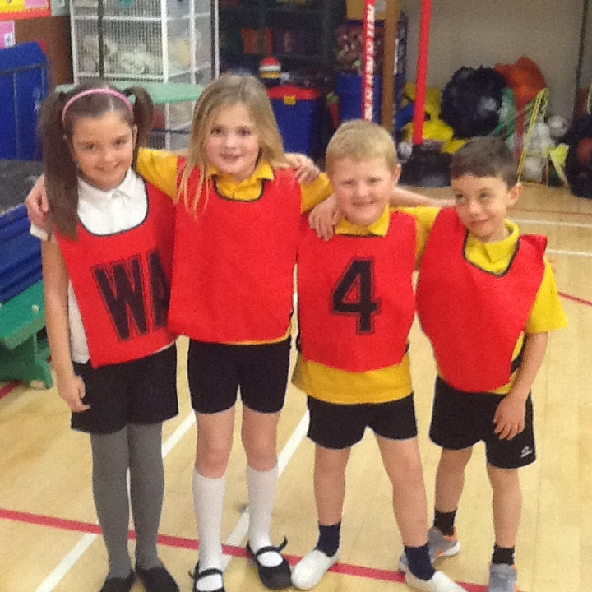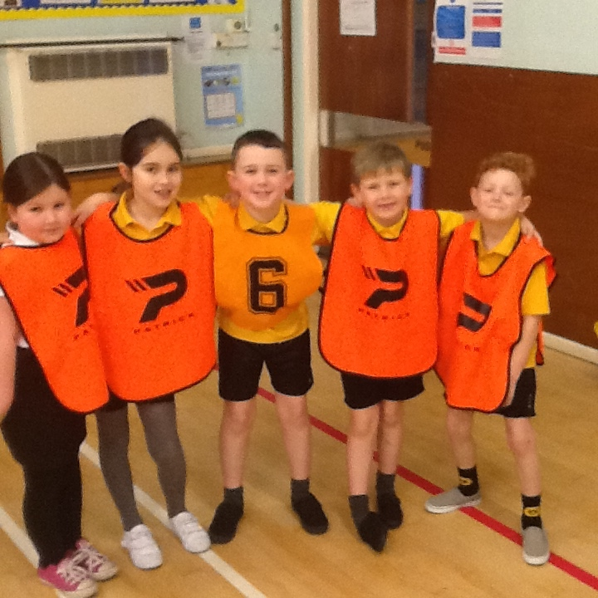

**Health and Wellbeing**

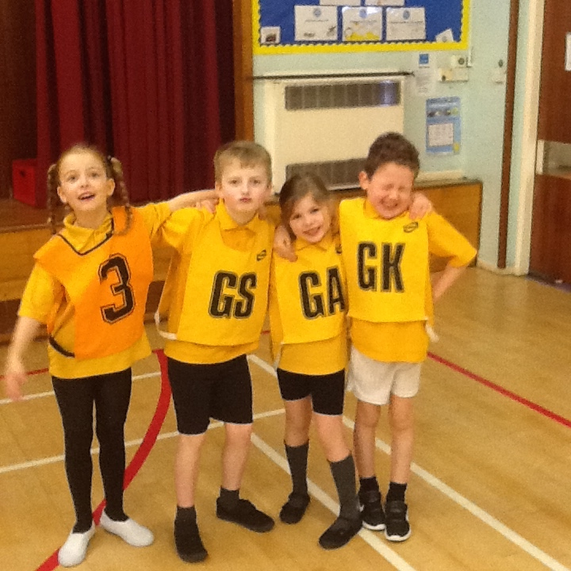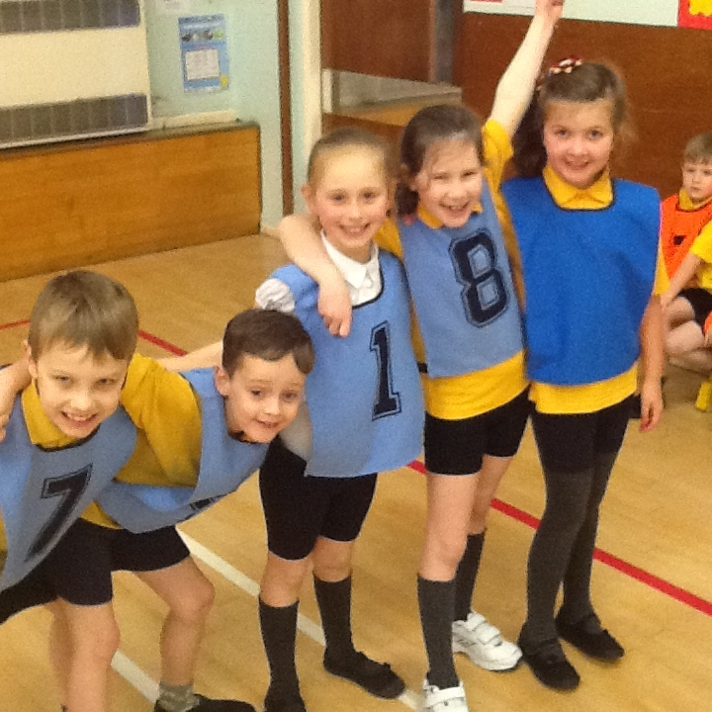In Health and Wellbeing we will be learning about the importance of safety on the roads and the internet. In our ‘PAThS’ sessions we will be learning about privacy and sharing feelings. Lastly, we will be evaluating how much we have learned since the beginning of P3 and how we can continue to progress. As part of P.E. we will be using the large apparatus as part of gymnastics. We will also learn about the game short tennis and develop our fitness through group games and activities.

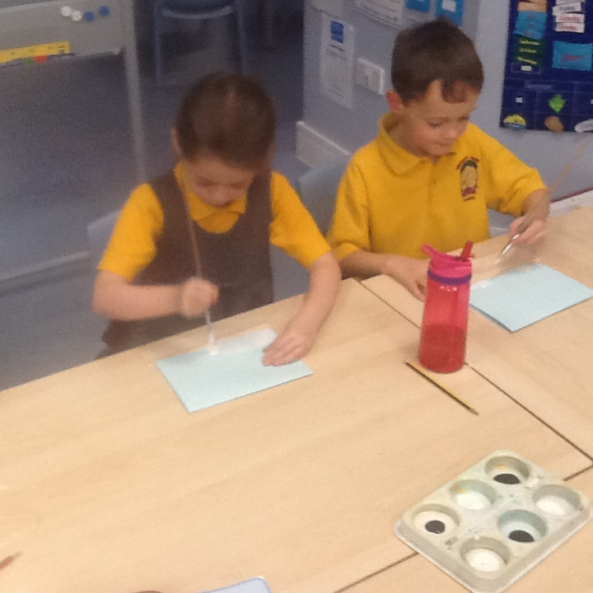

**Expressive Arts**

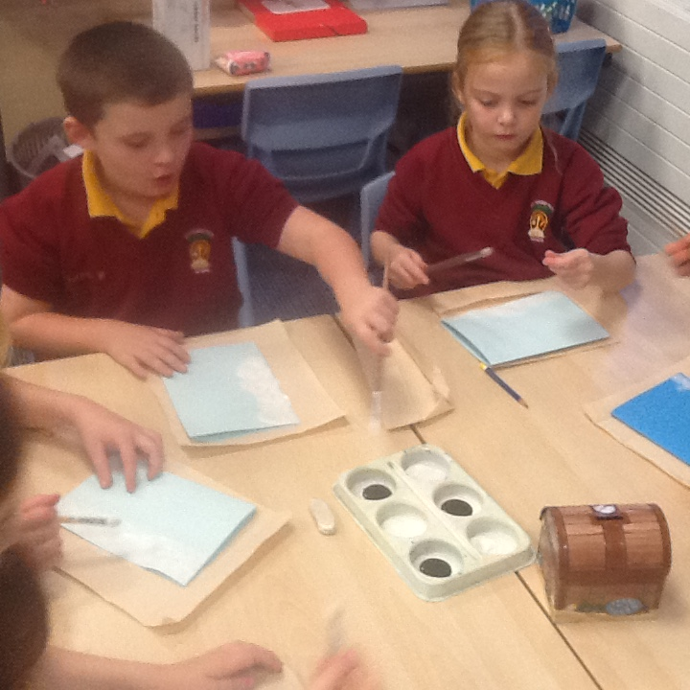As part of expressive arts we will be learning all about the wonders of Scotland. We have been busy creating our own tartans using wax crayons and watercolour paint. The children have enjoyed learning about the kilt and why they were perfect for keeping you warm when travelling over the glens of Scotland.

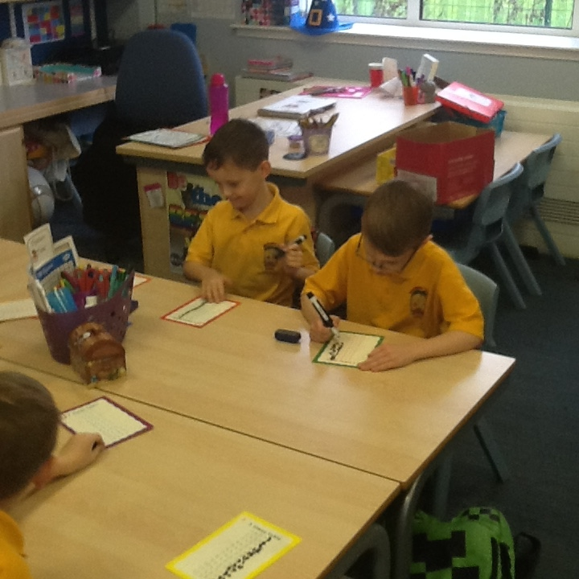Numeracy & Mathematics

In numeracy we have been making great progress on our multiplication skills by learning the 2,3,4,5 and 10 times tables. This term we will be moving onto division and fractions. We will use the language of sharing, halving and grouping. Also, we will continue to develop our mental strategies for addition and subtraction.

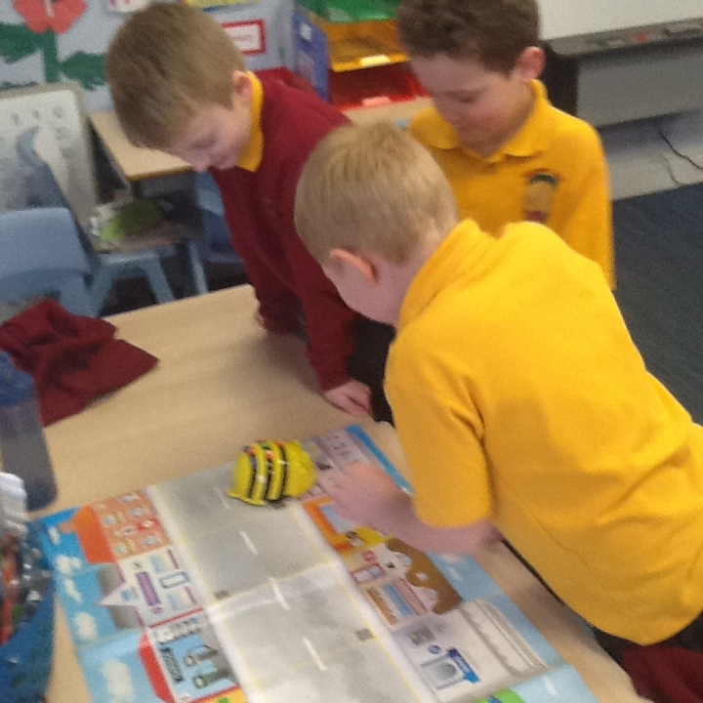



How you can help: Continue to spend time with your child helping them to memorise the times tables facts.

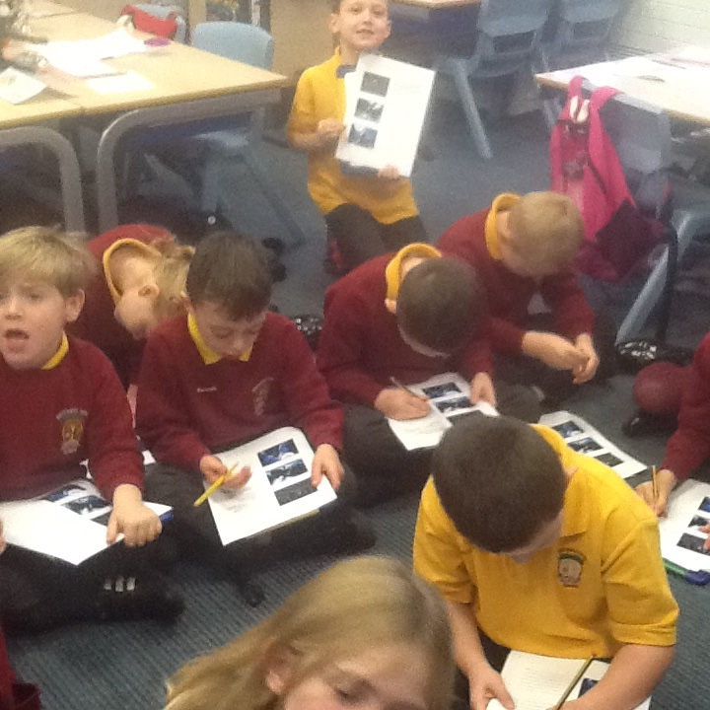

**Literacy**

This term we will be continuing to stretch sentences to make our stories more engaging. Through using a plan some of the children have highlighted how much it has helped them when setting out their stories. We will be writing newspaper articles on the sightings of the Loch Ness Monster and writing diary entries from Katie Morag’s point of view.

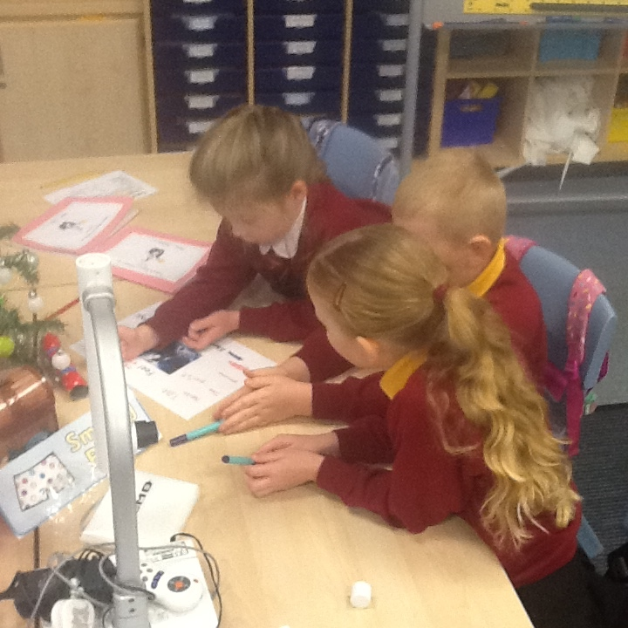We will be reading a range of Scottish poems and dialogue and investigating the meaning of Scottish words through making our own Scottish dictionaries.

We will continue to develop our joined cursive script and develop our phonic/spelling skills.



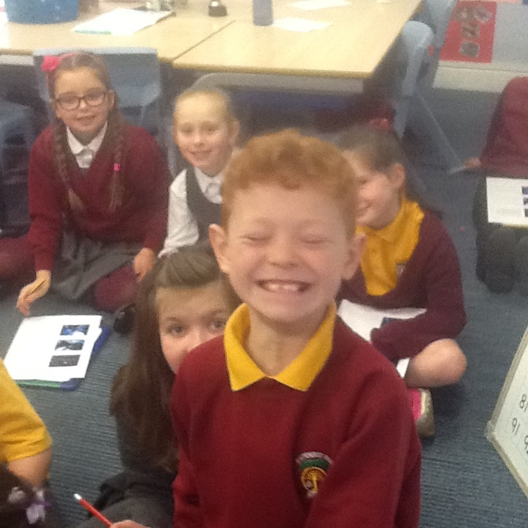How you can help: Encourage your child to read and listen to books. On ‘you tube’ you can often find free audio stories on your child’s favourite novels. Also, encourage your child to make up their own stories with strange settings and detailed characters.

**Topic**

Our topic this term will be learning about Katie Morag and her adventures. We will be looking at where Katie lives, the village in which she lives and her family. We will be following in Katie’s footsteps and exploring the world around us by visiting the local post office to see how they distribute the mail.

**STEM**

Looking ahead we are all really excited for the return of STEM Fortnight in February, where we will be taking on new challenges in Science, Technology, Engineering and Maths through a wide range of stimulating activities.

We are looking forward to a busy term ahead.

Miss Taylor and Primary 3a