We have settled very well into term 2 and made good progress with our learning. Our Halloween party was a great social event and a chance to enjoy games and party food with our friends. Here are some photographs from the day. Can you guess who the skeletons are and the character in the gorilla costume?

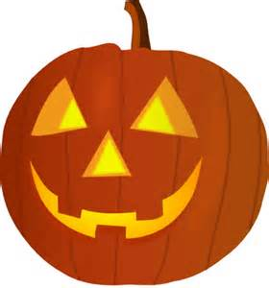

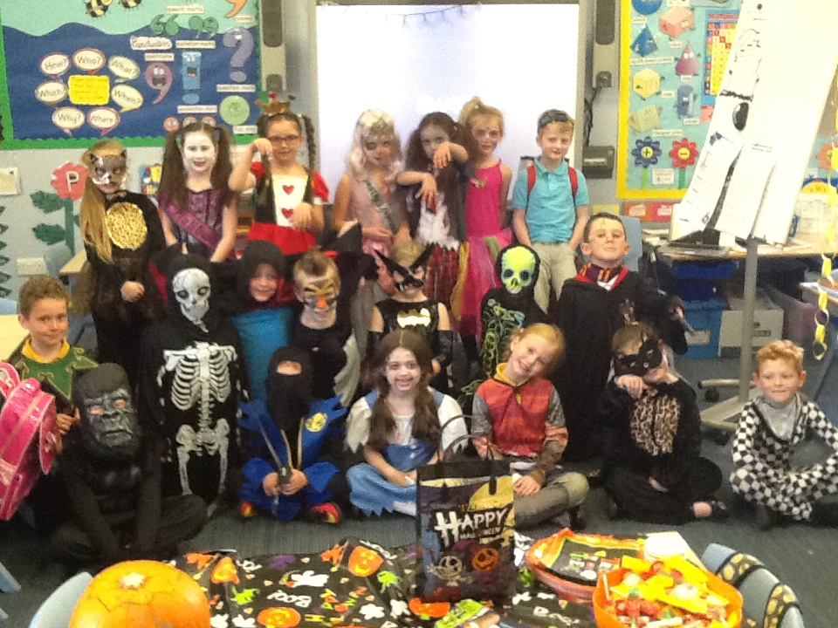
Halloween 2016
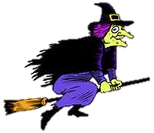
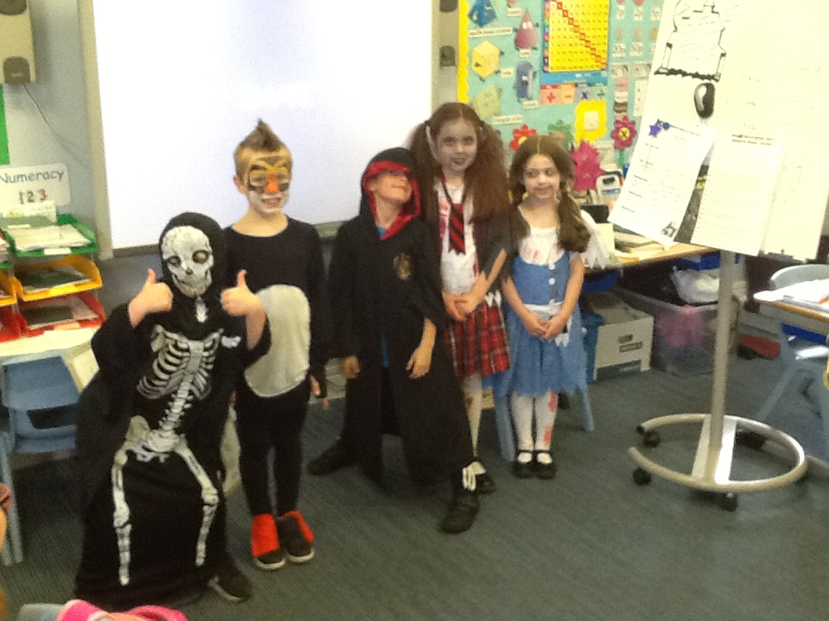
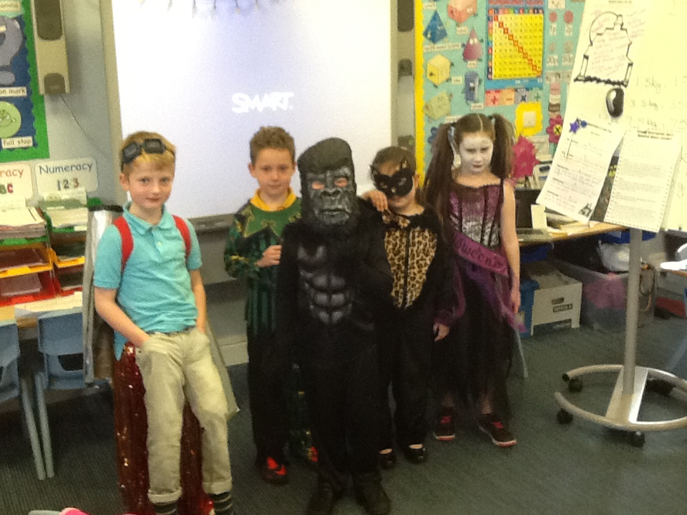

What Will We Be Learning About In Term 2?

Health and Wellbeing
In Health and Wellbeing we will be investigating healthy eating and thinking about making more healthy choices. In our ‘PATHS’ sessions we will continue to identify and discuss a variety of feelings as well as exploring manners through role play. In addition to this we will be assessing our learning and thinking about how we can improve.

Expressive Arts
In expressive arts we are busy working with Mrs McDougal to perfect our performance for the ‘Top of the Pops’ concert in December. We will also be making a “Christmas Surprise’ for the Christmas Fayre. Look out for our stall on the day!
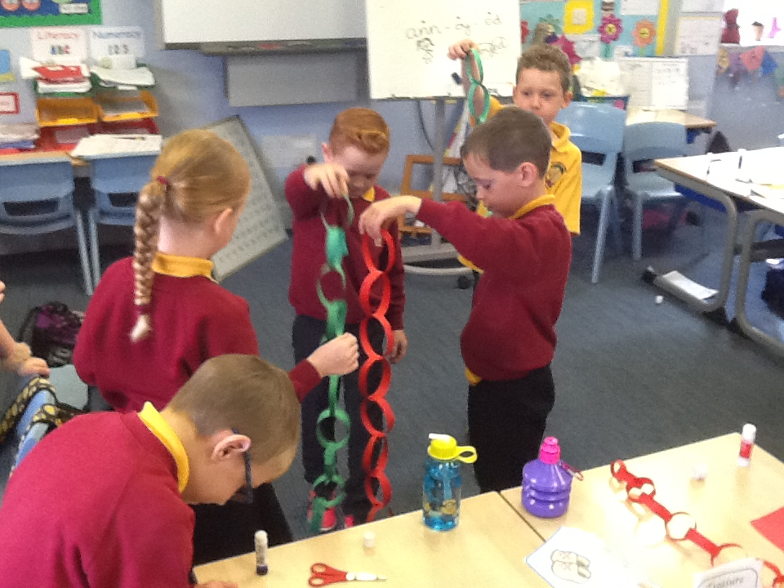
Numeracy & Mathematics
In numeracy we have worked very hard on our multiplication skills learning the 2,5 and 10 times tables. We will work on the 3 and 4 times tables this term. We will also continue to develop our mental strategies for addition and subtraction. As well as this we will develop our knowledge of shape and data handling.
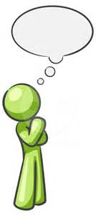
How you can help: Spend time with your child helping them to memorise the times tables facts.

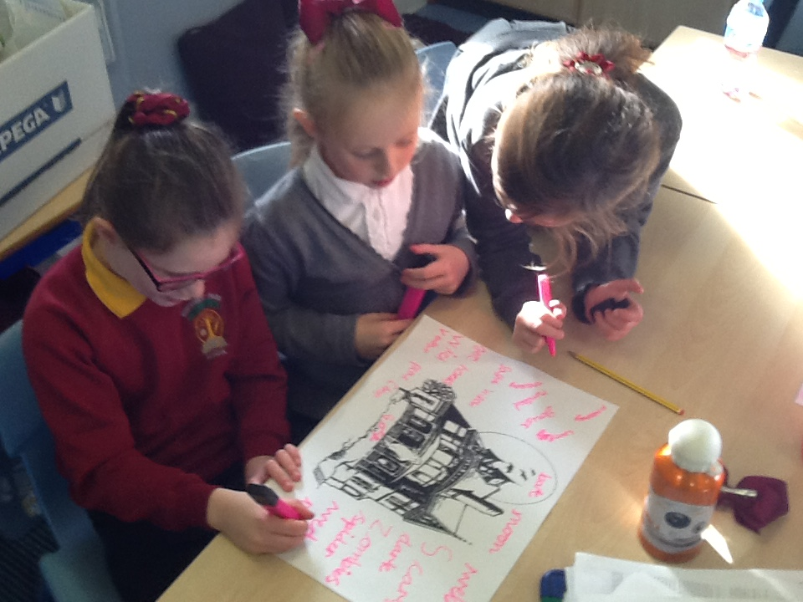
Literacy
In writing we will be developing good vocabulary in our writing as well as using accurate punctuation. We will be learning to plan a story effectively as well as looking at story settings.

In reading we will be reading a range of Non Fiction books and reading Plays.

We will continue to develop our joined cursive script and develop our phonic/spelling skills.
How you can help: Encourage your child to develop a love of reading by giving them access to good quality books and read to them often. Kilwinning library has a great selection of both fiction and non-fiction books and you will be made very welcome. Remember we will allocate books regularly on Bug Club.

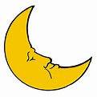
Topic
Our topic this term will be science based. We will be learning about night and day, the position of the sun at different times of the day and the different phases of the moon.

We are looking forward to a busy term.
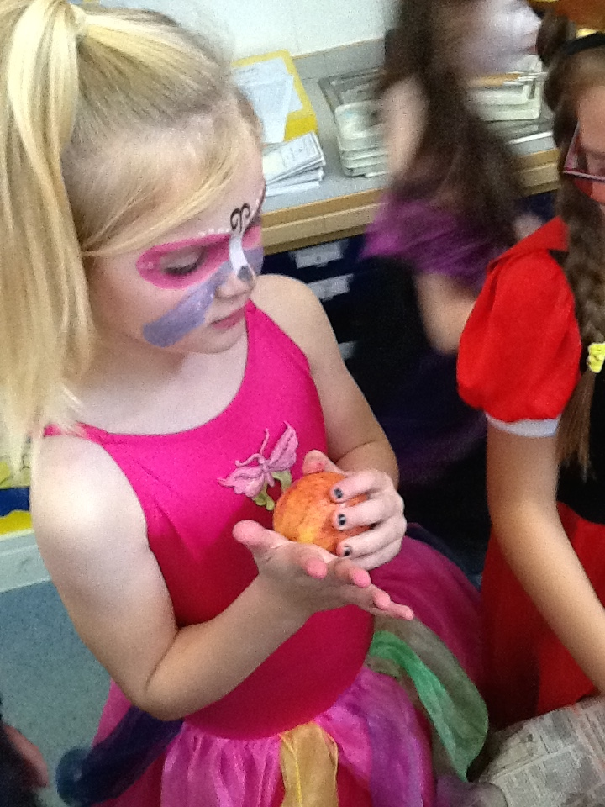
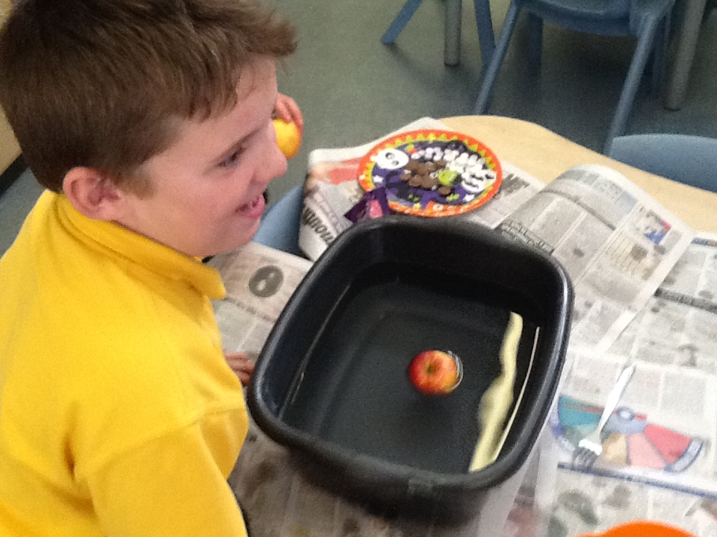
Miss Taylor and Primary 3a

