Primary 3 Termly News 2016/17

Welcome to Primary 3’s news for Term 1. Here is some of the learning that will be happening in our class.
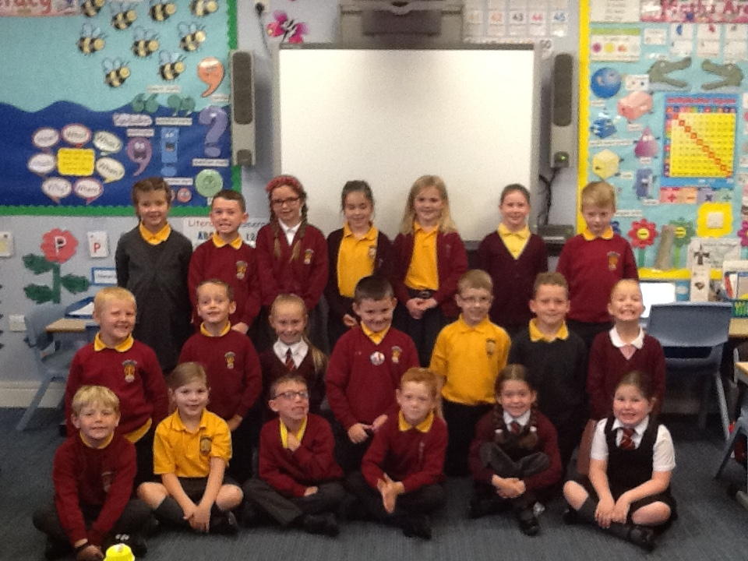

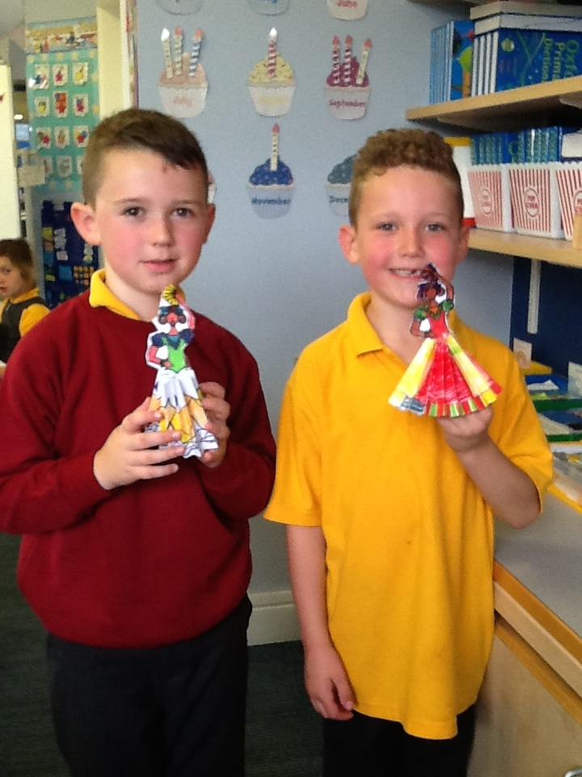
Our topic this term is Spain. We will be learning about the Spanish culture, where Spain is and its impact on the world. We will be comparing the lives of Spanish children with our own.

In Art we will be looking at the famous Spanish Artists Picasso and the art of Flamenco Dancing. We will be making stained glass windows relating this to our RME topic.

In Religious and Moral Education we will be looking at ‘The Local Church’ and the main elements of an act of Christian Sunday worship. We hope to visit Mansfield Trinity Church towards the end of the term.
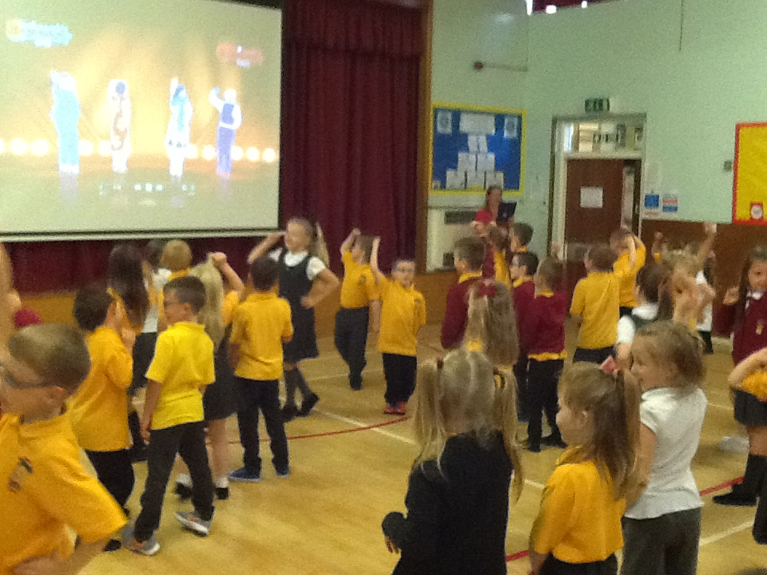
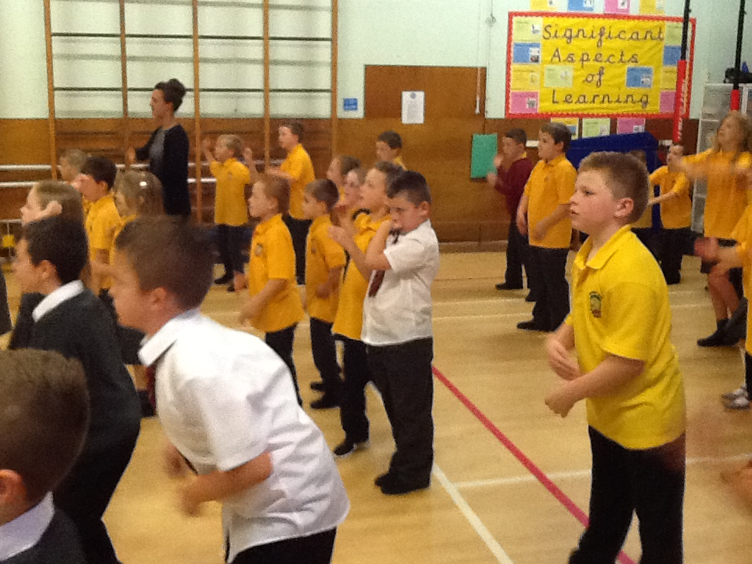
This term we will be developing the skills of football and athletics. We will also be looking at PAThS (Promoting Alternative Thinking Strategies) and recognising positive friendships. Our PE days are Monday and Wednesday. Could earrings please be removed or covered on these days.
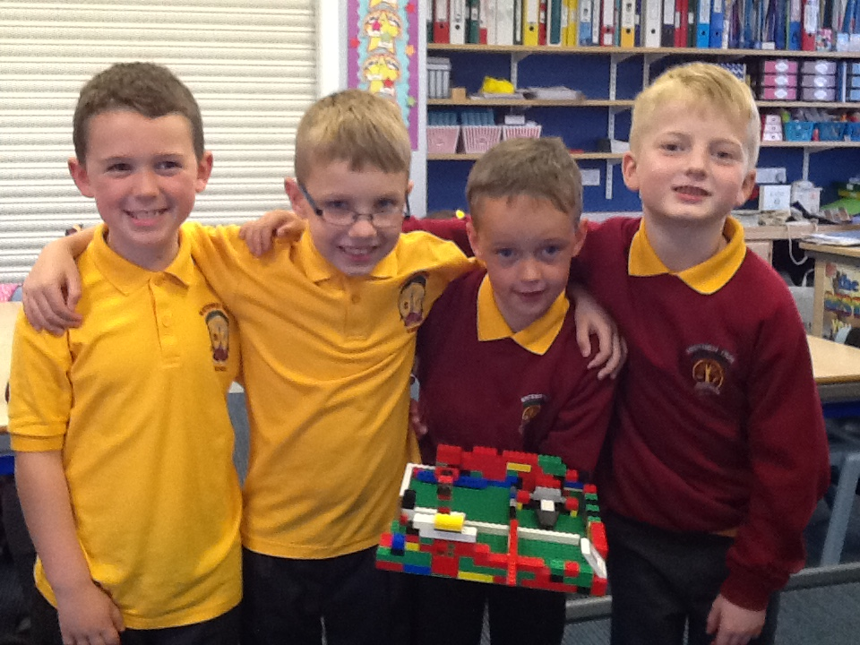
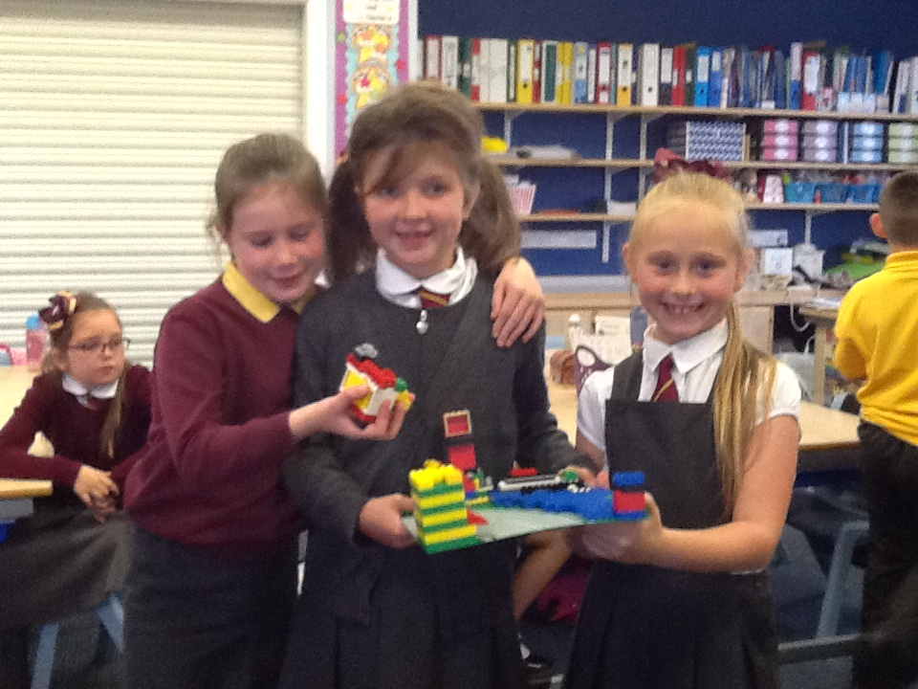
In Numeracy we will be building on our previous knowledge and understanding of Number and Number Processes and also developing an awareness of time.

We will also be working towards developing an understanding of times tables.

In Literacy we will be continuing to develop our reading skills. Your child will bring their book home to share with you when they have read it in school and completed work related to the text. Please continue to read to your child as often as possible and give them opportunities to read a wide variety of texts.

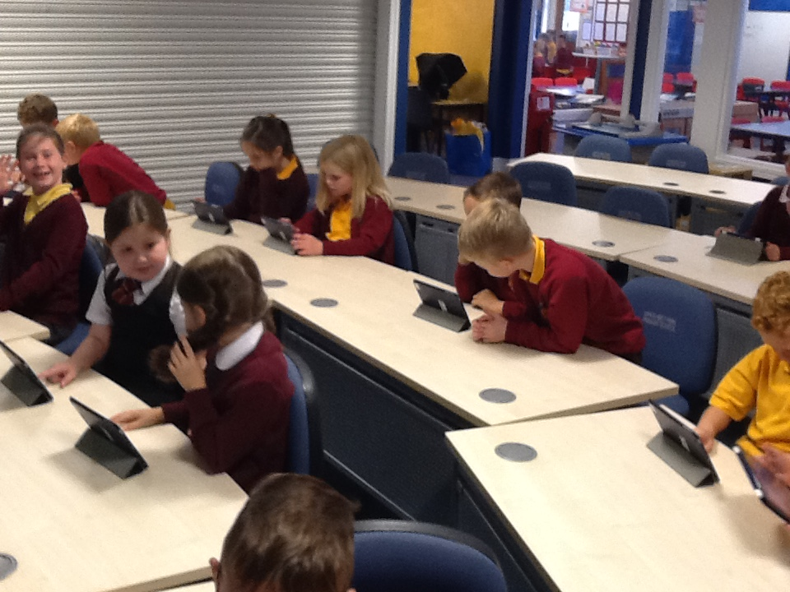
We are all looking forward to a very busy first term and we hope you enjoyed seeing our classroom and finding out about our routines during the recent open morning.

Miss Taylor and Primary Three children.

