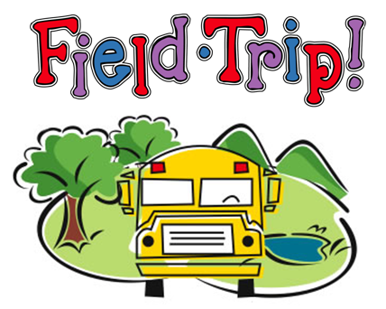

Take a look at these different links with an adult, then choose somewhere you would like to explore. There are so many to choose from that you might want to go to more than one place. Some of the places have online activities you can complete too!
A List with a Variety of Different Virtual Tours for Kids
https://www.goodtoknow.co.uk/family/best-virtual-tours-for-kids-536089
Edinburgh Castle Virtual Tour
https://artsandculture.google.com/story/VAWxcB3PgVhOvw
National Museums Scotland
https://www.nms.ac.uk/museum-at-home/
Scottish Maritime Museum in Irvine
https://www.scottishmaritimemuseum.org/virtualtours/
Virtual Field Trips to discover lots of places in America
https://www.weareteachers.com/best-virtual-field-trips/

