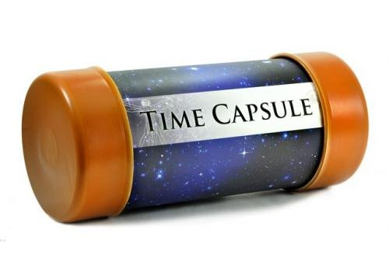
How to Make a Time Capsule
Lockdown has been a very unusual time in our lives and the Coronavirus pandemic will certainly be something written about in history. Maybe it would be nice for you to make a keepsake box, tin, jar or tub to look back at in the future and be able to tell your own children and even grandchildren what it was like.
You will need:
- A container which you can close, which you can decorate
- Your letter to your future self
- Your All About Me sheet
- Lots of memorabilia
- A plastic bag which isn’t biodegradeable, to keep your container waterproof if you store it somewhere damp.
What to do:
- Write your letter to your future self
- Write a fact sheet All About Me and draw a picture or take a picture
- Collect lots of different memorabilia
- Place everything neatly into your container and close it.
- Place it inside a bag and put a label on it.
- Put it somewhere safe and leave it there. Sometime in the future you will find it and look inside and remember all about this time.
Memorabilia ideas:
- Maybe your VE Day bunting if you still have it
- A newspaper with COVID-19 headlines
- Your rainbow pictures (maybe you could add these to your box when you take them down.
- A 2020 coin
- A 2020 stamp
- Things you have collected if you have had a nature walk, something from your garden or a visit to the beach
- Drawings or crafts you have done during Lockdown
- Your favourite recipe
- A photo of you having your first visit when Lockdown is eased on Thursday
- A painted pebble with the date on it.
- A packet of seeds ( who thinks they will grow in 10 years)
- Your handprint to see how much you have grown
- A note from each member of your family
- You could press flowers
- Photos of your family doing crazy things
- You could even add a sheet of toilet paper for a joke.

