W/beginning 25/5/2020

Time Capsule Letter Writing 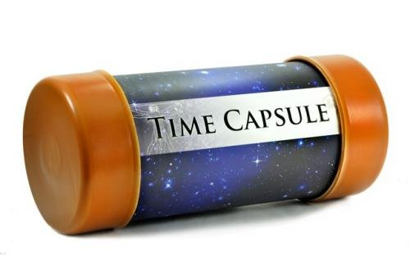

Can you write a letter to yourself about everything that is happening at the moment? This will be good to look back at when we are in P7!!

Here are some ideas you could include.
Can you describe Lockdown? What are you doing? Why are we doing this? What changes are there just now?

What are you doing while you are off? How are you getting exercise and fresh air? What are you doing to keep busy? What are you doing to have fun? Have you learned any new skills? Have you celebrated any special occasions? Can you write about it?
What is home learning like?
Can you write about the thing you are most excited about doing when this is over?
Can you write about something you are most thankful for?
Don’t forget to include your feelings in your letter.

Letter writing layout
Things to remember
- The address goes to left
- Start with Dear
- Write in sentences
- Capital letters
- Full stops
- Use different openers
- Use some adjectives (wow words)
- Can add some feelings (unhappy, confused, surprised)
- Can spell some common words correctly
- Can end with from or love (on a new line)

71 Marshmallow Street
Kilwinning
KA99 9NN
Dear Mrs Rowan
Today is 22nd May 2020 and we are in Lockdown. We have to
stay at home with our families and not go anywhere ......

