How to Make Table Turners Game to Learn Times Tables
- Cut a sheet of card into 12 rectangles, trying to keep them the same size. Write start in the first box, then the stations of the table you are learning. I will show you with the 2 times table.
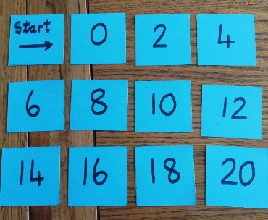

- Turn the start card over and write one of the times tables on the back of the card. I chose 2x3 which is 6. I then found the 6 card and turned it over.
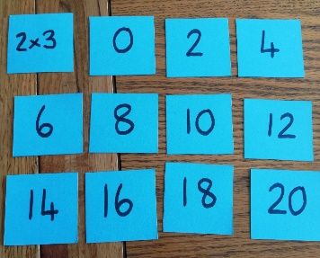
- 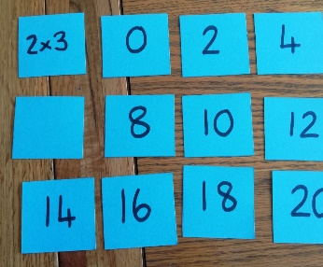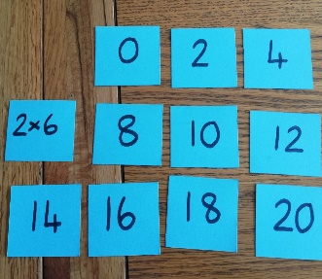

Write a different sum on the back of this card. I wrote 2x6 which is 12. I now have to find the 12 card to turn over.
- 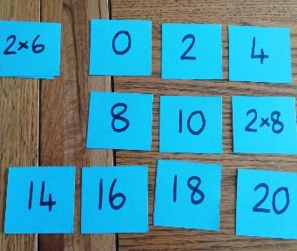 Again write a new sum on the back of the 12, now find the answer and turn it over. Continue the process until you have only one answer left.
I will share my photos in order, showing you the steps. This part is random, the order doesn’t matter as long as they are mixed up.

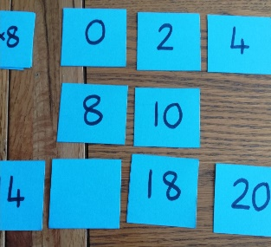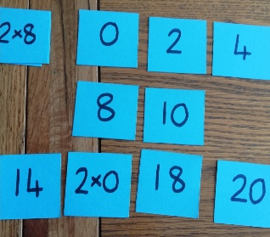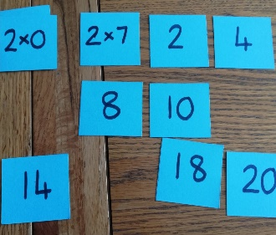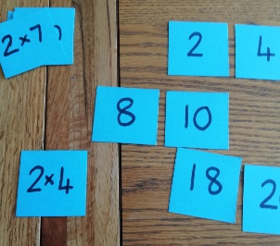

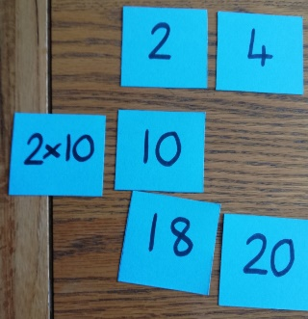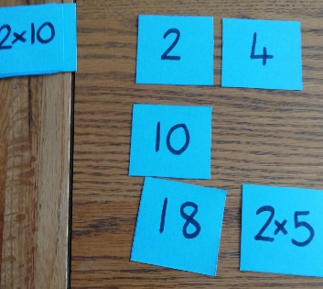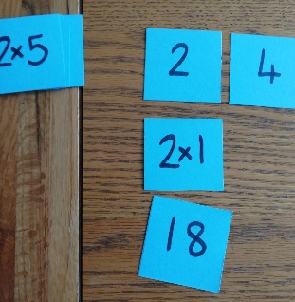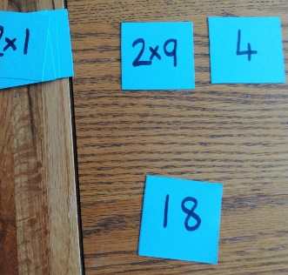

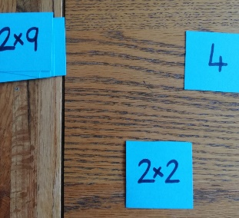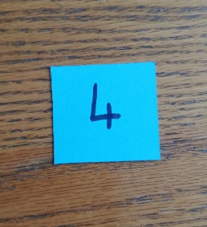

- On the back of your last card write Well Done! Or it could have a sticker or other form of praise.

How to Play the Game
Turn all the cards so that the answers are facing up the correct way, including the Start card.
Turn the start card and read the sum, find the answer and turn that card over. Now find the answer to that sum. Continue until you have no more sums.
To begin with I like to have all the answers in the correct order, this allows the child to count on in groups.
To make it more challenging mix them up.

This process can be done for any of the times tables. My suggestion is to use a different colour of card for each table or use a different colour of pen. This helps you keep them sorted.

