Calculation time!  - Can you write down five ways to make 17? You can use addition or subtraction.  (use other numbers in place of 17) | Go Shopping  - Go shopping with an adult, add together the price of 3 items.  - Calculate the change as if you paid using a £2 coin or a £5 or £10 note. | Measurement  - Practise using a ruler to draw lines that are:  5cm, 16cm, 29cm  - Then you can make them into pictures! | Shape Hunt  - Find 5 2D shapes and 5 3D shapes around your home.  - Record the number of faces, sides, edges and vertices (corners), each of the shapes have.
Estimate the Amount Game  - Play with a family member.  - Pour pasta into a jar or bowl and estimate how many pasta shapes there are.  - Count the shapes.  - The person who has the closest estimate wins a point.  - Refill the bowl and play again, the person with the most points wins the game! | Fun Friday Night TV  - Use a TV guide to create a viewing schedule for 2 hours and 15 minutes of television.  - Use the start and finish times for each programme to calculate their duration.  - List the programmes you could watch. |  | Kitchen Measuring  - When cooking or baking, use scales to weigh the ingredients.  - Record what you weigh and the amounts.  - Remember to use the correct unit of measurement (e.g. grams and kilograms  Get Surveying!  - Create a questionnaire and gather data about your family and/or friends about their favourite meals, snacks or drinks.  - You could present your data in a graph.
Numeracy Home Learning Challenges (First Level)
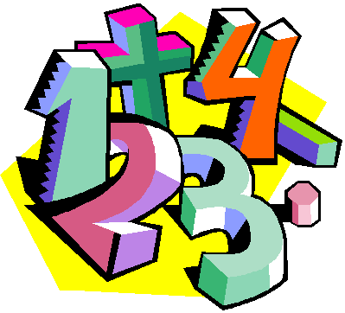
Name: ______________________________

Class: ________________________
Fractions at Home
- Make a list of 10 items that you could cut, fold or draw a line on to create fractions.
- Write whether they can be divided into halves or quarters.
Other Curricular Area Challenges | Art – Outdoor Patterns  - Head outside to create a picture using patters.  - Use natural resources (e.g. leaves, twigs, petals, etc) to make your patterns. | Music – Favourite Song  - Listen to one of your favourite songs, can you count the beats in the music.  - Make a tally mark for every 8 beats.  - Now listen to another song and do the same.  - Which song has the most tally marks? | HWB – Skipping Tables  - Practise your times tables by reciting them as you skip or hop.  - Use any times tables that you have learned in class or know!

