Questioning Quinn

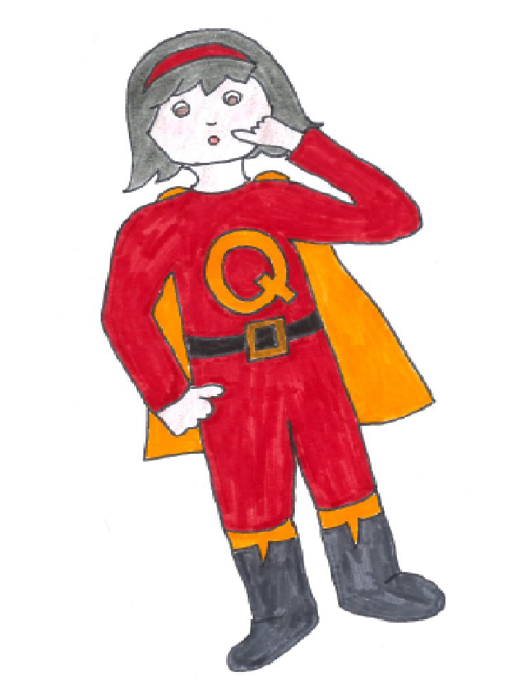

Questioning Quinn’s superpower is wondering about what she sees, hears and reads. She asks and answers questions to help her understand.

