**P2a News – Term 1**

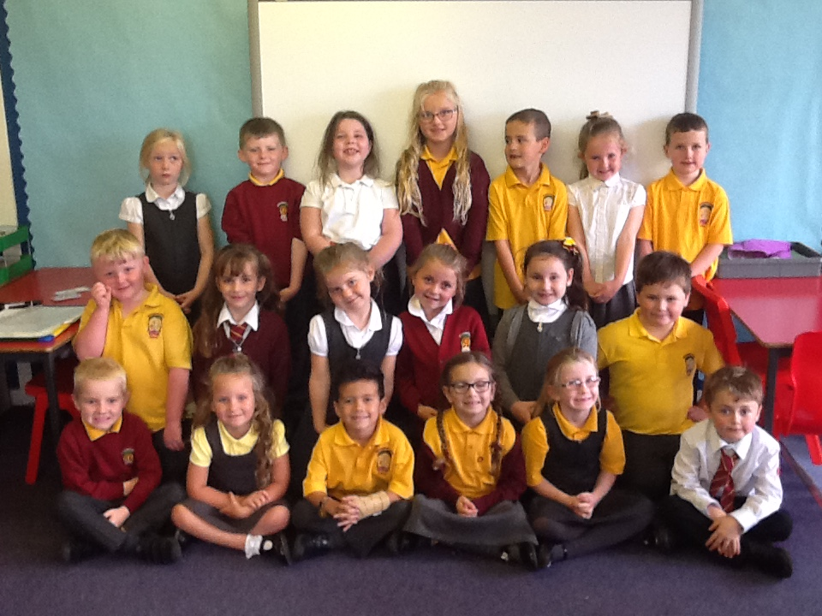

P2a!

Welcome back and thank you to everyone who made it to our drop-in morning. The children have settled well into the soft-start routine and enjoyed showing you round our classroom. We were absolutely delighted with all of your very kind and positive comments and remind you that we are always available to discuss any matters regarding your child.

This term our topic will be ‘Children of the world’. The children will be learning about what life is like for other children who live in different parts of the world. We will be discussing children’s rights through our charter and highlighting some of the things we take for granted which other children count a luxury. We have looked at children from Russia, Brazil, Ethiopia and India.

In numeracy, we will be building on our mental maths skills and learning to count in 2s, 5s and 10s. We are working really hard to perfect our number formation and we will also practice paying for goods and giving change from 20p.

In literacy we will be developing our phonics skills in order to read fact and fiction books. Handwriting and letter formation is a big focus for us this term and we will be learning how VCOP can improve our story writing. We know we must have a capital letter and full stop at every sentence and are trying to use ‘wow’ words to make our sentences exciting!

In Health and Wellbeing we are focusing on being a good friend and promoting alternative thinking strategies through our PAThS resource. On a Monday Mrs Dickinson will be taking the children for P.E. and Mrs Gaw will take them on a Friday. They will learn to dribble and pass the ball with control in hockey and score a goal in target practice.

In Religious and Moral Education we will be learning about Eid. We will be looking at Ramadan through Shakeel, a boy from India who is a muslim.

We are looking forward to a busy term and thank you for your continued support.