Week Beginning 23/03/20
 | Literacy | Numeracy | Health and Wellbeing
Monday | News  Can you write a couple of sentences about what you did over the weekend?  What? Where? Who? | Number bonds  Hit the button  Can you beat your own high score? | Joe Wicks Workout – 9:00am YouTube  Makaton sign of the week – Below table
Tuesday | Spelling  LSCWC – 3 times + a sentence for each or super sentences  Words for each group are below this table. | Addition  Can you copy and complete the sums?  Sums for each group can be found below. | Create an exercise routine with 5 exercises and take someone through your workout.  Remember to time how long we are doing each exercise for.
Wednesday | Reading  Can you read one of your bugclub books and retell the story to someone?  Can you also write about the emotional journey of one of the characters?  Sad? Happy? Excited? Why? | Subtraction  Can you copy and compete the sums?  Sums for each group can be found below | Cosmic Yoga  You can choose any yoga session you like.
Thursday | Writing  Can you make these sentences more interesting? Remember VCOP. Are you able to extend them?  The boy went outside.  The girl threw the ball.  The dragon lived in the cave.  The princess lived in the tower.  The dog barked.  The cat meowed. | Fractions  Can you write the fraction of coloured in sections for these objects?  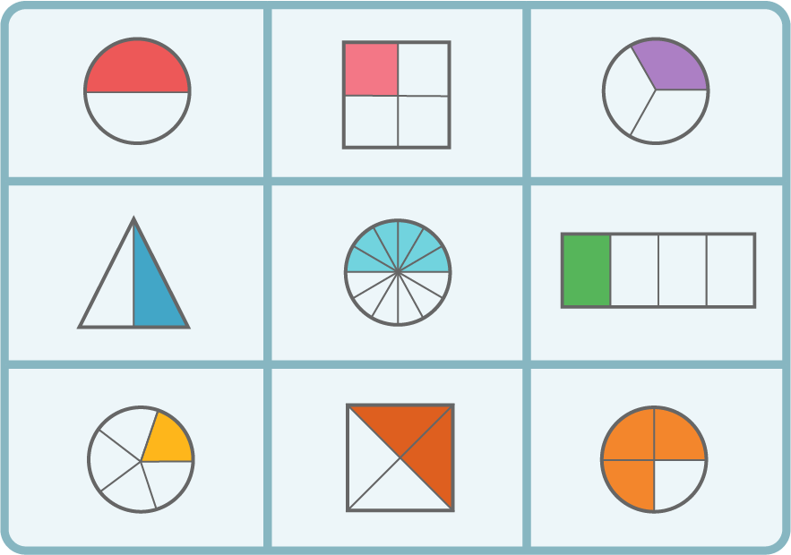 | Art for Kids Hub  Choose any instructional drawing you like and use your artistic skills to carefully copy and colour.
Friday | Reading  Can you write a book review telling us all about a book you have read this week?  What was it about?  Would you recommend it?  Book reviews can be shared on the “BOOKS BOOKS BOOKS” glow tab | Doubles and Halves  Hit the button  Can you set yourself a new high score for doubling? | Construction  Using any materials you can, can you create and take a picture of a fantastic building you have made?

Numeracy | Squares | Triangles | Circles
Addition | 17 + 23 =  36 + 14 =  23 + 7 =  14 + 26 =  100 + 27 =  65 + 35 =  103 + 27 =  230 + 170 = | 20 + 45 =  14 + 16 =  17 + 13 =  10 + 15 =  23 + 20 =  48 + 6 =  19 + 9 =  20 + 7 = | 7 + 4 =  8 + 3 =  7 + 7 =  10 + 10 =  13 + 3 =  20 + 0 =  15 + 3 =  3 + 7 =
Subtraction | 50 - 23 =  36 - 14 =  23 - 7 =  34 - 26 =  100 - 27 =  65 - 35 =  103 - 27 =  230 - 170 = | 70 - 45 =  24 - 16 =  17 - 13 =  30 - 15 =  23 - 20 =  48 - 6 =  19 - 9 =  20 - 7 = | 7 - 4 =  8 - 3 =  7 - 7 =  10 - 10 =  13 - 3 =  20 - 0 =  15 - 3 =  13 + 7 =

Makaton sign of the week
https://www.youtube.com/watch?v=ZjgNIA_woyo&safe=active

Spelling
Green – oa sound – loaf, goat, road, float (https://www.youtube.com/watch?v=KCJyHN0IFE8&safe=active)
Suns – ou sound – sound, found , sprout , mountain
Black – u_e sound – use, cute, amuse, computer

