Add –ar to these sounds to make a word. Draw a Pictures to match.

C ar | 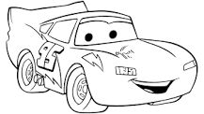
J_____
St_____
P ____k
Sh ___k

