Primary 1 Literacy Task Week Beg 15.02.21
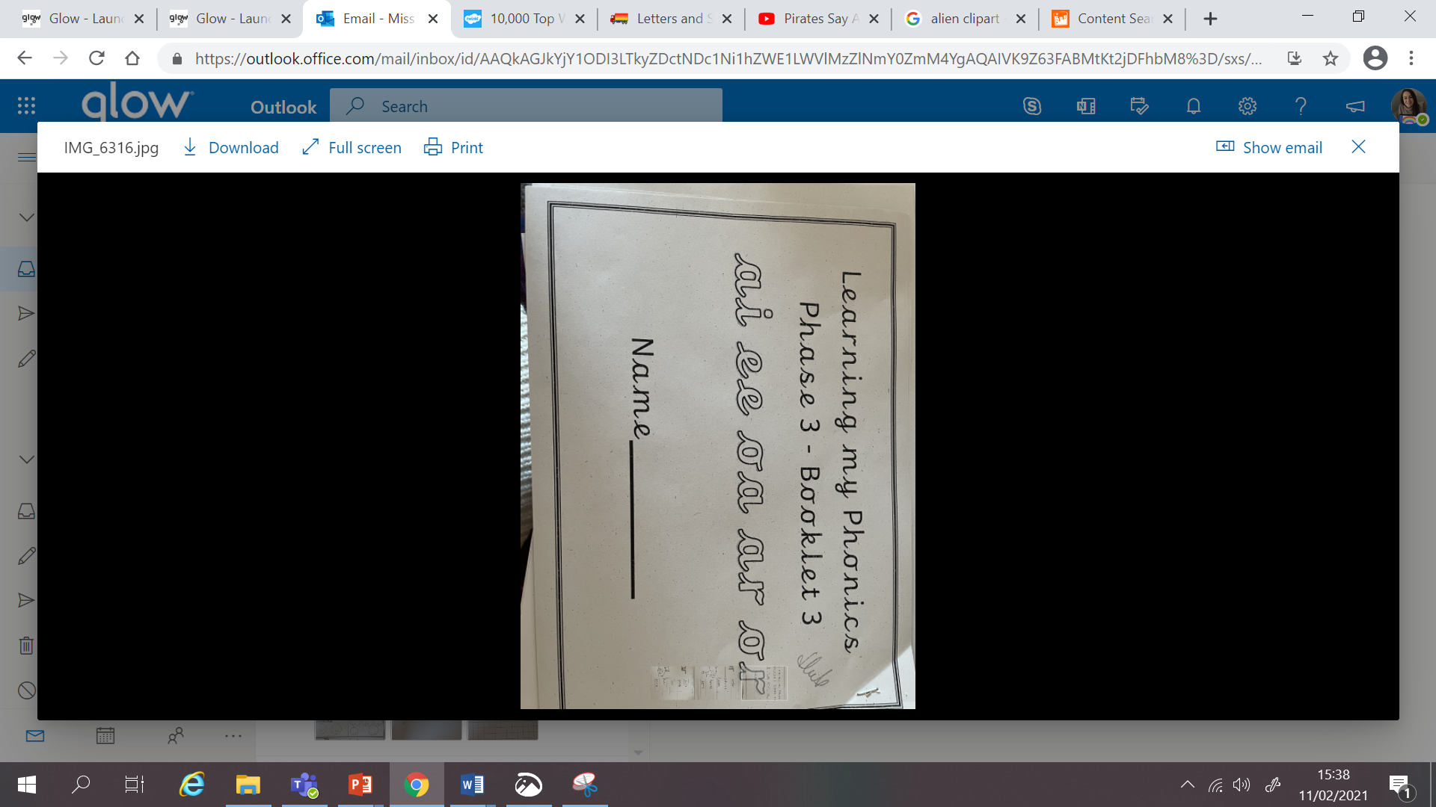
Guided reading book this week: ‘‘Let’s Rock!’
Choose another book on Bugclub to read for enjoyment.
Try and read all of the pink books before moving on the red.

If you managed to get to school last week, you will have a new phonics booklet to support our new sounds. I have uploaded alternative pages for those who did not manage to collect.
 | H O L I D A Y
Tuesday  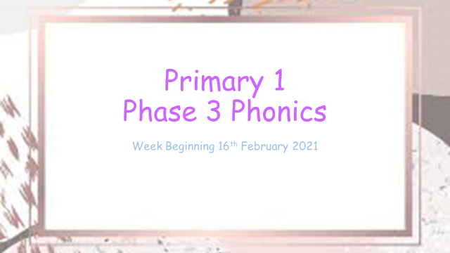 | 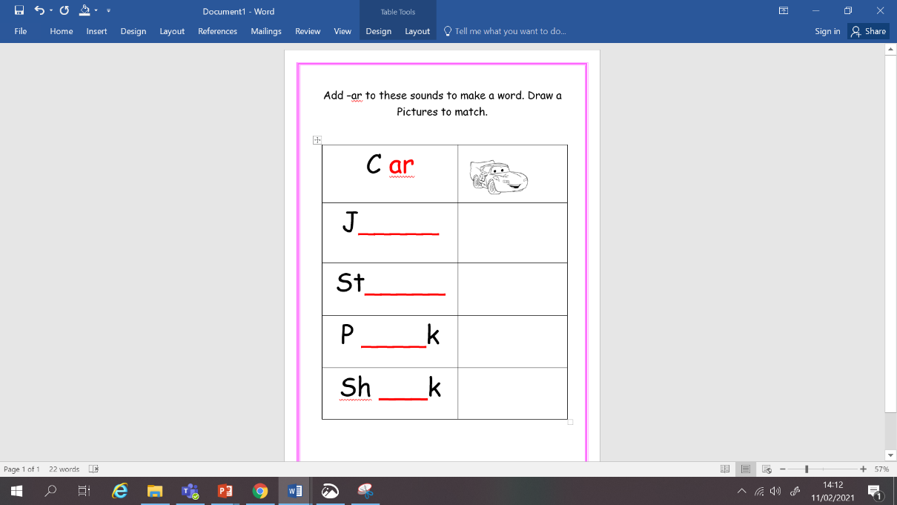  Phonics – See PowerPoint.  ar sound  LI: To learn new sounds to blend to make a word.  Go through the PowerPoint and use the videos to help learn the new sound of the day.  Use your knowledge to build new words using your blending skills.  Task: Phonics jotter job and ar worksheet.
Wednesday  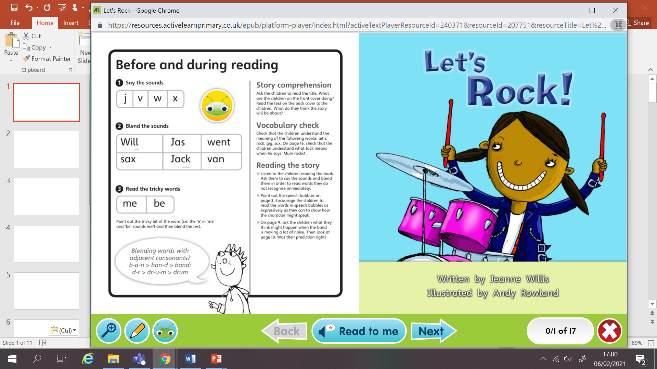 | Reading Live Lesson – ‘Let’s Rock’  I have assigned this to everyone Bug Club. We will read it together and go over the task on our live call.  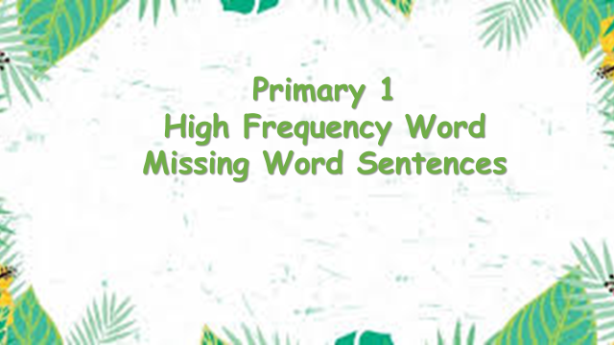  Task 1: Can you create your own band? Draw a picture of your band and give it a name!  Task 2 : Missing word sentences. I need your help to put the sentences back together so I can work out what word is missing!
Thursday | Phonics – See PowerPoint.  oo sound  LI: To learn new sounds to blend to make a word.  Go through the PowerPoint and use the videos to help learn the new sound of the day.  Use your knowledge to build new words using your blending skills.  Task: Phonics jotter job and ‘or’ online game/ phonics booklet.
Friday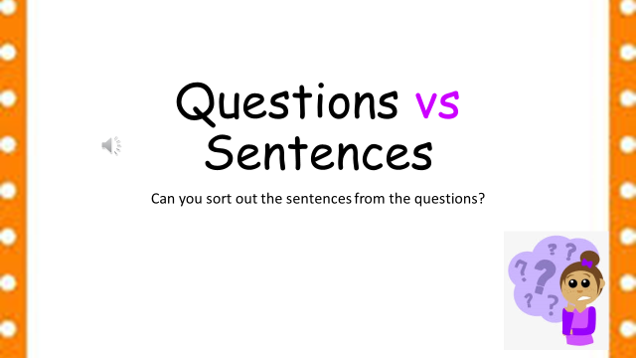 | Writing: See PowerPoint.  LI: To write 3 different questions.  What is the difference between a sentence and a question? Let’s find out!  An alien has landed in our school playground and we need to think of 3 different questions to ask him before he leaves again!  Task: Identify questions and write 3 questions for the alien.

