Primary 1 Numeracy Tasks Week Beg 15.02.21
Every day, count forwards and backwards from 20.
Everything you need is on the weekly PowerPoint.
Monday | IN – SERVICE DAY!
Tuesday  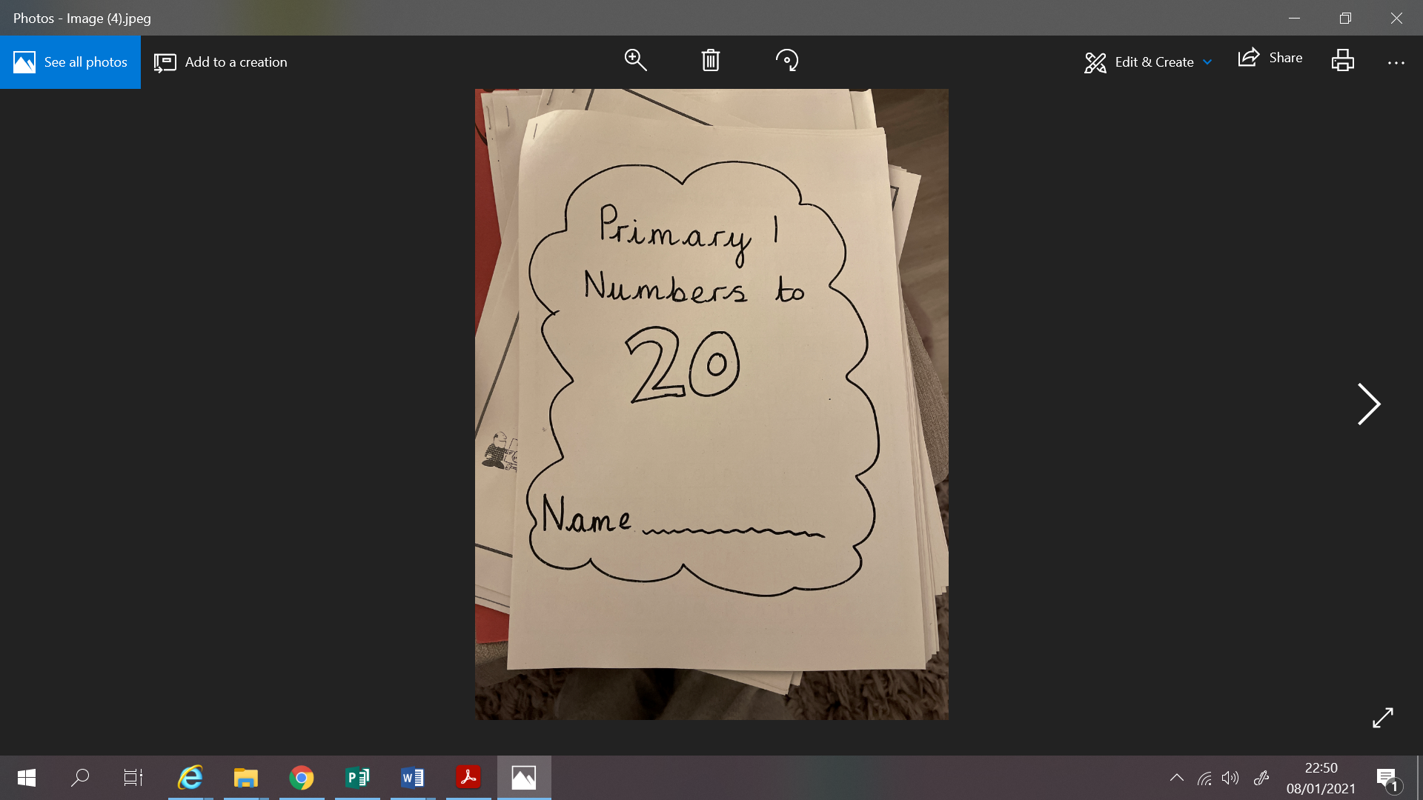 | 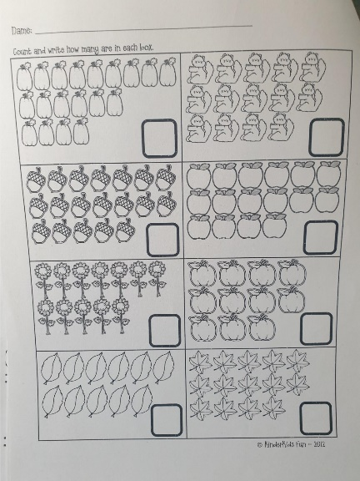  Counting to 20  Challenge yourself to count to 100  L.I. To count an amount of items in rows  Have a go at writing numbers to 100. Maybe an adult could call the number and you see if you can write it down.  We are looking at counting amounts of items and write the correct number in the box.  Task: Page 7 of your counting to 20 booklet
Wednesday  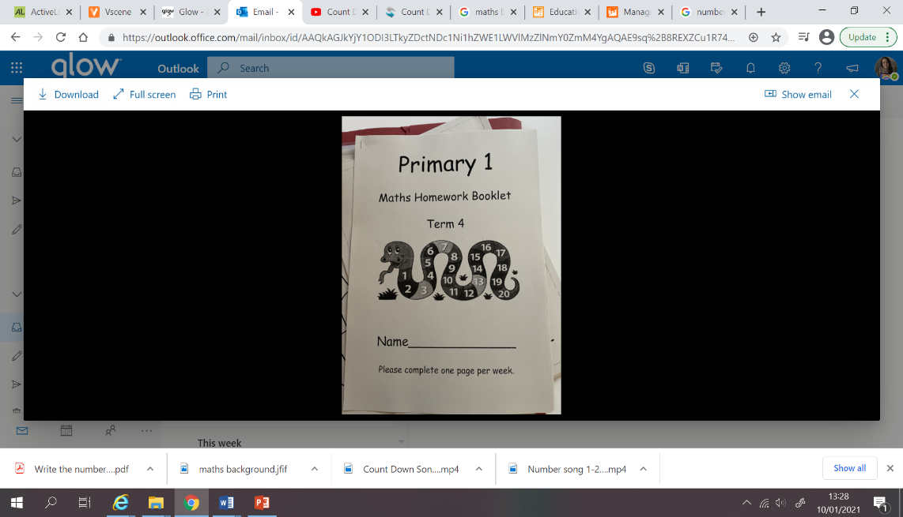 | 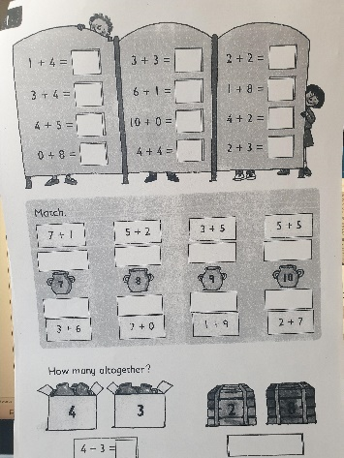  Colour the Amount of Objects  LI: I can identify and colour in a certain amount of objects from numbers 0-20.  Can you colour in the right amount of items noted in the little bubbles at the side.  Task: Page 4 of Snake Number booklet.
Thursday  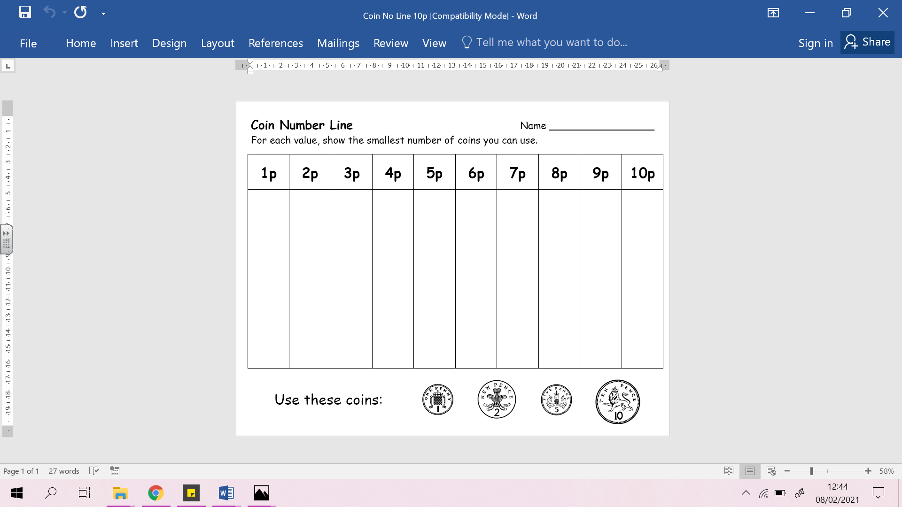 | Money  LI: To make an amount of money using the smallest amount of coins.  I can begin to recognise coins to the value of £1.  Task: For each value can you use the smallest amount of coins to show the value.
Friday  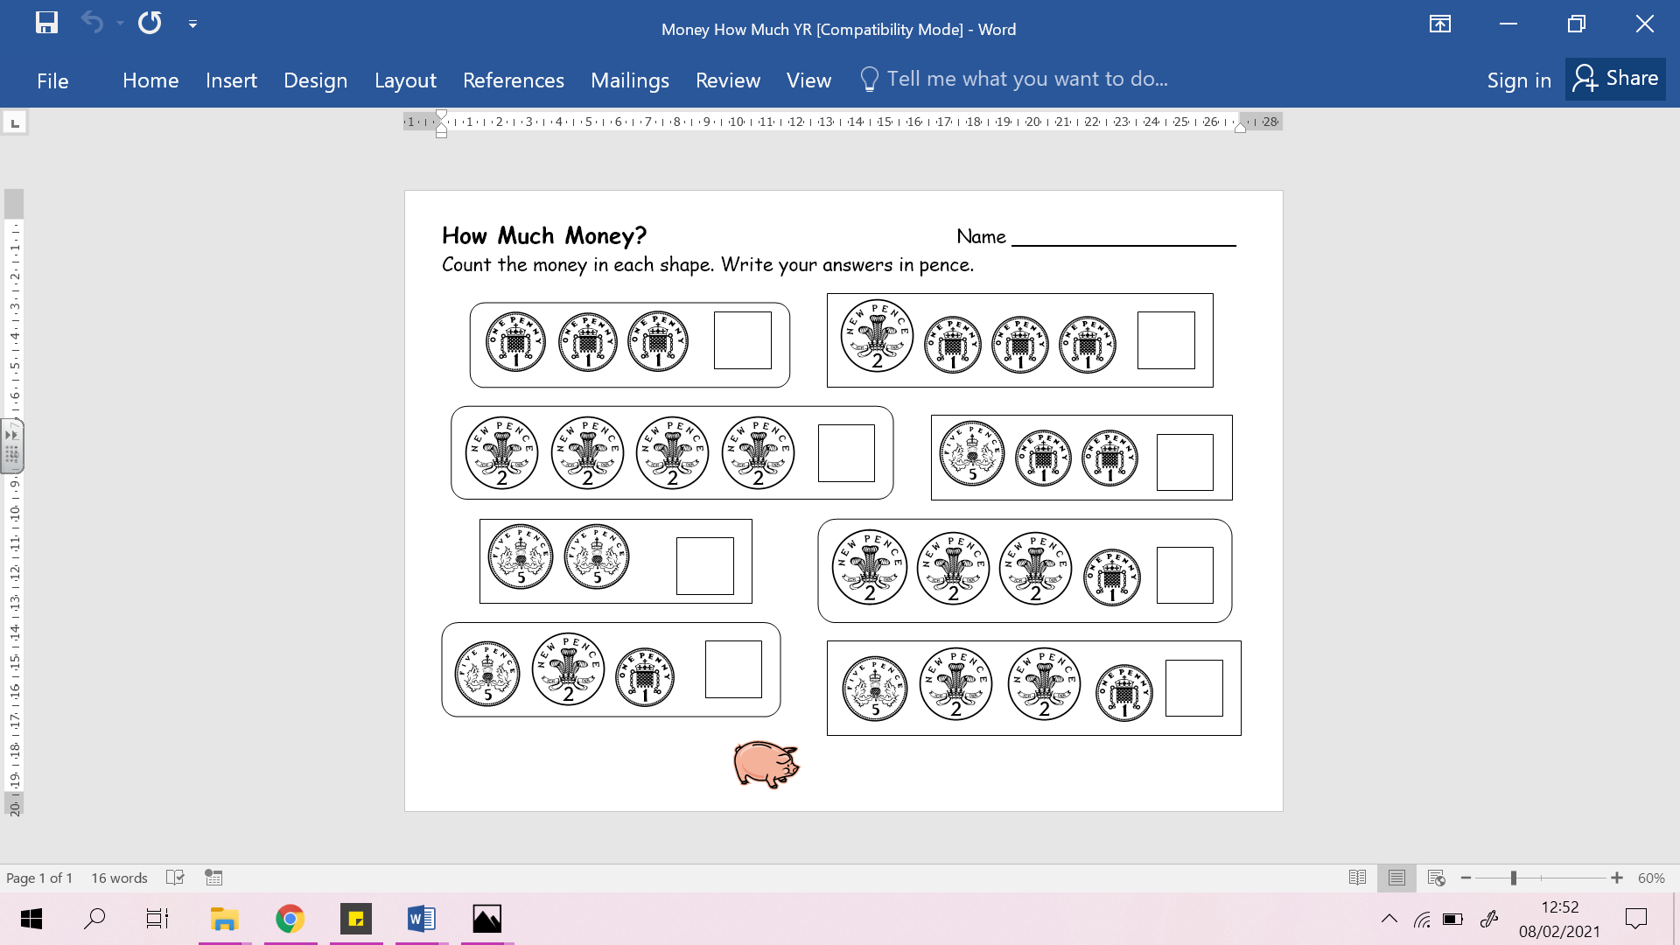 | Money  LI: To begin to add amounts of money  Look carefully at the coins and see if you can find the total.  Task: Add the coins together to see the total amount of coins

