Primary 1 Literacy Task Week Beg 08.02.21
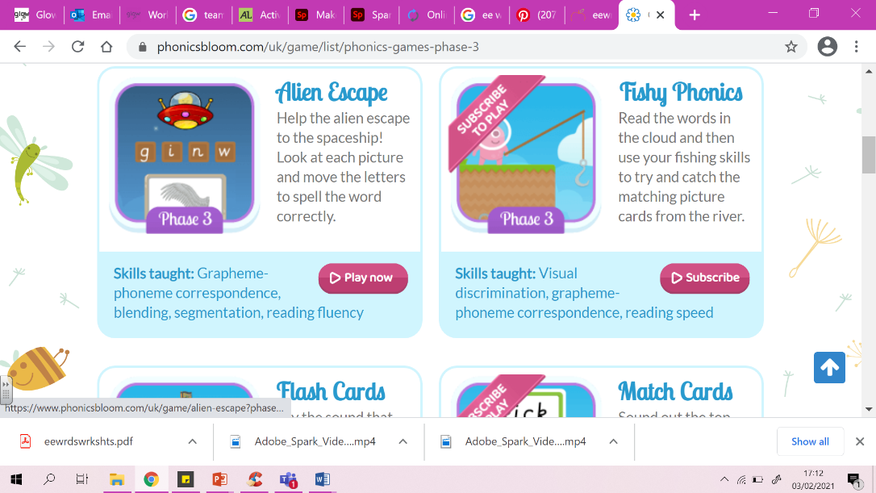
Guided reading book this week: ‘‘The Fox and the Ducks’’
Choose another book on Bugclub to read for enjoyment.
Try and read all of the pink books before moving on the red.

Daily Phonics Bloom Games.
Monday  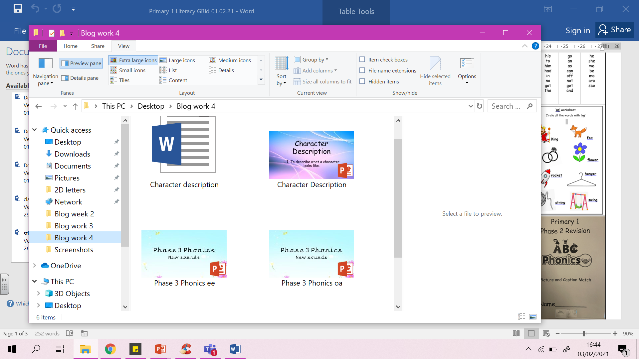 | 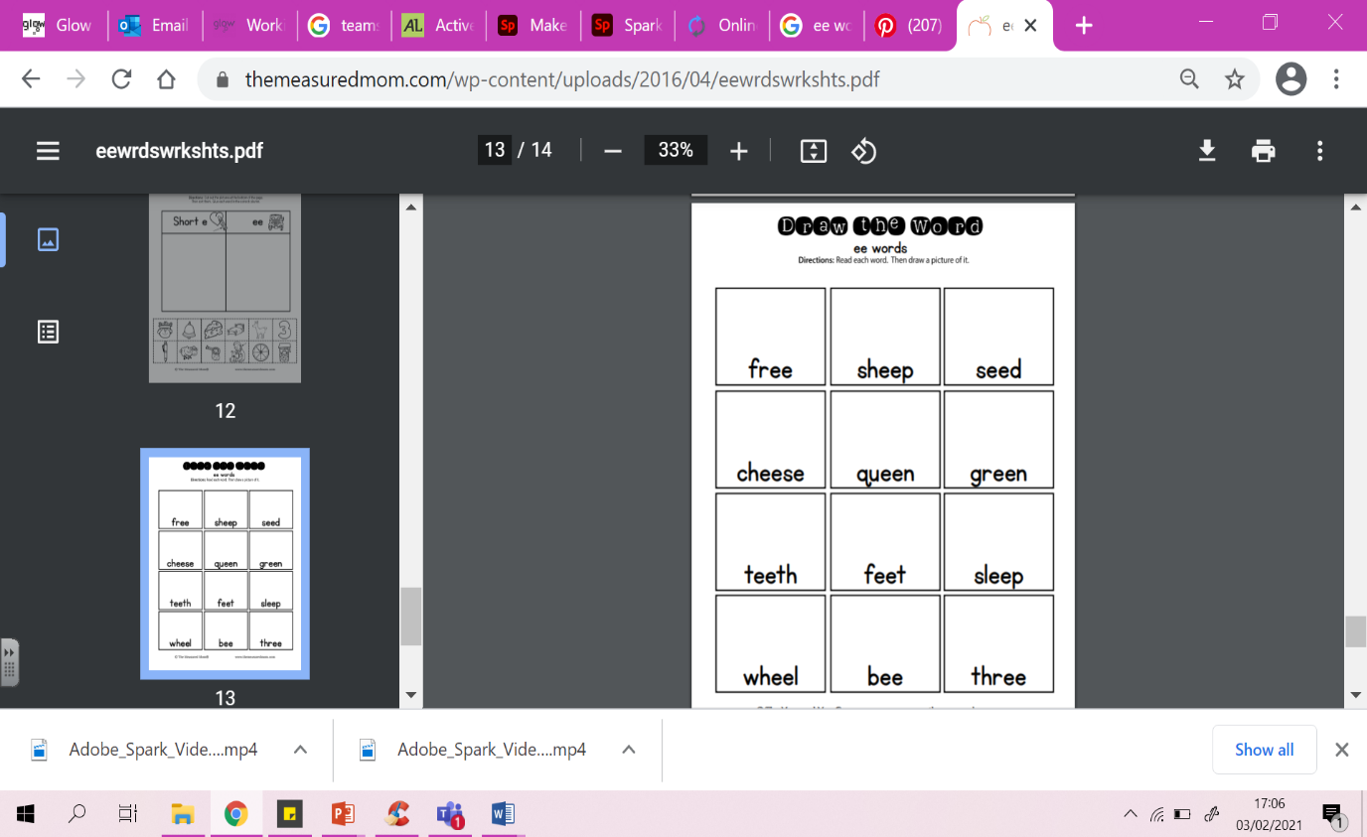  Phonics – See PowerPoint.  ee sound  LI: To learn new sounds to blend to make a word.  Go through the PowerPoint and use the videos to help learn the new sound of the day.  Use your knowledge to build new words using your blending skills.  Task: Phonics jotter job and ee worksheet.
Tuesday | 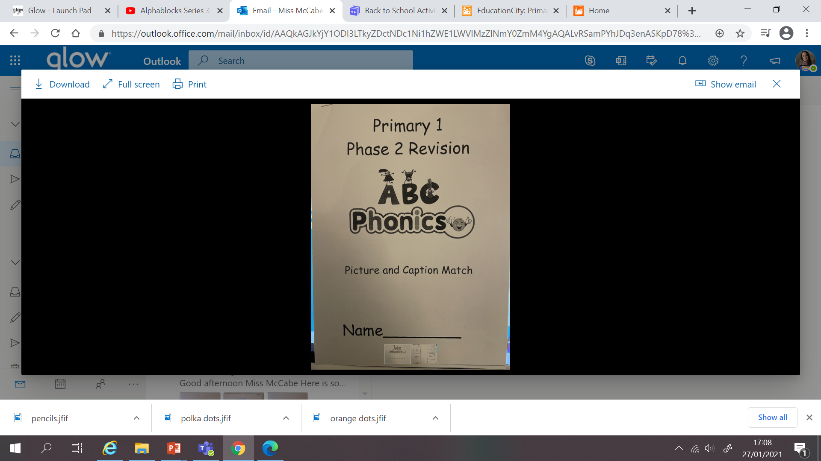  Phonics – See PowerPoint.  oa sound  LI: To learn new sounds to blend to make a word.  Go through the PowerPoint and use the videos to help learn the new sound of the day.  Use your knowledge to build new words using your blending skills.  Task: Phonics jotter job and picture caption workbook.
Wednesday  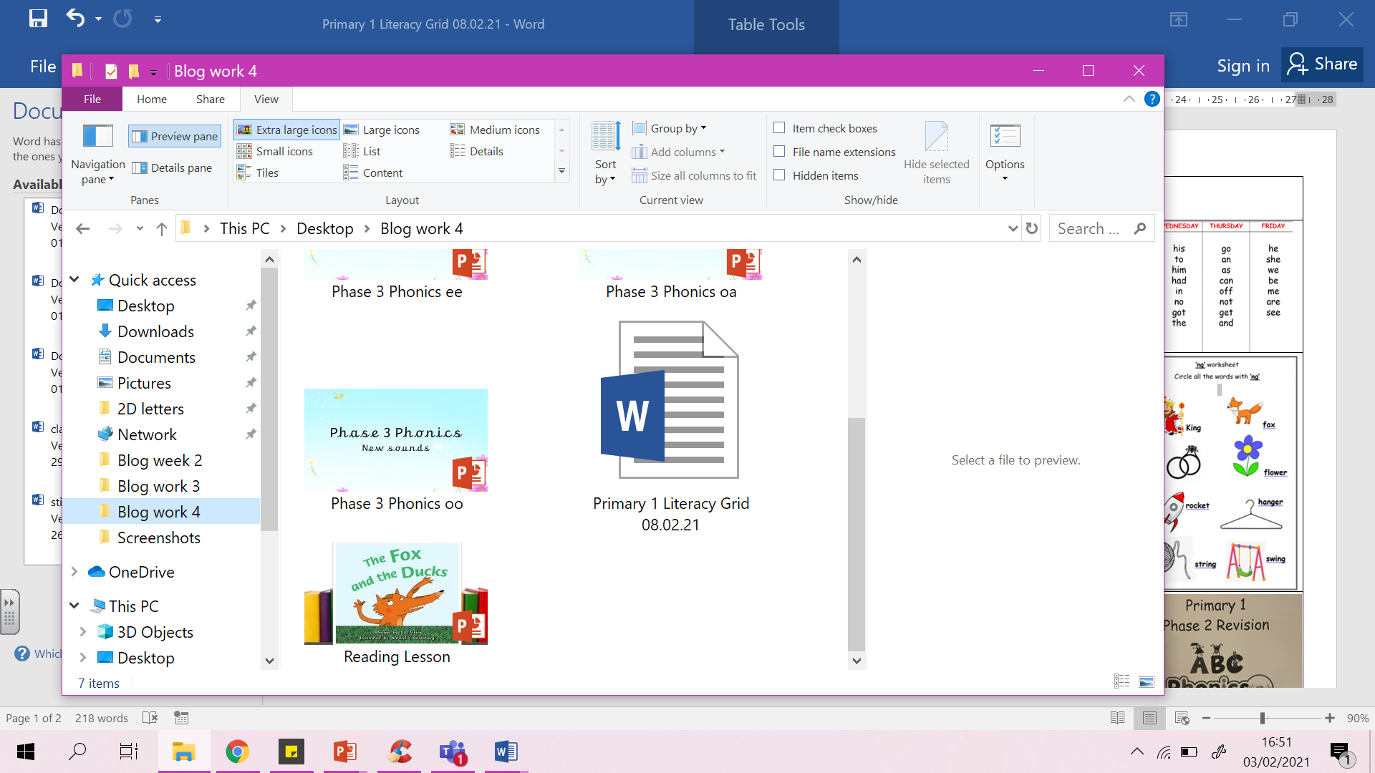 | Reading Live Lesson – ‘‘The Fox and the Ducks’’ PowerPoint  Reading task- using similar sound patterns to recognise words.  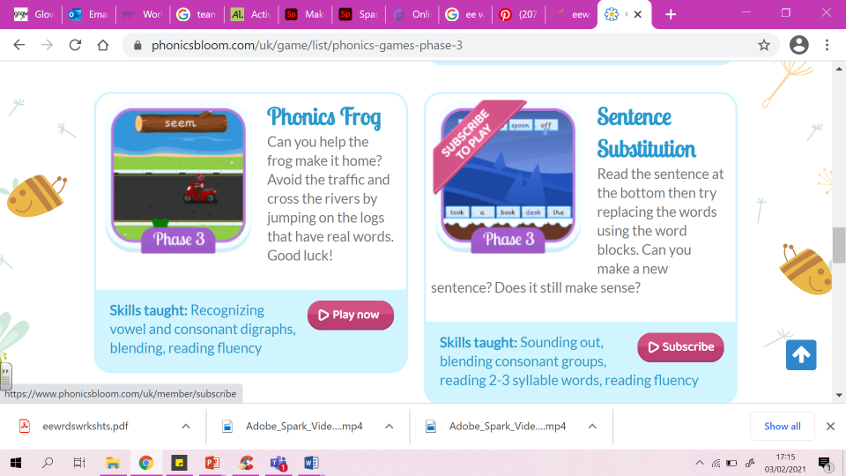  Task:?  Phonics: PhonicsPlay game  https://www.phonicsbloom.com/uk/game/phonics-frog?phase=3
Thursday | 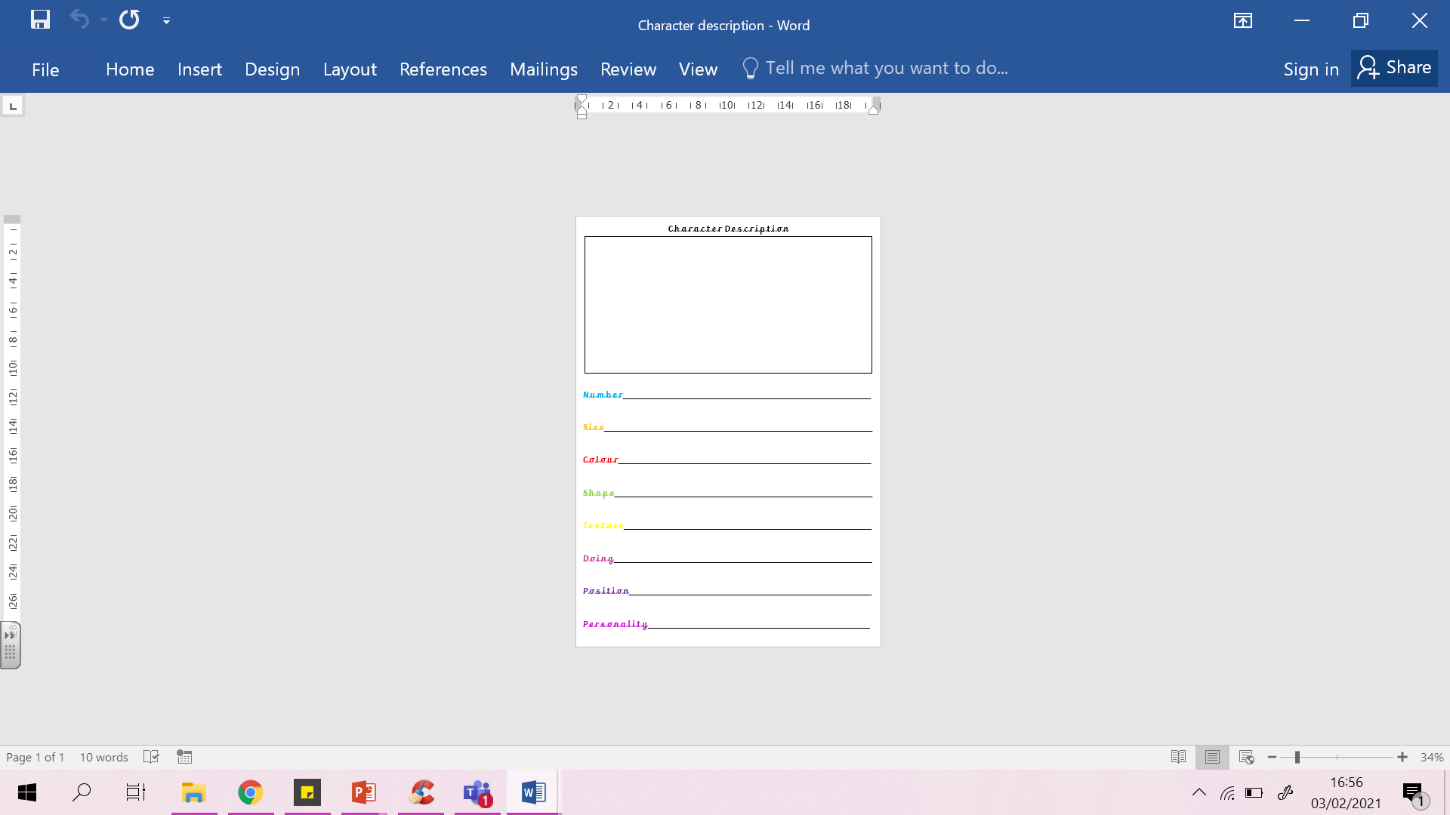  Writing: See PowerPoint.  LI: To describe what a character looks like.  Think of what a characters features will be if describing what they look like on the outside and the inside.  Task: Complete the sentences to write a character description.
Friday | Holiday!

