Primary 1 Literacy Task Week Beg 01.02.21
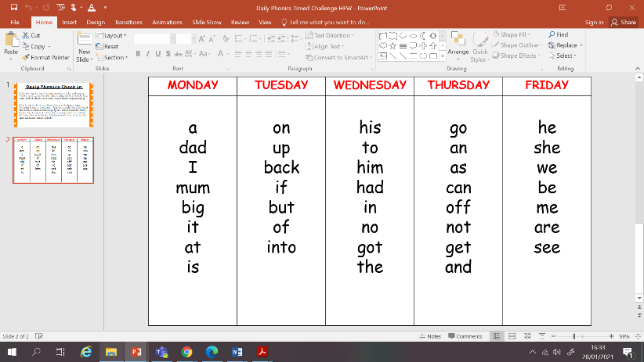
Guided reading book this week: At the Fun Fair
Choose another book on Bugclub to read for enjoyment.

Daily Phonics Timed Challenge. Complete 1 column per day
Monday  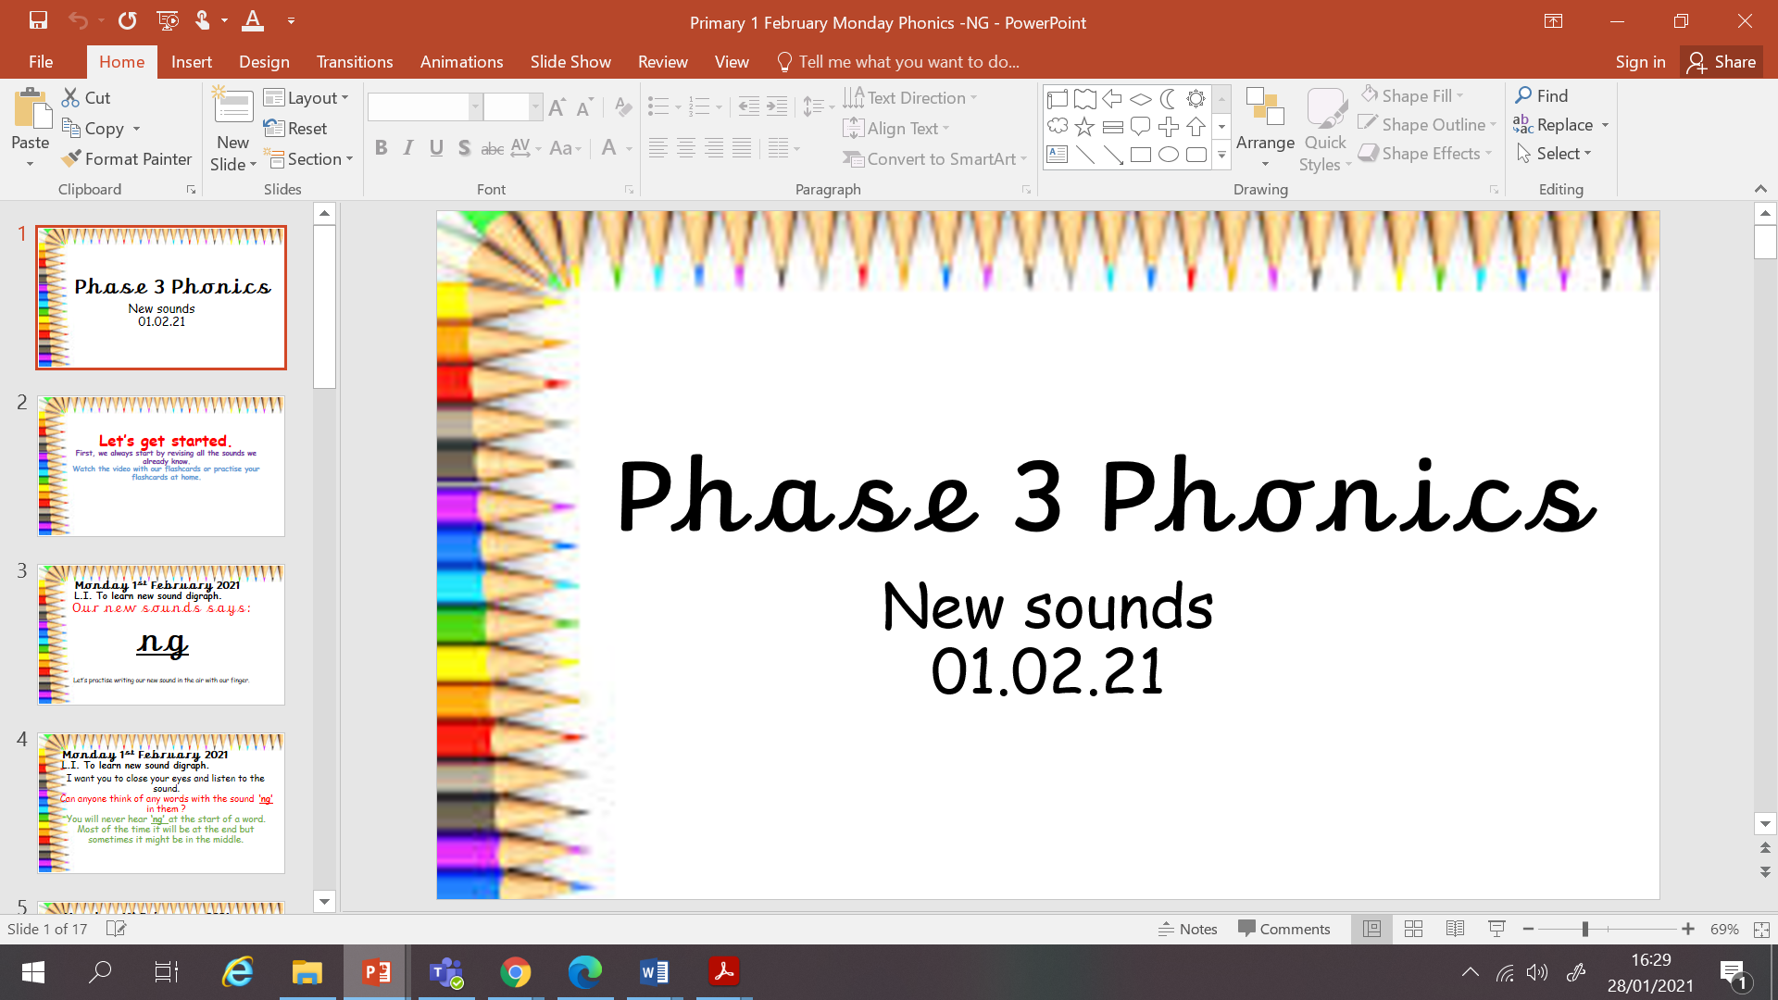 | 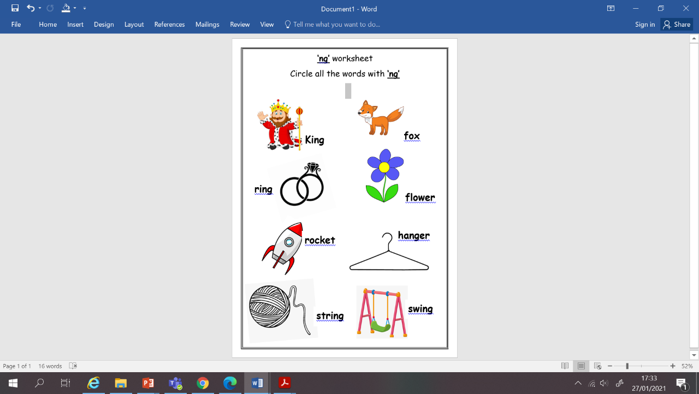  Phonics – See PowerPoint.  ng sound  LI: To learn new sounds to blend to make a word.  Go through the PowerPoint and use the videos to help learn the new sound of the day.  Use your knowledge to build new words using your blending skills.  Task: Phonics jotter job and NG worksheet.
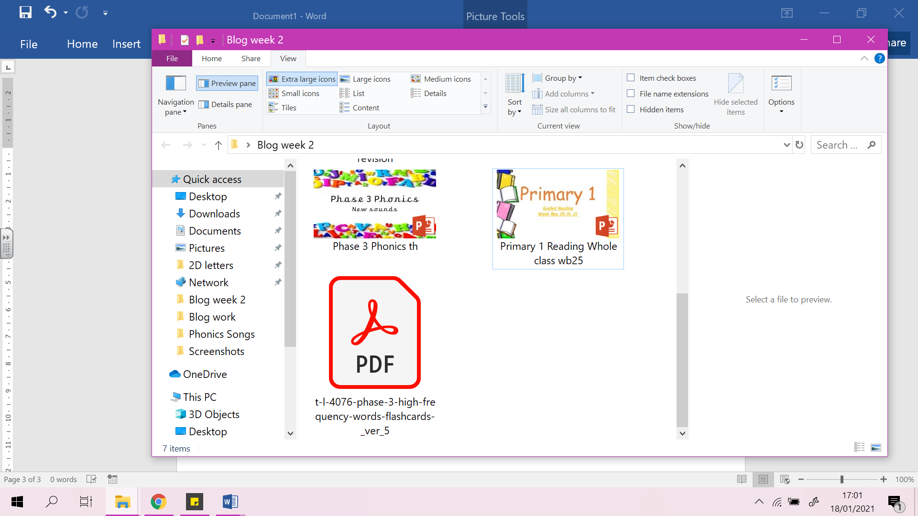  Tuesday | Reading Live Lesson – ‘‘At the Fun Fair’’ PowerPoint  Reading task- using similar sound patterns to recognise words.  Task: Can you design and describe your own fun fair ride?  Phonics: PhonicsPlay game  https://www.phonicsplay.co.uk/resources/phase/3/buried-treasure
Wednesday  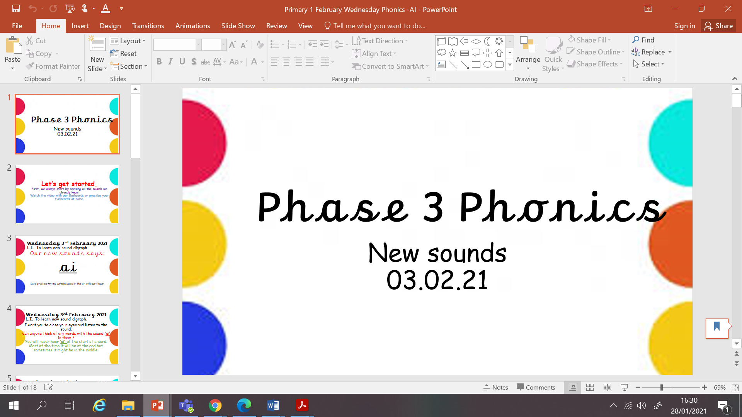 | 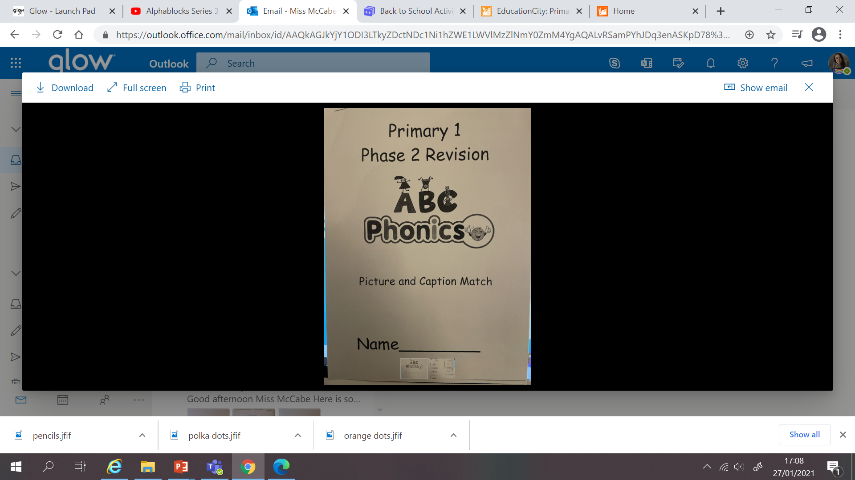  Phonics – See PowerPoint.  ai sound  LI: To learn new sounds to blend to make a word.  Go through the PowerPoint and use the videos to help learn the new sound of the day.  Use your knowledge to build new words using your blending skills.  Task: Phonics jotter job and picture caption workbook.
Thursday  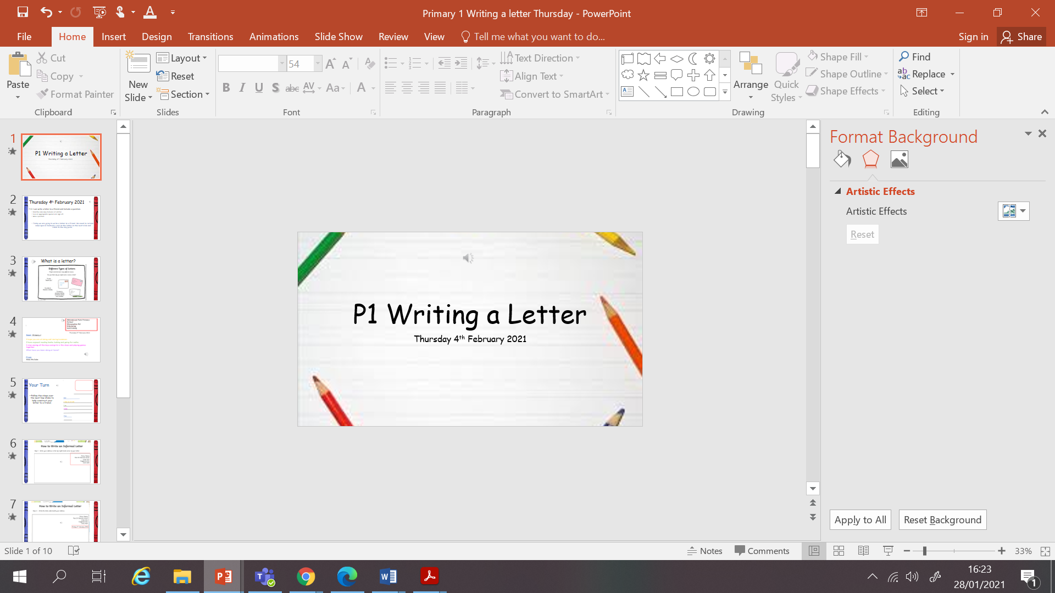 | 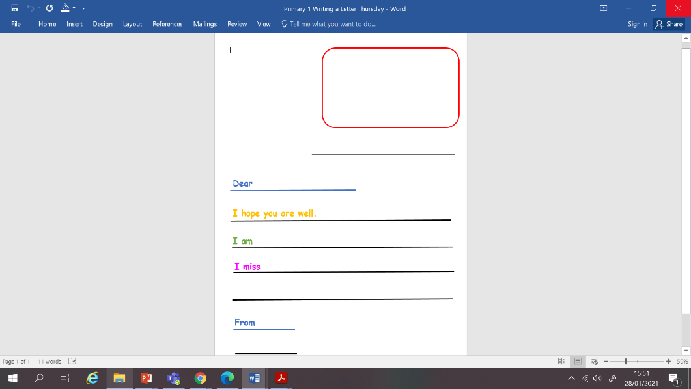  Writing: See PowerPoint.  LI: To write a letter to a friend.  Listen to the instructions and use the writing template, fill in the key features of a letter and complete the sentence.  Task: Complete the sentences to write a letter to a friend.
Friday  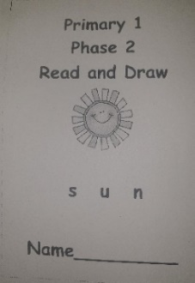 | Phonics: Read and Draw  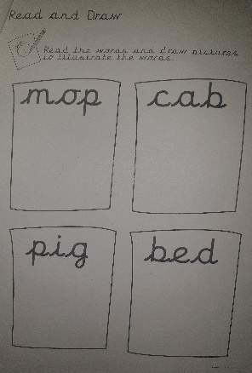  LI: I can use my sounds to read and draw CVC words.  Practise blending and making words  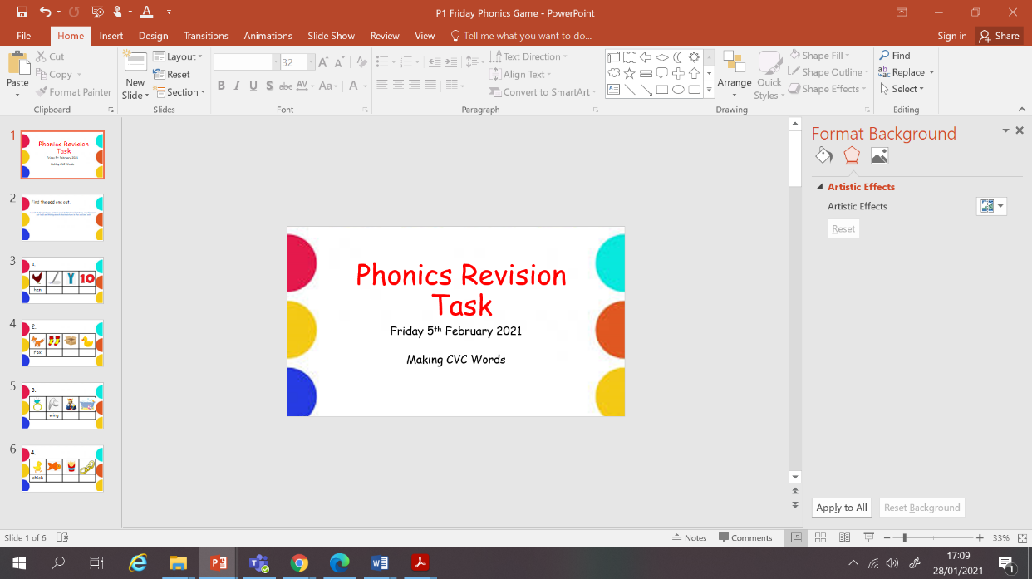  Task: Phase 2 Read and Draw booklet, page 4.  Phonics Powerpoint – Odd one out.

