Primary 1 Numeracy Tasks Week Beg 25.01.21
Everyday, count forwards and backwards from 20.
Everything you need is on the weekly PowerPoint.
Monday  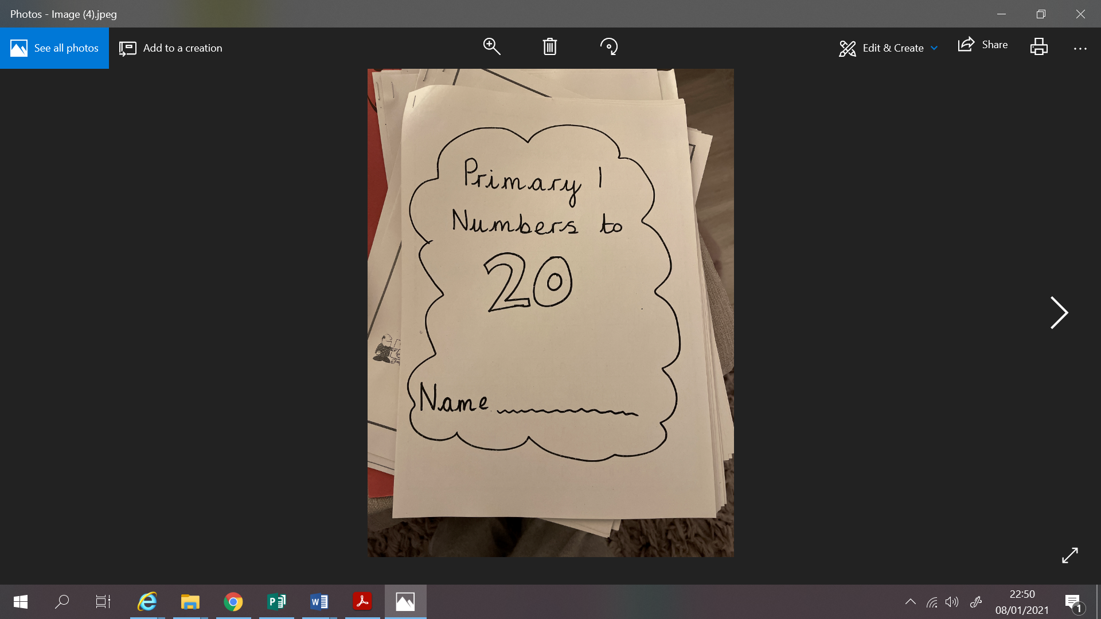 | Counting to 20 - See PowerPoint.  Count forwards and backwards from 20.  Practise writing down the numbers 1 – 20 make sure that the numbers are written down correctly so 12 not 21.  We are looking at blank number lines. We need to look at the first and last number on the number line to try and help us guess what number the arrow is pointing to.  Complete the 4 examples on the PowerPoint.  Task: Page 5 of your counting to 20 booklet
Tuesday  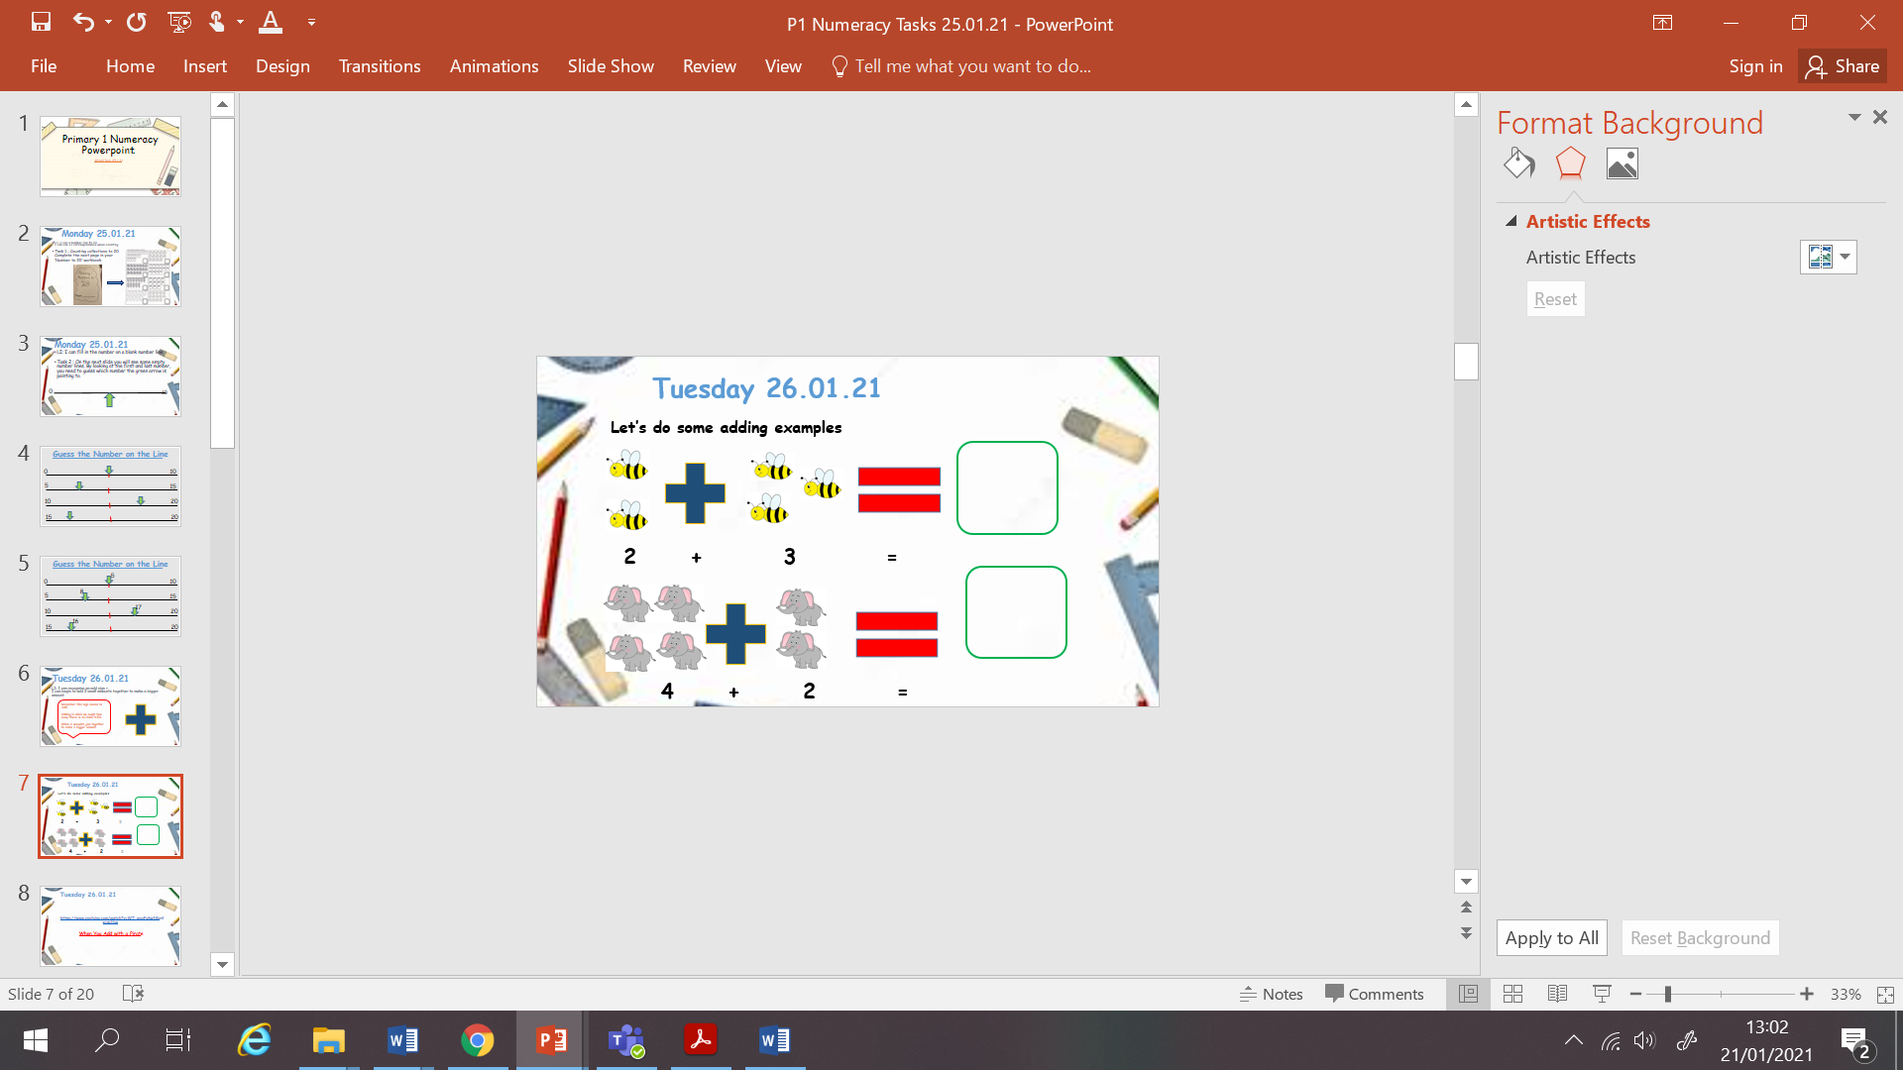 | Simple Addition  Let’s look at simple addition, there is some examples on the weekly PowerPoint and video to watch as well.  Count the total amount of objects in the pictures. Write the number underneath to help create your sum.  Task: Dino Addition Worksheet.
Wednesday | 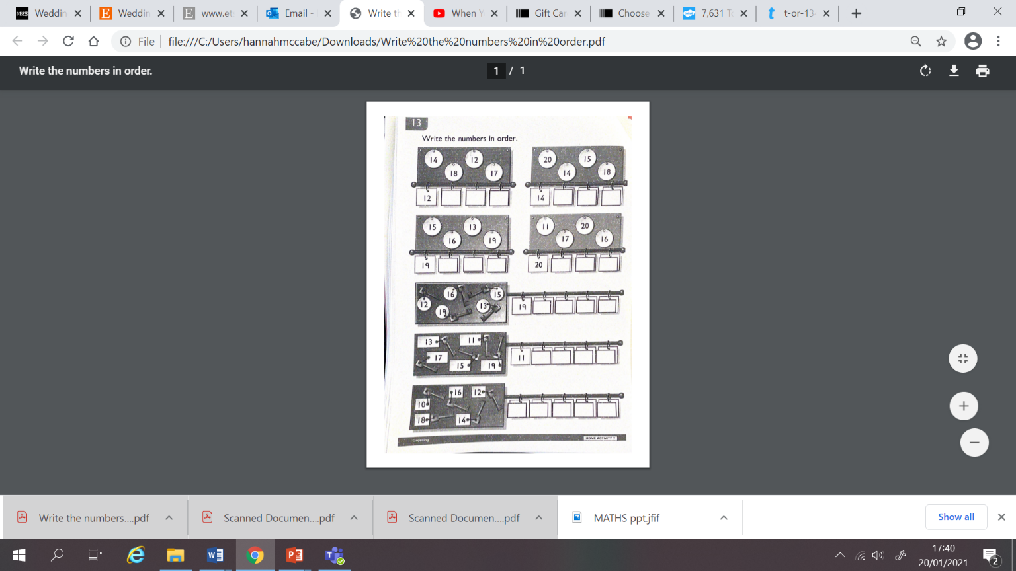  Write The Missing Numbers  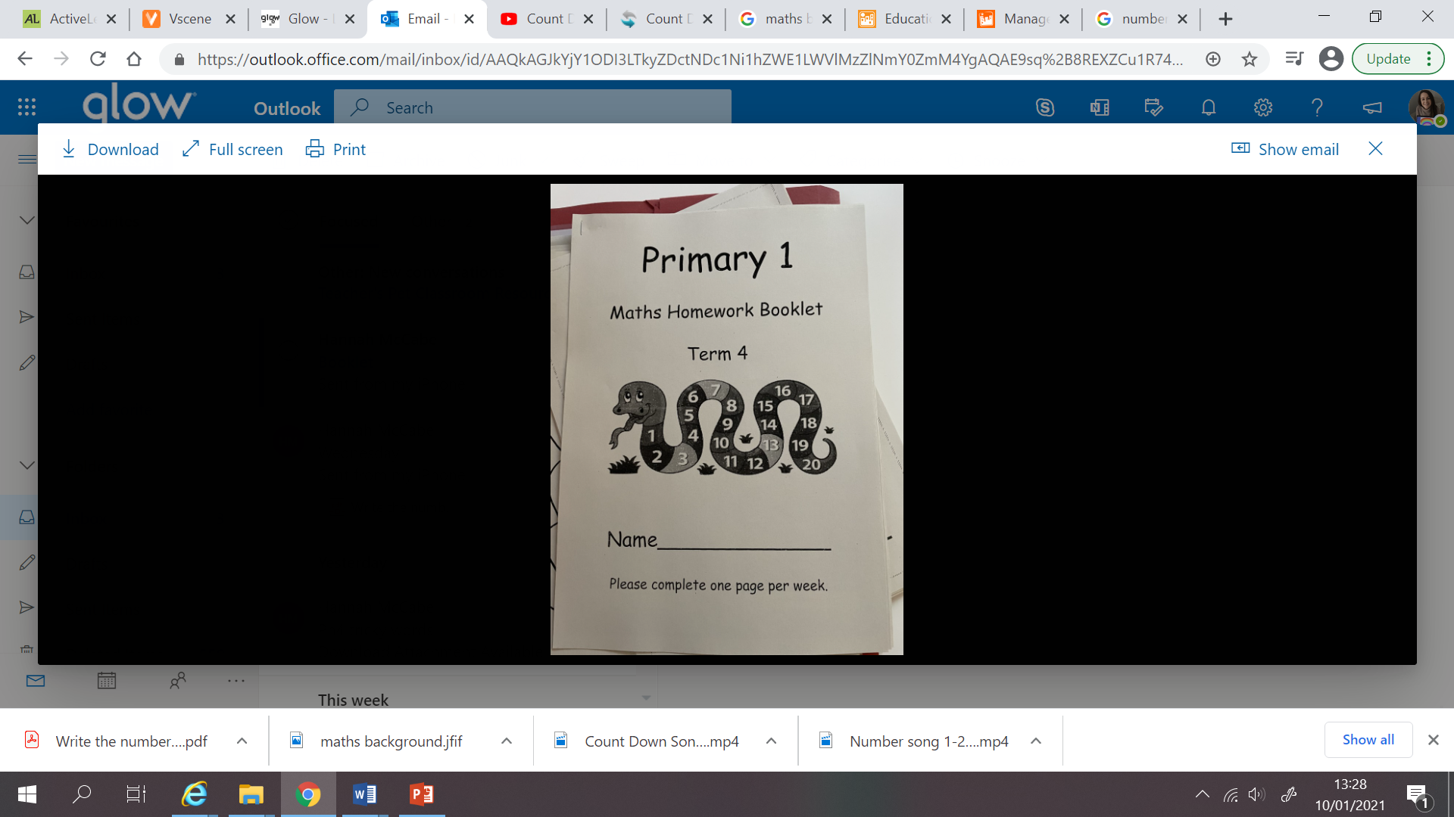  See Numeracy PowerPoint  LI: I can order number from 0-20, putting the smallest number first.  These numbers are all muddled up and it’s your job to try and put them in the right order!  Task: Page 3 of Snake Number booklet.
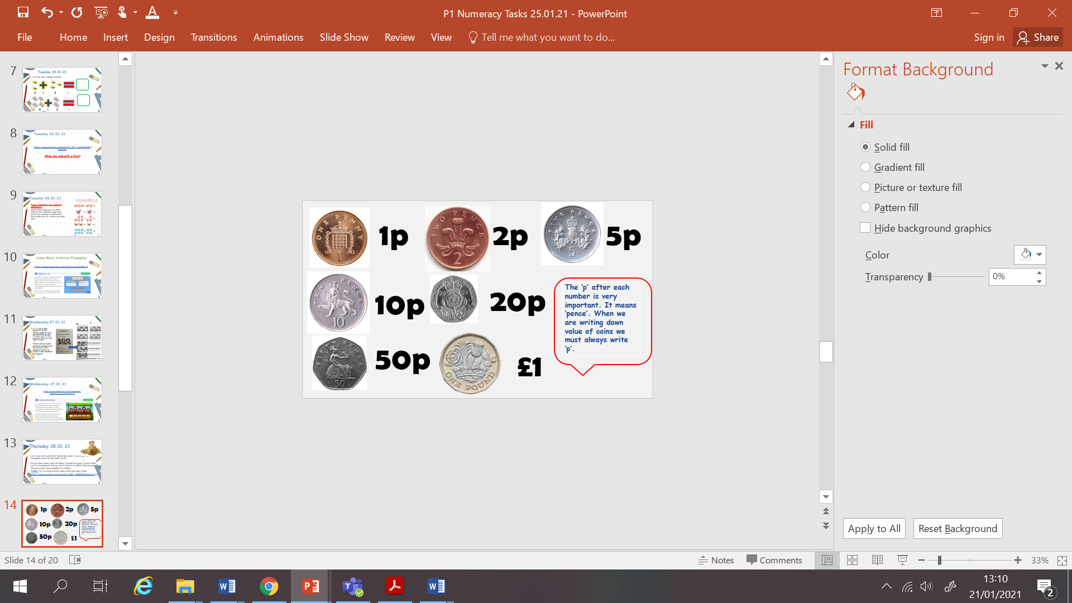  Thursday | Money  LI: I can sort coins that looks the same. I can begin to recognise coins to the value of £1.  Money video: https://www.youtube.com/watch?v=vs8F_g3MGtM&safe=active  Task: If you have some coins at home look them out and investigate them. Look at the numbers on them, look at the details and the pictures on them. What do you see? Have a go at drawing around some coins, or sort them in to categories.
Friday  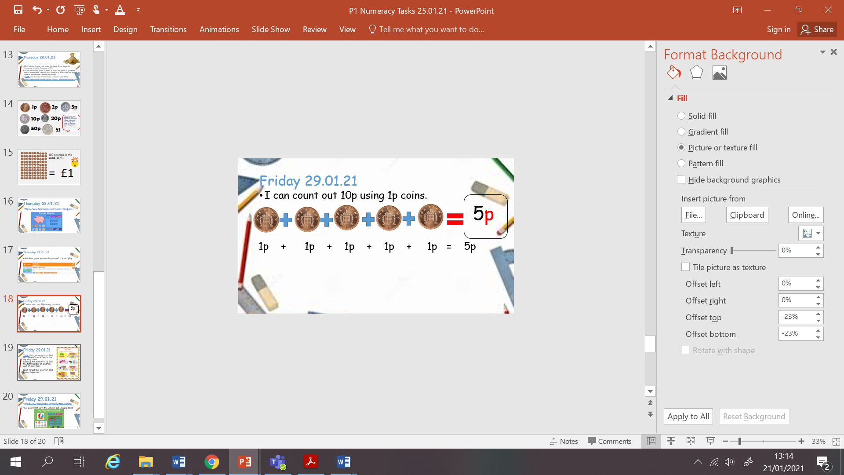 | 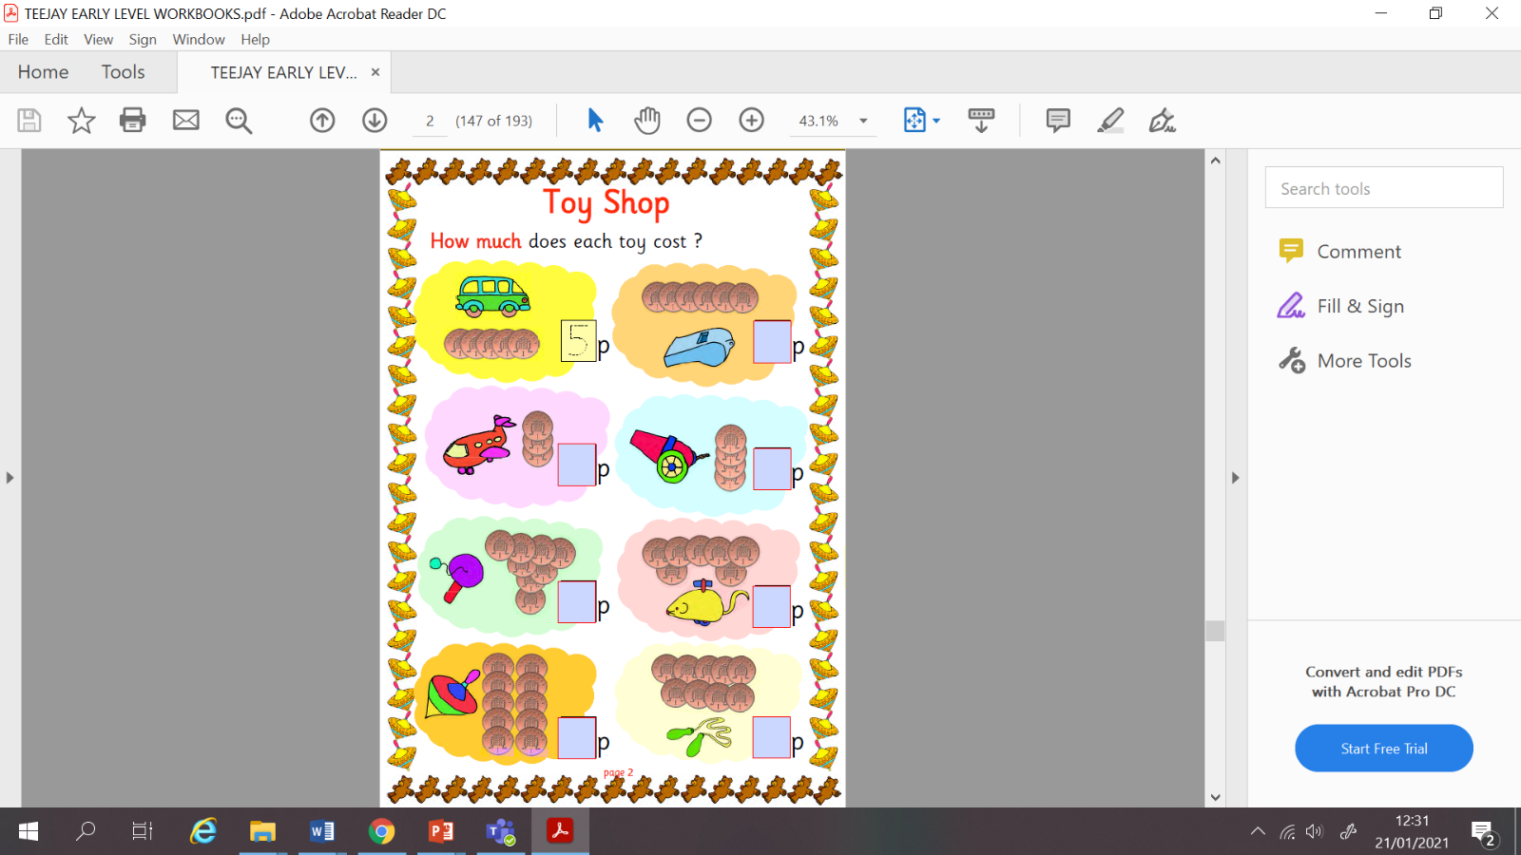  Money  LI: I can count 1p coins to make 10p.  Task: Your job today is to find out how much each item in the toy shop costs.  Count up the number of 1p coin, the total number of 1p is the cost of each item.

