Primary 1 Literacy Task Week Beg 25.01.21
Guided reading book this week: ‘What is in my Net’
Choose another book on Bugclub to read for enjoyment.
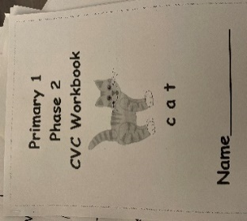  Monday  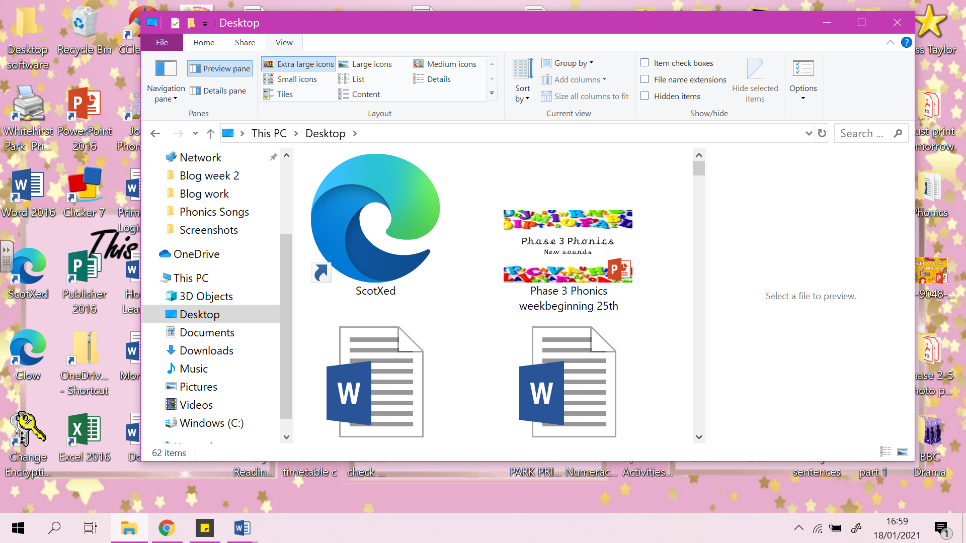 | Phonics – See PowerPoint.  ch sound  LI: To learn new sounds to blend to make a word.  Go through the PowerPoint and use the videos to help learn the new sound of the day.  Use your knowledge to build new words using your blending skills.  There are additional tasks in the PowerPoint so you don’t need to do the CVC workbook today.  Task: CVC Booklet page 3. Read the word and match them to the correct picture.
Tuesday  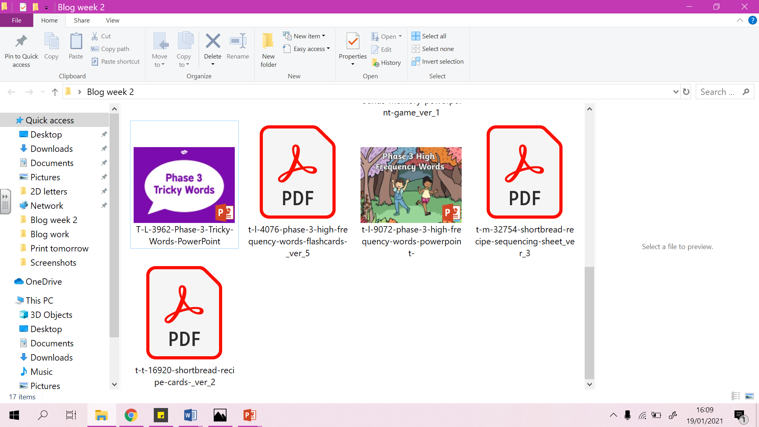 | Phonics – See PowerPoint.  sh sound  LI: To learn new sounds to blend to make a word.  Go through the PowerPoint and use the videos to help learn the new sound of the day.  Use your knowledge to build new words using your blending skills.  Task: Match the sound to the picture.  Then look at the Phase 3 tricky words activities  See how fast you can go answering them  TIP –write down any of the words your child gets incorrect and that way you can focus on these words.
Wednesday  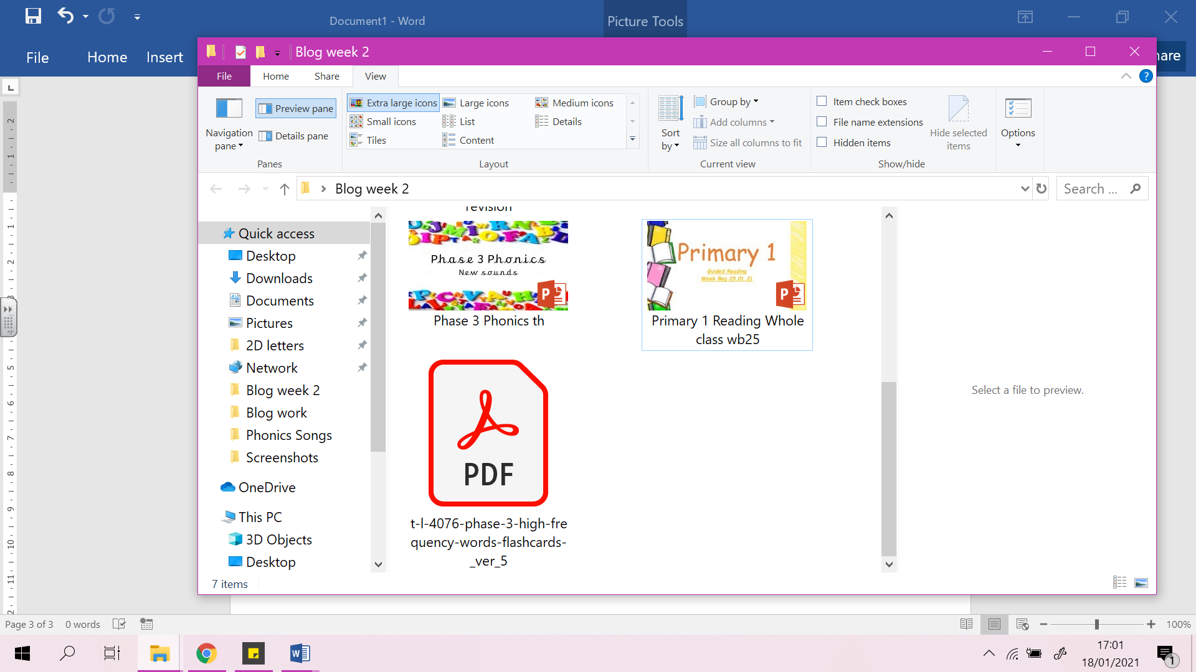 | Reading Live Lesson – ‘‘What is in my Net’’ PowerPoint  Reading task- using similar sound patterns to recognise words.  Task: Can you put the pictures in the correct order.  Phonics – See PowerPoint.  th sound  LI: To learn new sounds to blend to make a word.  Go through the PowerPoint and use the videos to help learn the new sound of the day.  Use your knowledge to build new words using your blending skills.  Task: Match the sound to the picture.
Thursday  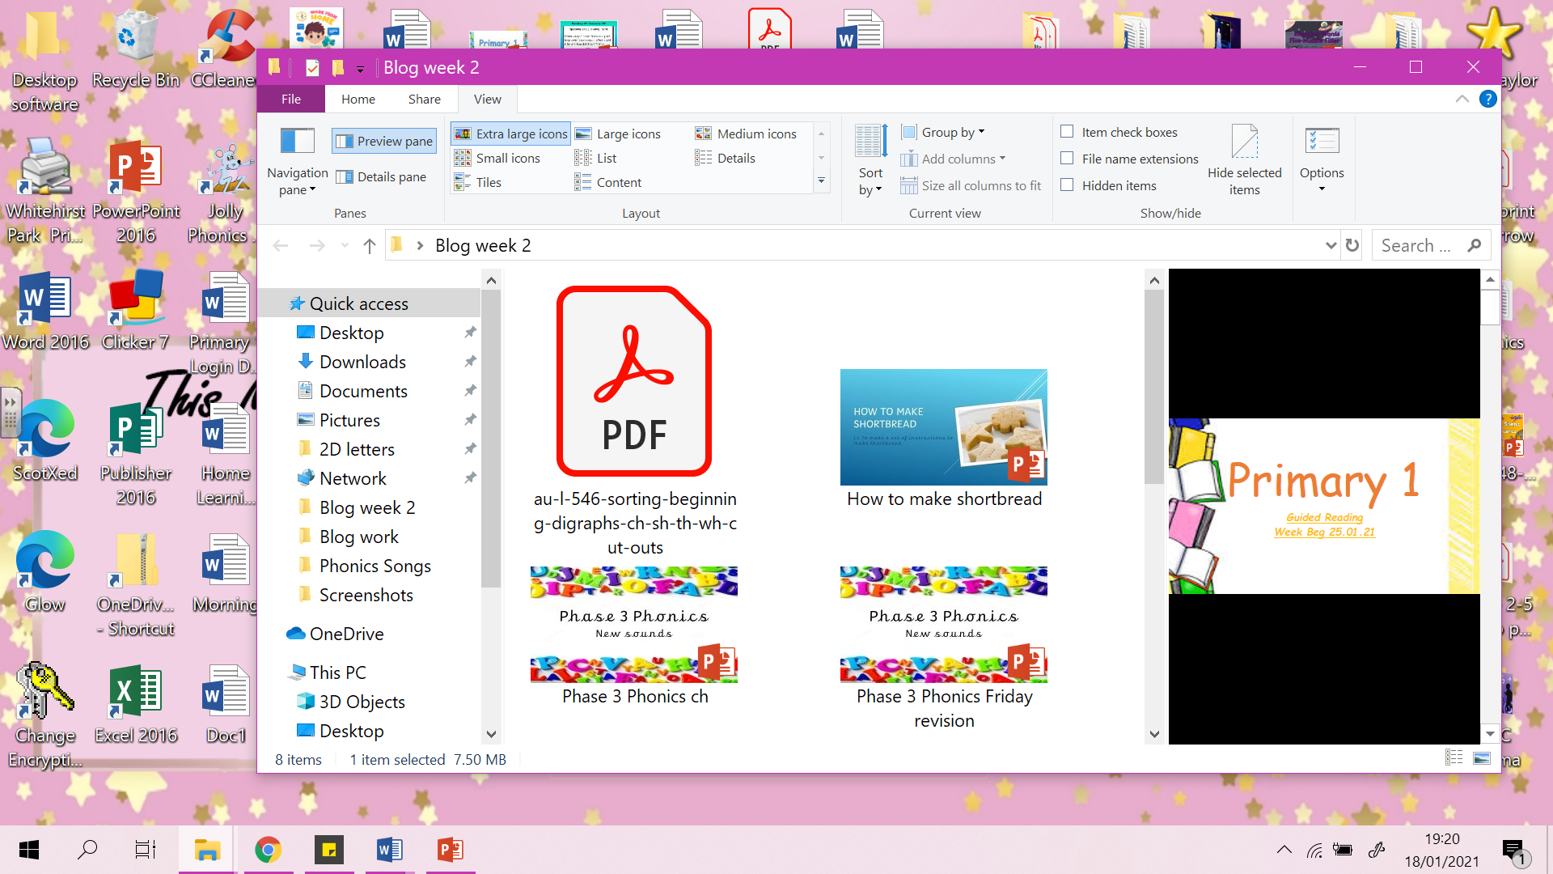 | Writing: See PowerPoint.  LI: To create a set of instructions on how to make Shortbread.  Using the writing template can you write a set of instructions on how to make shortbread.  Task: Draw and write the steps you need to do to make shortbread.
Friday  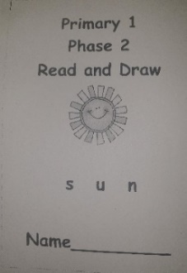 | Phonics: Read and Draw  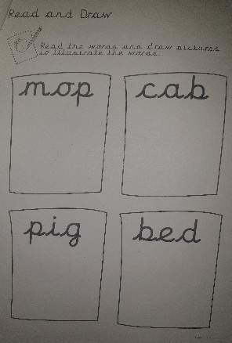  See Phonics PowerPoint  LI: I can use my sounds to read and draw CVC words.  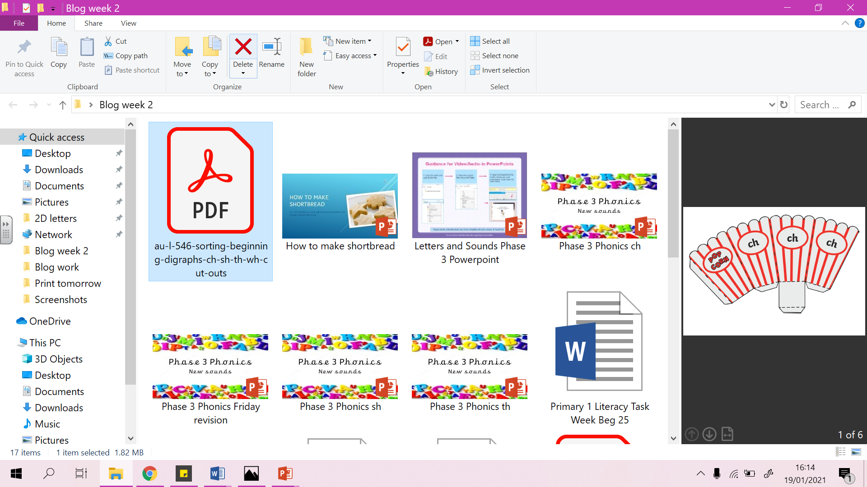  Game: https://www.scootle.edu.au/ec/viewing/L7855/index.html# find the words that have the ch, sh, th sounds.  Task: Phase 2 Read and Draw booklet, page 2.  Extention game – Sort the items into the correct popcorn box (see blog even just use the words and use bowls).

