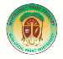 Miss Johnstone and Mrs Robertson’s March 2022 homework Challenge 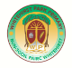
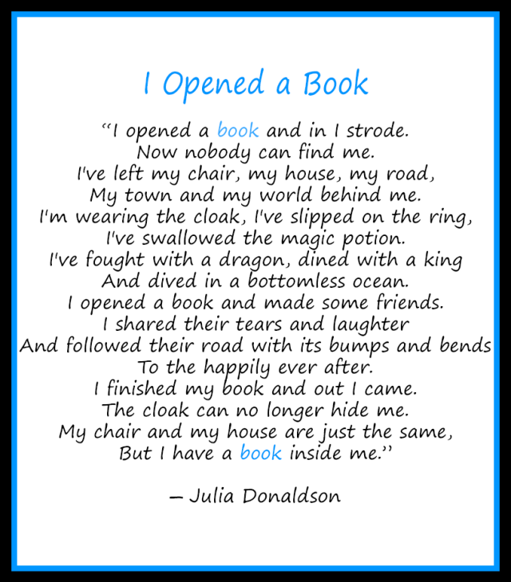
This month’s challenge is in celebration of World Book Day which is on Thursday 3rd March 2022
Your Challenge: Through March, share with us a photograph/video of you enjoying reading – this could be sharing your favourite book/comic, visiting your local library, reading a recipe/instruction etc.
Tweet your photo/video tagging @WhitehirstPs or send it to Miss Johnstone (who will tweet it directly). gw09johnstonelouise@glow.sch.uk
We look forward to seeing all your March ‘Reading’ photographs.

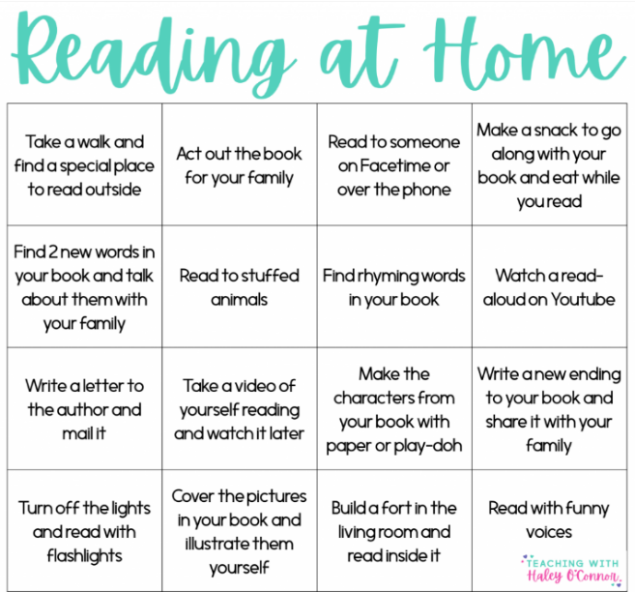

Article 31 You have the right to play and relax by doing things like sports, reading, music and drama.

