Pennyburn Primary School

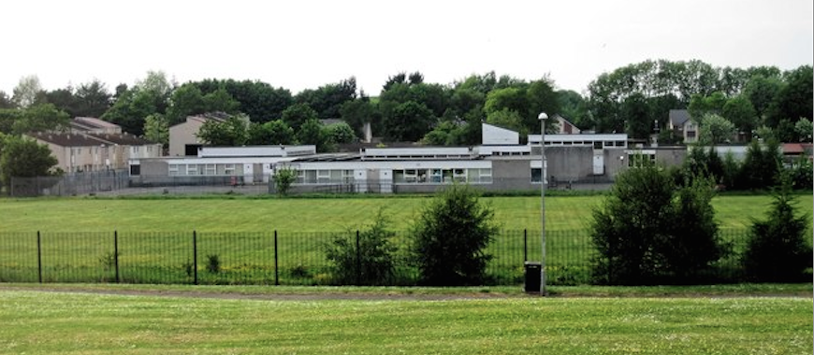Handbook
2021 - 2022
Pennyburn Primary School
Sundrum Place
Pennyburn
Kilwinning
KA13 6SE
01294 552807

Contents

Head Teacher Introduction

Education and Youth Employment Directorate………………………………………

Directorate Aims and Priorities

Section 1: School Information …………………………………………………………

- School Aims, Values, Ethos
- School Contact Details (Address, Telephone, Email, Fax)
- School Staff
- School Calendar/Holidays

Section 2: School Procedures …………………………………………………………

- School Security
- Positive Relationships
- Playground Supervision
- Absence from School Premises at Breaks
- School Dress Code
- Dress Code for PE
- Personal Belongings
- Mobile Phones
- Information in Emergencies
- Listening and Learning

Section 3: Footwear, Clothing, Free School Meals and Transport………………

- Footwear and Clothing Grants
- Free School Meals
- School Transport Policy

Section 4: School Registration, Enrolment and Attendance……………………..

- Registration and Enrolment
- Attendance at School
- Structure of Classes
- Transfer to Secondary School

Section 5: Curriculum for Excellence....................................................................

- Curriculum for Excellence
- The Capacities
- Extra-Curricular Activities
- Assessment and Reporting
- Homework

Section 6: School Improvement ………………………………………………………

- S&Q Report/Improvement Plan

Section 7: Support for your Child……………………………………………………..

- Additional Support for Learning
- Dispute Resolution Procedures
- Further Support
- Equalities
- Equality Act 2010
- Child Protection
- Inclusion
- GIRFEC
- Psychological Services
- Data Protection
- Medical and Health Care

Section 8: Parental Involvement ……………………………………………………..

- Parent Council
- Home School Links
- Reports to Parents
- Homework
- School Committees

Section 9: Pupil Data Collection and Protection Policies…………………………

Appendix 1: Important Contacts

Head Teacher Introduction

The staff and children of Pennyburn Primary School extend a warm welcome to all parents, friends and visitors to our school.

We want our school to be a happy, caring and stimulating place for everyone and welcome your assistance and co-operation in achieving this.

This handbook is provided to familiarise you with some of the educational organisational and social aspects of our school and to foster the good relationship, which already exists between home and school.

I do hope you find our handbook informative and useful, but should any of your questions not be answered here; please do not hesitate to contact me.

I look forward to meeting and working with you to ensure that your child’s primary education is both happy and rewarding.

Sharon Johnstone
Interim Head Teacher

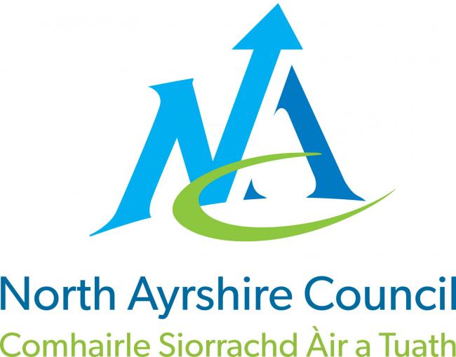

Education and Youth Employment Directorate

What we want to achieve

Our Overall Aim

Ensuring people have the right skills for learning, life and work.

Our Priorities

- We will create the conditions for our children and young people to access the highest quality learning experiences from ages 3-18.

- We will support our children and young people to become successful learners, confident individuals, effective contributors and responsible citizens.

- We will offer opportunities to our young people and their families to play a more active role in school life and encourage more participation in learning.

- We will work with all young people to build their resilience, supporting their mental health and physical well-being.

Section 1: School Information

School Contact Details
Pennyburn Primary School
Sundrum Place
Kilwinning
Ayrshire
KA13 6SE
Telephone Number 01294 552807
E-mail: pennyburn@ea.n-ayrshire.sch.uk
Present roll 181 pupils

If you have any concerns regarding the education of your child(ren) please do not hesitate to make an appointment to speak to the Head Teacher.

Cluster Schools
Kilwinning Academy
Corsehill Primary | Corsehill Primary | Blacklands Primary

Abbey Primary | Whitehirst Park Primary

School Aims, Values, Ethos

The vision of Pennyburn Primary School is:
A school in the community a community in the school:

Our values are:
Respect Ambition Responsibility

As well as our Vision and Values we work towards the 4 capacities within Curriculum for Excellence:

Responsible Citizens
We will:
- Respect others, their beliefs and opinions.
- Be responsible and look after our school and the environment.
- Understand we can have impact on the world around us.
- Realise the consequences of the decisions we have made.
Successful Learners
We will:
- Be enthusiastic and enjoy our learning.
- Try our best to work hard in all areas of our lives.
- Strive to achieve our full potential.
- Have a positive attitude to learning experiences.
- Celebrate our successes
- Aim to achieve the highest of standards.

Confident Individuals
We will:
- Develop our confidence and self-esteem.
- Make informed decisions.
- Have faith in ourselves and the choices we make.
- Show and earn respect.
- Be healthy and active achieving a positive well being
At Pennyburn we strive to create a happy, safe and nurturing community where everyone is respected, treated fairly and enjoys learning.
We actively promote honesty, kindness and a sense of pride in all individuals, allowing everyone to achieve their very best.

Effective Contributors
We will:
- Work with each other, cooperating as a team.
- Have confidence to try new things
- Share ideas and ask questions
- Believe in our abilities
- Take the lead and show initiative.

School Staff
Interim Head Teacher | Mrs Sharon Johnstone
Depute Head Teacher | Mrs Karen Heron
Principal Teacher | Mrs Elaine Kerr
P1 Teacher (s) | Mrs Elaine Mathieson/ Mrs Susan Findlay
P2 Teacher | Miss Holly Milliken/ Mrs Louise King
P3/2 Teacher | Mrs Jaqueline Brown
P4/3 Teacher | Mrs Laura Moore
P5/4 Teacher | Mrs Jenny Travers
P6/5 Teacher | Mrs Valerie O’Hara
P7/6 Teacher | Mr Scott Cook/ Mrs Hazel Gourley
P7 Teacher | Mrs Elaine Kerr
Additional Support Needs Teacher | Mrs Dawn Hotchkiss
Reading Recovery Teacher | Mrs Lynne Paton
Classroom Assistants | Mrs Bernadette Dougan
 | Mrs Michelle Clark
 | Mrs Morag Meechan
 | Mrs Anne McGrath
Early Years Practitioners | Mrs Alexis McDowell
 | Miss Chloe Summers
Nurture | Mrs Amy McKinnon
Nurture Assistant | Mrs Roseanne McLean
Education Assistant | Mrs Anne Ramsey
Education Assistant | Mrs Julie Clark
Janitor | Mr John Stevenson
Kitchen Assistant | Mrs Joyce Bradford
School Nurse | Mrs Charrone Hodge
Educational Psychologist | Mrs Catherine Patterson
Home School Inclusion | Mrs Lisa Craig
Home School Link | Mrs Elaine Connor

Supply Staff
From time to time it will be necessary to bring in staff to cover sickness and staff training. Over this year we will build up a bank of reliable supply colleagues who are familiar to the children. Unless we need emergency cover for sickness your child will always be told when a supply teacher has been booked to take their class.

North Ayrshire School Dates Session 2021/22

Term | Dates of Attendance | Day | Date | Cumulative Holiday / Closure Total | Cumulative Working Days
Term 1 | Teacher (In-Service) | Tuesday | 17-Aug-21
 | Pupils Return | Wednesday | 18-Aug-21
 | Teacher (In-Service) | Monday | 20-Sep-21
 | Close | Friday | 08-Oct-21 |  | 39
Term 2 | Pupils Return | Monday | 18-Oct-21 | 5
 | Teacher (In-Service) | Thursday | 18-Nov-21
 | Local Holiday | Friday | 19-Nov-21
 | Local Holiday | Monday | 22-Nov-21 | 7
 | Close | Wednesday | 22-Dec-21 |  | 85
Term 3 | Re-open | Thursday | 06-Jan-22 | 17
 | Local Holiday | Friday | 11-Feb-22
 | Local Holiday | Monday | 14-Feb-22
 | Teacher (In-Service) | Tuesday | 15-Feb-22
 | Pupils Return | Wednesday | 16-Feb-22 | 19
 | Close | Friday | 01-Apr-22 |  | 145
Term 4 | Re-open | Tuesday | 19-Apr-22 | 30
 | May Day | Monday | 02-May-22 | 31
 | Teacher (In-Service) | Friday | 27-May-22
 | Local Holiday | Monday | 30-May-22 | 32
 | Pupils Return | Tuesday | 31-May-22
 | Close | Wednesday | 29-Jun-22 | 66 | 195
22/23 | Pupils Return | Thursday | 18-Aug-22

Section 2: School Procedures

School Security
North Ayrshire Council has introduced procedures to ensure the safety and security of children and staff when attending or working in a school. A number of security measures are used including the use of a visitors’ book, badges and escorts while visitors are within the school building. Anyone parent/carer or visitor at a school for any reason will be asked to report to the school office. The school staff will then make any necessary arrangements in connection with the visit to the school.
It is the policy of the school that any member of staff will approach a visitor and ask for verification of identity. This measure ensures that children work in a safe and protected environment. We appreciate your support in carrying out all of the above measures.

Positive Relationships
The school is committed to developing a nurturing approach and promoting positive relationships. Like every community, our school is built on the relationships within it, across it and its connections with others. Every member of staff is responsible for establishing and maintaining positive relationships with each other, with parents and with partners and most importantly with the young people in their care.Our expectations of behaviour for children and young people are high. Some children may require additional support in relation to their behaviour, and the school will work positively with the young person and the parents, and other partners, as appropriate, to ensure positive outcomes are achieved.

North Ayrshire Council is committed to the principles of restorative practices. This is a solution-focused approach to managing behaviour and resolving difficulties and which promotes healthy relationships that enable better behaviour and better learning.

The school has a code of conduct to ensure the safety and well-being of all and parents are asked to support the school fully in this matter.

Playground Supervision
The Council meets the terms of the legal requirement that pupils be supervised in the playground by at least one adult during the interval or lunchtime if there are fifty or more pupils at the school. Our policy reflects that of North Ayrshire Council in terms of the Schools (Safety and Supervision of Pupils) (Scotland) Regulations 1990.
An adult presence is provided in playgrounds at break times. Pupils who travel by contracted school transport and arrive at school more than ten minutes before the start of the school day have accommodation allocated to them within the school during inclement weather.
Absence from school premises at breaks
Schools have a duty to look after the welfare of their pupils. This means that the staff should take the same care of pupils as a sensible parent would take, and this includes taking reasonable care of pupils' safety during intervals and lunchtimes.
It is the policy of North Ayrshire Council that pupils should not leave the school grounds at intervals. Primary pupils should only leave school grounds at lunchtimes when they are going home for lunch with their parents' agreement. Parents should put this request in writing to the Head Teacher. Pupils will leave and return through main entrance door of the school.
Parents should encourage their children to follow these rules in the interests of safety.
School Dress Code
It is the policy of North Ayrshire Council to support the introduction of a reasonable and flexible dress code in schools in its area. The Council encourages each school to adopt its own code, after consultation with parents and pupils.
The Council believes that establishing a school dress code has many benefits. These include improvements in safety, security, positive behaviour and community spirit and a decrease in bullying and in expense for parents.

The Council will support schools in encouraging and helping pupils to conform to the chosen dress code. Some types of clothing will not be allowed at school in any circumstances, for reasons of safety, decency or wellbeing.
Types of clothing which will not be allowed include:
- Clothes which are a health or safety risk
- Clothes which may damage the school building
- Clothes which may provoke other pupils
- Clothes which are offensive or indecent
- Clothes which encourage the use of alcohol or tobacco

All items of clothing should be clearly labelled with the child's name in case of loss. It is appreciated that parents and pupils are distressed over the occasional loss of pupils' clothing and/or personal belongings. Parents are asked to assist in this area by ensuring that valuable items of clothing or personal belongings are not brought to school.

Personal Belongings
It is appreciated that parents and pupils may be distressed over the occasional loss of pupil’s clothing and/or personal belongings. Parents are asked to assist by ensuring that valuable items of clothing or personal belongings are NOT brought to school.
Parents should note that the authority does not carry insurance to cover the loss of such items

Dress Code for PE
For health and safety reasons all children must wear suitable clothing for PE. 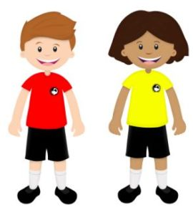This consists of shorts and t-shirts with soft shoes for indoor activities.

We adhere strictly to health and safety guidelines and pupils must remove any item that may cause danger, i.e. metal buckles, jewellery. These items are the responsibility of the pupil. Long hair should be tied back.

School Meals
Meals are served daily from the multi-choice cafeteria. The meals are planned to offer a healthy diet for the children. Please inform us if your child has any specific allergies. Parents of children who require a special diet can arrange this by contacting the school or Early Years Class.
There are arrangements in place for children who would prefer to eat a packed lunch.

Mobile Phones
While the benefits of mobile phones are recognised, they can be a serious distraction to work. Pupils whose mobile phones disrupt lessons can have them confiscated until the end of the school day. Repeated disruption may result in phones being retained until uplifted by a parent.
Inappropriate use of text messages and/or photographs/recordings (video and audio) whilst in school may be treated as a breach of the school’s code of conduct or a serious incident, which could be referred to the police.
All mobile phones should be handed to the school office for safekeeping and will be returned to the pupil at the end of the day.
Information in Emergencies
We make every effort to maintain a full educational service but on some occasions circumstances arise which lead to disruption. Schools may be affected by, for example, severe weather, and temporary interruption of transport, power failures or difficulties of fuel supply. In such cases, we shall do all we can to let you know about the details of closure or re-opening. We will keep you in touch by using letters, texts (where possible), NAC website, notices in local shops and community centres, announcements in the press and West FM.
Should you have doubts about deteriorating conditions during the day, it may be advisable to contact the school. Parents should ensure that the school is aware of the emergency arrangements made for their child and have responsibility to update us with contact numbers.

Listening and Learning
It is the policy of North Ayrshire Council to try to encourage feedback on the education service from parents and pupils. This is part of our overall commitment to giving the best possible service and to working in partnership.
We are therefore very interested in feedback of all kinds, whether it is compliments, suggestions or complaints. If you wish to register a comment of any type about the school you can do this by writing, telephoning or making an appointment to see someone. All feedback is welcome and helps us keep in touch.
If, in particular, you have a complaint about the school please let us know. It is better that these things are shared openly and resolved fairly, rather than being allowed to damage the home/school relationship. There will be no negative consequences arising from making a complaint and we will deal with the issue as confidentially as possible. If we have made a mistake we will apologise quickly and clearly and try to put things right.
There are some things which you should take note of in relation to making a complaint:
- The Council has a Two Stage Policy when dealing with complaints from parents.
- It is helpful if complaints are made initially to the Head Teacher. This makes sure that the school knows what is going on and has an opportunity to respond and resolve the issue.
- We will try to respond as quickly as possible, but often issues are complex and need time to investigate. It is therefore helpful if you can give some details of the issue and ask for an early appointment to discuss it.
- If you are not satisfied with our response then you still have the right to request that your complaint is raised as a Stage 2 Complaint. Should you wish to request this you should contact Education and Youth Employment at Cunninghame House, Irvine, KA12 8EE, Telephone (01294 324400).
- If, after receiving our final decision on your complaint, you remain dissatisfied with our decision or the way we have handled your complaint, you can ask the SPSO to consider it. We’ll tell you how to do this when we send you our final decision.
- You should also note that you have the right to raise unresolved concerns with your local councillor MSP/MP.
- Parent Councils have an important role in developing links between the school and the wider parent body and can often be helpful in helping to deal with issues of general concern. However parents are advised that individual, more personal complaints are not appropriate for raising via parent councils due to the need for appropriate confidentiality.

Section 3: Educational Grants: Footwear, Clothing, Free School Meals and Transport

Footwear and Clothing Grants
Parents receiving Universal Credit will normally be entitled to grants for footwear and clothing for their children. Universal Credit claimants monthly income must not exceed £610, however, some parents earning more than this may still be eligible. Parents who still receive Income Support, Income based Job Seeker’s Allowance, any income related element of Employment and Support Allowance, Support under part V1 of the Immigration and Asylum Act 1999, Child Tax Credit only (with income under £16,105),, Working Tax Credit or Housing Benefit may also still be entitled to grants for footwear and clothing for their children.

Parents who may be unsure whether they can apply should contact the Council’s welfare Reform Team on 0300 99 4606 or the Council Contact Centre on 01294 310000 for further advice.

Information and application forms may be obtained from schools.

Free School Meals
Children of parents receiving job seeker’s allowance or income support are entitled to a free midday meal and free milk. Parents and Carers should contact 01294 310000 for further information.

Please Note: ALL pupils in P1-3 are entitled to a free school meal, which includes milk.

Other than P1-P3 pupils, only those children whose parents receive job seeker's allowance or income support will be entitled to free milk. Milk may however be available for purchase in the school during the lunch period.

School Transport Policy
North Ayrshire Council has a policy of providing free transport to all primary pupils who live more than two miles from their catchment area school by the recognised shortest safe walking route or through the link attached below:

Free School Transport

These forms should be completed and returned before the end of February for those pupils beginning school in August to enable the appropriate arrangements to be made.

Applications may be submitted at other times throughout the year but may be subject to delay while arrangements are made. The appropriate officer has discretion in special circumstances to grant permission for pupils to travel in transport provided by the authority, where places are available and no additional costs are incurred.

Where free transport is provided it may be necessary for pupils to walk a certain distance to the vehicle pick-up point. Walking distance in total, including the distance from home to the pick-up point and from the drop-off point to the school in any one direction, will not exceed the Council's limits (see above section). It is the parents’ responsibility to ensure that their child arrives at the pick-up point on time. It is also the parents’ responsibility to ensure that their child behaves in a safe and acceptable manner while boarding, travelling in and leaving the vehicle. Misbehavior can result in children losing the right to free transport.

Please see attached link to the Council’s School Transport Policy:

School Transport Policy

Section 4: School Registration, Enrolment and Attendance

Registration and Enrolment
The date for registration of school beginners is advertised in the local press and is normally in January each year. Pupils will be registered in the school for their catchment area.

Parents are provided with information about the school and procedures for making placing requests, if required. Arrangements for meetings with parents and induction days for pupils will be notified during the spring and summer terms.

Parents of pupils who have moved to the area or who wish their child to transfer to the school should contact the school office for information about appropriate procedures and to arrange a visit to the school.

Parents are welcome to contact the Head Teacher at any time by visiting or telephoning the school.

Attendance at School/Lateness
It is the responsibility of parents of children of school age to educate their child(ren). Most do this by ensuring that their child(ren) attend(s) school regularly.
Attendance is recorded twice a day, morning and afternoon. Absence from school is recorded as authorised, unauthorised or temporarily excluded.

Parents are asked to inform the school by letter or telephone if their child is likely to be absent for some time, and to give the child a note on his or her return to school, confirming the reason for absence.
If there is no explanation from a child’s parents, the absence will be regarded as unauthorised.

Every effort should be made to avoid family holidays during term time as this both disrupts the child’s education and reduces learning time. Parents should inform the school by letter, before going on holiday, of the dates. Such absence will be authorised only where certain and very specific family circumstances exist. The majority of family holidays taken during term time will be categorised as unauthorised absence.

Parents may request that their children be permitted to be absent from school to make an extended visit to relatives. Only written requests detailing the destination, the duration and the provision that will be made for their continuing education will be granted. Such extended absences will be recorded separately from the normal attendance and absence information.

The School Inclusion Worker investigates unexplained absence, and the authority has the power to write to, interview or prosecute parents, or refer pupils to the Reporter to the Children’s Panel, if necessary.

Structure of Classes
Primary schools educate pupils at seven broad year stages, Primary 1 to Primary 7. A year stage is defined as a group of pupils entering primary education at a common date. Schools are staffed based on the total number of pupils. However, the numbers of pupils at each year stage will vary. This means that head teachers are required to organise classes to make best use of available staff, resources and space to the benefit of all children in the school.

Pupils may, therefore, be taught in a single stage class or a composite class where two or more year stages are grouped together. This may also change as pupils move from one year to the next.

National guidelines on the curriculum indicate that pupils should progress through learning experiences tailored to their own needs and abilities. This means that pupils in all classes follow programmes designed to help them progress at their own level. This applies to all pupils regardless of whether or not they are in a composite or single year stage class.

The National agreement on class sizes states that the maximum number of pupils in a class is 25 in P1 30 in P2– P3, and 33 in P4 -7. In a composite class, the maximum number is 25.

Transfer to Secondary School
Pupils are normally transferred between the ages of eleven and a half and twelve and a half, so that they will have the opportunity to complete at least 4 years of secondary education. Parents will be informed of the arrangements no later than January of the year preceding the date of transfer at the start of the new session.

Pennyburn Primary School is an associated primary school of:

Kilwinning Academy
Dalry Rd
Kilwinning
01294 552807

During their time in P7, pupils are taken to Kilwinning Academy as part of the induction programme. Teachers from local primary schools and their secondary colleagues have worked together to create a Pupil Profile of Achievements which will be completed in Primary 7 and passed onto the secondary school. Teachers from both schools liaise to ensure a smooth transition which focuses on progression for pupils. Parents will be informed of the details of the visits when appropriate.

Curriculum for Excellence

Curriculum for Excellence is the national curriculum for Scottish schools for learners from age 3 to 18. It aims to raise standards, prepare our children for a future they do not yet know and equip them for the jobs of tomorrow in a fast changing world.

Curriculum for Excellence enables professionals to teach subjects creatively, to work together across the school and with other schools, to share best practice and explore learning together. Glow, Scotland’s unique, world-leading, online network supports learners and teachers in this and plans are already in place for parents across the country to have access to Glow.

Teachers and practitioners will share information to plan a child’s “learning journey” from 3-18, ensuring children continue to work at a pace they can cope with and with challenge they can thrive on.

Curriculum for Excellence balances the importance of knowledge and skills. Every child is entitled to a broad and deep general education where every single teacher and practitioner will be responsible for literacy and numeracy – the language and number skills that unlock other subjects and are vital to everyday life. There is emphasis too on health and wellbeing – to ensure that the school is a place where children feel safe and secure.

Curriculum for Excellence develops skills for learning, life and work to help young people go on to further study, secure work and navigate life. It brings real life into the classroom, making learning relevant and helps young people apply lessons to their life beyond the classroom.

It links knowledge in one subject area to another helping children understand the world and make connections. It develops skills so that children can think for themselves, make sound judgements, challenge, enquire and find solutions.

There are new ways of assessing progress and ensuring children achieve their potential. Ultimately, Curriculum for Excellence aims to improve our children’s life chances, to nurture successful learners, confident individuals, effective contributors, and responsible citizens, building on Scotland’s reputation for great education.

Curriculum for Excellence: The Four Capacities
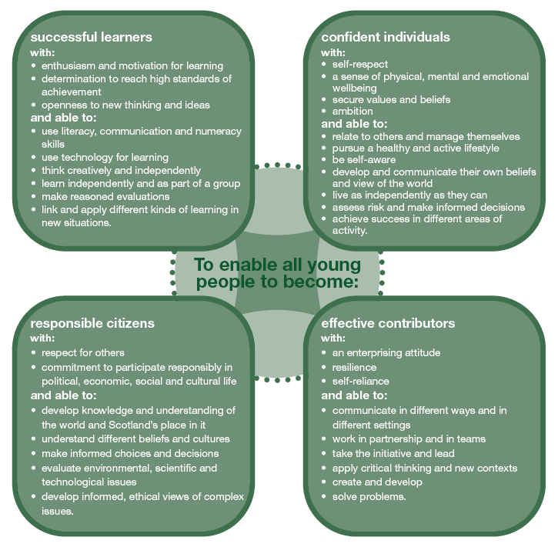
Further Information about Curriculum for Excellence and the Experiences and Outcomes can be found on the Curriculum for Excellence website.

www.educationscotland.gov.uk/thecurriculum/whatiscurriculumforexcellence.

Extra-Curricular Activities

We are keen to provide as many after-school leisure activities as possible. However, this depends on the talents and goodwill of staff and parents/friends who are prepared to give up their valuable time to organise clubs for children.
Below is just a sample of clubs that we run over the year
School Clubs
Homework Hub
Netball
Reading
Cosmic
Cycling Proficiency
Dodge Ball
Construction
Computing
Gardening
Art & Craft
Football
Basketball
Choir
We are very fortunate to have facilities, which could accommodate clubs such as table-tennis, volley-ball, etc. All we need are volunteers! If you could help in any way, please let us know.

Assessing Children’s Progress in the Broad General Education (BGE) Early Years – end of S3

Assessment is a central part of everyday learning and teaching for children and young people. Evidence of progress is gathered on an on-going and informal basis through asking questions, observing children working together and making formative comments on their work. Children may also assess their own work or that of their classmates; this is called self and peer assessment. Some assessment is more formal such as projects, investigations and standardised assessments.

The assessment of children’s progress throughout the BGE (Early – S3) is based on teachers’ views: their professional judgement. Teachers draw on their professional knowledge and understanding of the child; on the benchmarks for literacy and numeracy, which provide clear information about what children and young people should be able to do and demonstrate by the end of a Curriculum for Excellence Level; and on a wide range of assessment information.

Teachers of P1, P4, P7 and S3 are asked at the end of every school year whether children have achieved the relevant Curriculum for Excellence level for their stage in reading, writing, talking and listening (literacy), and their ability to understand and work with numbers (numeracy). Most children are expected to have achieved the early level by the end of P1, first level by the end of P4, second level by the end of P7 and third or fourth level by the end of S3.

The government has also introduced new national standardised assessments which cover some aspects of reading, writing and working with numbers. These assessments are completed online and are automatically marked by the online system giving teachers immediate feedback to help plan next steps and support children’s progress.

Teachers remain best placed to know how the children in their class are progressing. Their professional judgement will continue to be the most important way of assessing your child’s progress at school.

As a parent, you continue to have a key role in helping your child to learn. Your child’s teacher will keep you informed about how your child is progressing. Please contact us if you have any concerns about their learning, assessment or for more information on how you can support your child’s learning at home.

Homework
Parents have a very important role in helping their children to get the best out of school and it is important that they take an active interest in their child's progress at school. This can be done by:

- Encouraging hard work and high standards at all times
- Stressing the importance and relevance of what is learned at school
- Supporting the school's policy on homework and discipline

The type of homework will vary depending on the age and ability of individual pupils. Reading commonly forms part of the homework set and will be specified by the teacher on a reading marker. Parents are encouraged not only to read with their child but also to discuss the story and pictures.

In the early and middle stages oral reading should be practiced regularly at home whereas in the upper primary, where children are competent in the mechanics of reading, a greater emphasis may be placed on silent reading and comprehension. Reading for enjoyment should be encouraged at all stages.

Spelling is also an important part of homework from P3 onwards (although some children may be asked to practice even earlier). Math’s homework will be given to consolidate understanding and proficiency at all stages of the school.

From time to time pupils are given assignments and Personal projects which may involve research, investigation, preparing a speech, learning a poem or a similar activity.

We really appreciate the involvement of parents and are very grateful to those parents who so faithfully sign reading markers and jotters to confirm that they have overseen each piece of work.
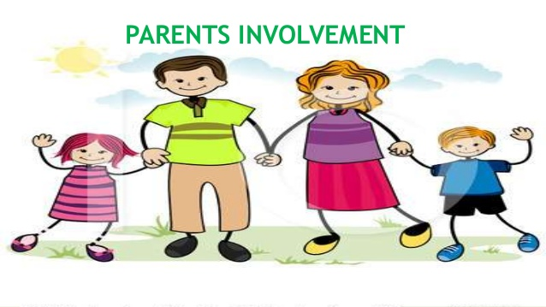
School Improvement
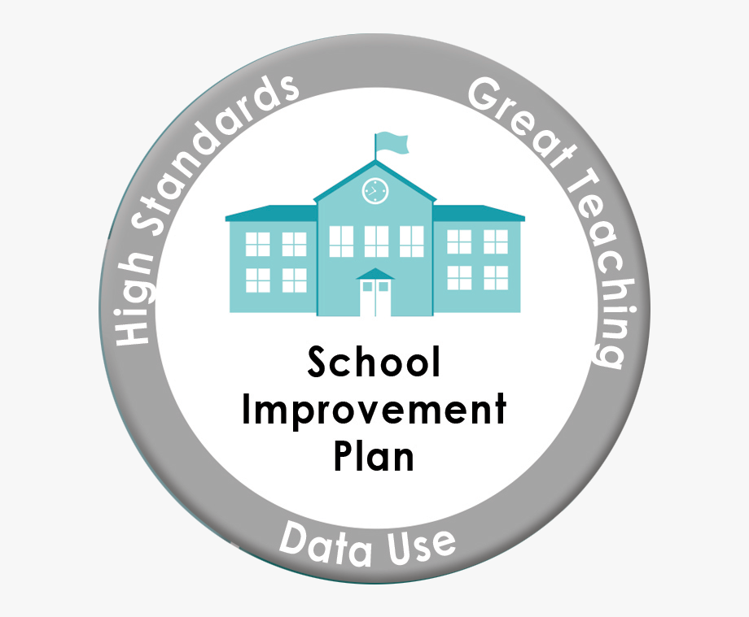

S&Q Report/Improvement Plan

Schools in North Ayrshire follow a Quality Improvement process designed to highlight strengths and identify areas for improvement. The process is based on the school’s self-evaluation process with Heads of Service and Senior Managers involved in at least three formal validation visits each session.

This validation process involves talking to pupils, staff and parents about learning and improvements made by the school. This results in actions for improvement for the school to take forward in their planning process.

In addition, themed reviews are undertaken from time to time e.g. to look and report on the quality of the Broad General Education (3-18) and Senior phase Education within secondary schools. This process is based upon standards and expectations contained within the following National Standards documentation:

- National Improvement Framework
- How Good is Our School? 4
- How Good is Our Early Learning and Childcare?

A Standards and Quality Report and School Improvement Plan are produced on an annual basis by every school and centre. Staff, Parents/ Carers, Young People and School Partners will play an active role in the development of these key school documents.

Pennyburn Primary School
Sundrum Place
Kilwinning
North Ayrshire
KA13 6SE

Support for your Child

Equalities
In line with North Ayrshire Council policy, educational provision is open to all pupils, regardless of sex, age, religion, race, disability or any other potential barrier and all reasonable measures will be taken to ensure that the curriculum is available to every child. Schools also have a duty to promote equality and to eliminate racist and other discriminatory behaviours.

Equality Act 2010
The Equality Act 2010 has been drawn up to tackle inequality and prevent discrimination against people on the basis of ‘protected characteristics’. It brings together several existing laws and aims to make understanding the law simpler and also introduces a new single public sector equality duty, which requires public bodies to actively advance equality.

The duties set out in Chapter 1 of Part 6 of the Equality Act apply to all schools. These provisions protect pupils at the school and in the case of admissions, those applying or wishing to apply for admission. Former pupils are also protected from discrimination or harassment.

Guidance on the Act and its requirements for schools in relation to the provision of education can be accessed here:

Equality Act Guidance

Child Protection
The Education and Youth Employment Directorate has a fundamental duty to contribute to the care and safety of all children and young people in North Ayrshire. In fulfilling this duty, the service must engage in close partnership with parents/carers and relevant agencies, primarily the Health and Social Care Partnership and where appropriate the Scottish Children’s Reporter’s Administration. The Service will work in partnership with a number of levels within the establishment or school within the cluster or local area and through Integrated Children’s Services and Community Health Partnership.

The Standard Circular entitled, “Protecting North Ayrshire Children” provides guidance for policy and practice within all educational establishments. The Council is one of the key partners in the North Ayrshire Child Protection Committee, a multi-agency group which takes the lead role in ensuring that our children and young people are cared for, protected from harm and grow up in a safe environment.

Each school has a named Child Protection Co-ordinator who is the main point of contact for school staff and for external agencies seeking contact with the school on child protection matters. There is an extensive staff-training programme available to staff and, in addition, at the beginning of each school session all staff receive an update on child protection policies, safeguarding and procedures.

Inclusion
North Ayrshire Council is committed to supporting the well-being and educational progress of all learners including those with Additional support needs. Including learners requires all staff to demonstrate commitment, innovation and flexibility in order to ensure that all children and young people have access to quality learning opportunities and experiences. Our Inclusion Strategy states that:

- An inclusive approach to education supports an ethos of achievement and high expectation, recognises difference, respects these differences and sees differences between learners as opportunities for learning.
- An inclusive approach to education promotes tolerance and a positive understanding of diversity.
- An inclusive approach to education alleviates the barriers to learning, supports the achievement of all and has positive relationships at its heart.

The presumption of mainstream as outlined in the Standards in Scotland’s Schools (2000) sets out that children will be educated in a mainstream setting unless exceptional circumstances apply. North Ayrshire therefore has a duty to ensure that clear assessment outlines the additional support needs of a child or young person which may require support in an alternative provision.

Where this is the case, North Ayrshire has a clear process that supports the Team around the Child to make a recommendation for consideration of alternative provision. This is outlined in the Standard Circular E19 and requires establishment staff to work with parents/carers to ensure all supports have been put in place to support a child or young person in their mainstream context before submitting clear evidence of what has been implemented and going on to request alternative provision. North Ayrshire council staff will then make a recommendation based on the evaluation of this evidence and a review of the needs of the young person and the current peer group in each setting.

The Education (Disability Strategies and Pupils’ Educational Records) (Scotland) Act, October 2002, requires local education authorities to prepare and implement accessibility strategies to improve, over time, access to education for young people with disabilities. Access covers:

- The physical building and grounds
- The curriculum (both formal and informal)
- Information on any educational planning that might affect the child’s/young person’s education

The Education (Additional Support for Learning) (Scotland) (2009) Act sets out certain duties on local education authorities and confers certain rights on children and their parents. These duties include the need to:

- Identify, assess and address the need for additional support for any child or young person failing to benefit from school education, for whatever reason
- Seek and take account of the views of the child or young person on issues relating to their education
- Engage in helpful partnership working with parents/carers and staff from other agencies

These are the various pieces of legislation that support the right to inclusion and that define the main features of that right.

Additional Support for Learning
Any child who needs more or different support to what is normally provided in schools or pre-schools is said to have ‘additional support needs’. This includes children who may need extra help with their education as a result of issues arising from social and emotional difficulties, bullying, physical disability, having English as an additional language, a sensory impairment or communication difficulty.

The Additional Support for Learning Act
The Education (Additional Support for Learning) (Scotland) Act 2004 came into force in November 2005. In June 2009, the Act was amended. These amendments form the Education (Additional Support for Learning) (Scotland) Act 2009 and came into force on November 2010.

Main provisions of the Act
- The Act provides the legal framework underpinning the system for supporting children and young people in their school education, and their families.
- This framework is based on the idea of additional support needs. This broad and inclusive term applies to children or young people who, for whatever reason, require additional support, long or short term, in order to help them make the most of their school education and to be included fully in their learning.
- The 2009 Act automatically deems that all looked after children and young people have additional support needs unless the education authority determine that they do not require additional support in order to benefit from school education.
- In addition, education authorities must consider whether each looked after child or young person for whose school education they are responsible requires a co-ordinated support plan.

Duties under the ‘Additional Support for Learning’ legislation
North Ayrshire must assess any pupil with additional support needs and provide with any support necessary for them to benefit fully from their education. All the evidence says that it is best to intervene early to prevent any difficulties developing and taking root. For example by making sure reading is very well taught and that all pupil gets encouragement and support at home we can hopefully reduce later difficulties.

Whatever the type of challenge that arises, it is important to detect it early, develop a shared understanding of what is needed (the school may request extra specialised help to do this) and take action to help to pupil achieve. Whenever we start this process for any child or young person, we will always explain to them and to their parents/carers what our concerns are and what we will do to help.

The school can get support from a range of visiting professionals including Educational Psychologists. These professionals are regularly in all schools and teachers and others will ask for informal advice on supporting pupils for example on the best way to support a pupil who is having difficulties with reading. If the school wants more detailed individual help then they would talk to you about formally involving the educational psychologist. The educational psychologist can only be involved in consultation, collaborative assessment and planning interventions for your child after you agree to this.

For a few children and young people their needs are so complex that professionals from two or more agencies need to work together over a significant length of time to enable the child to benefit from school education.

The authority approach to staged intervention has been updated to take ensure it is line with the CYP (2014) and ASL (2004) (amended 2009) Acts. The aim is to ensure children and young people get the right support at the right time.

Where a child or young person has additional support needs, extra planning is required every time there is a move to a new class, new school or college. How far ahead this transition planning needs to start depends on the particular type of needs but for most children and young people with Additional Support Needs transition planning should start at least one year before the date of the planned move.
Detailed advice on transition planning is provided in the Supporting Children’s Learning Code of Practice, which can be accessed at the following link:

Supporting Children's Learning Code of Practice

Dispute Resolution Procedures
If you feel that things are not being done properly to support your child then the Council has a range of ways to work with you to resolve any issues. You can ask at any time for a copy of the booklet called ‘Resolving Disagreements’. This booklet will give you ways to make sure your concerns are listened to and addressed.

Further Support
The following organisations are able to provide advice, further information and support to parents of children and young people with ASN.

- Enquire: Scottish Advice and Information Service for Additional Support for Learning
Website Link: Enquire
Helpline: 0345 123 2303
Email: info@enquire.org.uk

- Scottish Independent Advocacy Alliance
Website Link: siaa
Telephone: 0131 260 5380
Email: enquiry@siaa.org.uk
- Scottish Child Law Centre
Website Link: sclc
Telephone: 0131 667 6333
Email: enquiries@sclc.org.uk

Section 9: Pupil Data Collection and Protection Policies

The Scottish Government and its partners collect and use information about pupils through the Pupil Census to help to improve education across Scotland. This note explains why we need this information, how we use it and what we do to protect the information supplied to us.

Why do we need your data?
In order to make the best decisions about how to improve our education service, Scottish Government, education authorities and other partners such as the SQA and Skills Development Scotland need accurate, up-to-date data about our pupils. We are keen to help all our pupils do well in all aspects of school life and achieve better examination results. Accurate and up-to-date data allows us to:

- plan and deliver better policies for the benefit of all pupils
- plan and deliver better policies for the benefit of specific groups of pupils
- better understand some of the factors which influence pupil attainment and achievement
- plan and implement targeted approaches to reducing the poverty-related attainment gap
- share good practice
- conduct teacher workforce planning
- target resources better
- enhance the quality of research to improve the lives of young people in Scotland
- provide a window on society, the economy and on the work and performance of government by

- publishing statistical publications and additional tables about School Education
- providing school level information

Data policy
Information about pupils’ education is collected through our statistical surveys in partnership between the Scottish Government and Local Authorities through the ScotXed Programme which aims to help schools and Local Authorities by supporting efficient collection, processing and dissemination of statistical information. The Scottish Government then provides analysis of the data to support research, planning, management and monitoring of education services as well as to produce National Statistics publications.

Education data within Scottish Government is managed effectively by secure systems and is exploited as a valuable corporate resource, subject to confidentiality restraints. As part of its data policy, Scottish Government will not publish or make publicly available any information that allows individual pupils to be identified, nor will data be used by Scottish Government to take any actions in respect of individuals. Data is held securely and no information on individual pupils can or would be made publicly available by Scottish Government.

The individual data collected by Scottish Government through the Pupil Census is used for statistical and research purposes only.

Your Data Protection Rights
Any sharing or linkage of data will be done under the strict control of Scottish Government, and will be consistent with their data policy and the National Data Linkage Guiding Principles. Decisions on the sharing or linkage of data will be taken in consultation with relevant colleagues and individuals within and outwith Scottish Government as part of a Data Access Panel. At all times the rights of the individual (children or adults) under the GDPR and other relevant legislation will be ensured. Further information can be found on:

Scottish Exchange of Data: Privacy Information

Concerns
If you have any concerns about the ScotXed data collections you can email the Data Protection & Information Assets Team on dpa@gov.scot or the Head of Education Analytical Services, Mick Wilson, at mick.wilson@gov.scot or by writing to Education Analytical Services, Area 2A-North Victoria Quay, Leith, EH6 6QQ. Alternative versions of this page are available, on request from the ScotXed Support Office, in other languages, audio tape, Braille and large print.

Alternatively complaints may be raised with the Information Commissioners Office at casework@ico.org.uk.

Appendix 1

Important Contacts

Interim Executive Director (Communities)
Audrey Sutton
North Ayrshire Council
Cunninghame House
IRVINE
KA12 8EE
01294 324414

Head of Service
Caroline Amos
North Ayrshire Council
Cunninghame House
IRVINE
KA12 8EE
01294 324416

Head of Service
Andrew McClelland
North Ayrshire Council
Cunninghame House
IRVINE
KA12 8EE
01294 324413

