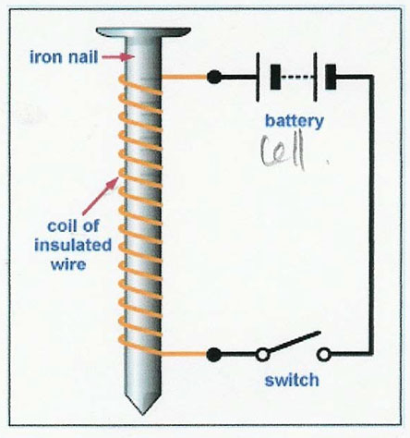
Making an Electromagnet
Materials
-60cm of insulated copper wire
-Large Iron nail
-Switch
-3 - 6V power supply

