Egg Drop.
You are required to design and build a lander that will safely deliver a capsule to the surface of an alien planet.
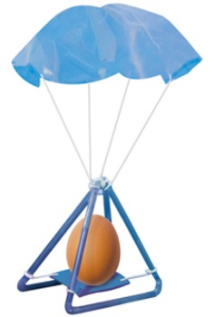
You have a total budget of £10
Egg drop cost sheet:
Item | Cost
Straws | £0.25 each
Newspaper | £0.50 per sheet
String (50cm) | £1.00
Tape (20cm) | £1.00
Paper cup | £2.00 each
Balloons | £2.00 each
Bubble wrap | £4.00 per sheet
Replacement Egg | £6.00 each

Before you begin:
You must sketch a design and make a list of the equipment you will need and the total cost of your design.

Possible Challenges:
-Cheapest successful lander
-Lightest successful lander
-Land on a planet with no atmosphere (parachutes won’t work!)
-Reusable lander

Adaptations:
Change cost values to reflect a real-world engineering project. Include values of thousands, hundreds of thousand and millions to reinforce place value.

