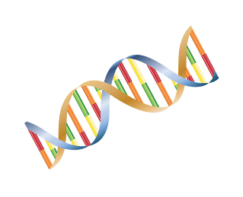
Extracting DNA
 | Mash up strawberry in a plastic bag to release DNA from the nucleus.
30mL | Add DNA extraction fluid to the bag and mix with the strawberry.
 | Filter the mixture to remove solid parts of the strawberry.
 | Using a pipette add some cold alcohol to the DNA mixture.
 | Wait for the DNA to form in the alcohol layer above the liquid strawberry.

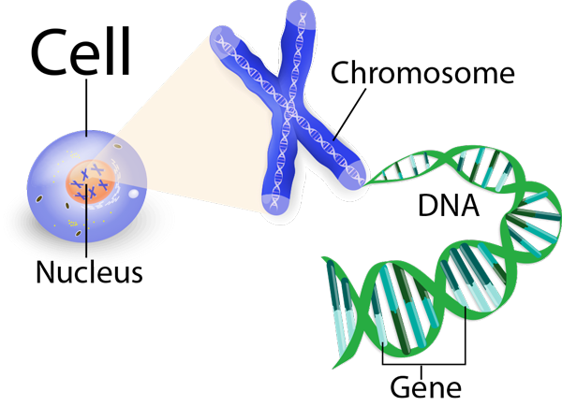
DNA facts!
- Clones are organisms that contain exactly the same DNA.
- A section of DNA that determines a genetic trait (hair colour, eye colour) etc is called a gene.
- DNA is found in the nucleus of a cell.
- DNA is tightly wound into structures called chromosomes.
- DNA forms a structure called a double helix.
- The structure of DNA was first discovered in 1953 by Francis Crick and James Watson.
- A DNA fingerprint can be used to identify criminals.
- The first animal to be successfully cloned was a sheep named Dolly.
- 98.4% of Human DNA is identical to the DNA of a Chimpanzee.

