**Will cold or warm water dissolve more sugar cubes?**

**Words we need to know**

**Solution:** A liquid that has another substance dissolved in it.

**Solute:** The substance that has dissolved.

**Solvent:** The liquid that has dissolved the solute.

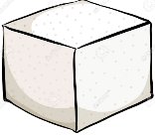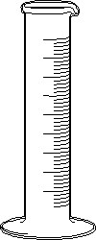

2.

1.

**Sugar cube**

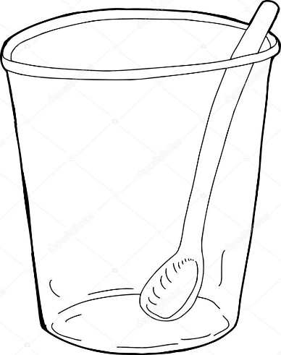

3. Stir

**20mL water water**

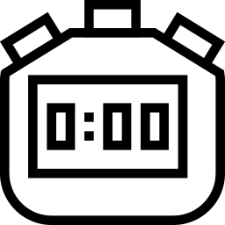

3:00

**Add sugar cubes 1 at a time, make sure each cube has dissolved**

|  |  |
| --- | --- |
| **Water temperature** | Image result for tally marks  **Number of sugar cubes dissolved in 3 minutes** |
| Cold |  |
| Warm |  |

**Conclusion:**

Our results show…..

**Analysis**

In our experiment the solute was the:

In our experiment the solvent was the:

In our experiment we made a solution of:

Teacher notes:

Materials per group:

Sugar cubes (approx. 15 per group)

1 Plastic cup

1 spoon/stirrer

Warm and cold water.

Timer/stop watch

Variations:

-To investigate effect of particle size pupils could record the time taken for a sugar cube to dissolve compared to the time taken for a crushed sugar cube to dissolve.

-To investigate the effect of stirring, record the time taken for a sugar cube to dissolve in hot water with no stirring. Compare to the time taken for a sugar cube to dissolve in warm water with stirring.

Safety considerations.

* Sugar cubes are low risk.
* Warm water should be at a temperature that does not pose a risk of burns.
* Consider slip hazards from spills. Have paper towel at hand to clean spills.