**Will a whole tablet dissolve faster or slower than a broken tablet?**

**Words we need to know**

**Solution:** A liquid that has another substance dissolved in it.

**Solute:** The substance that has dissolved.

**Solvent:** The liquid that has dissolved the solute.

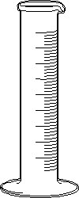

1.

2.

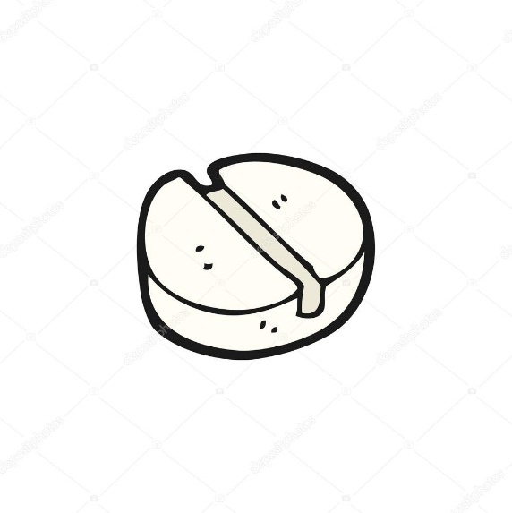

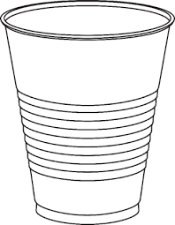

**100mL water water**

3.

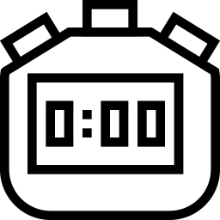

|  |  |  |
| --- | --- | --- |
| **Volume of water** | **Tablet** | **Time to dissolve (seconds)** |
| 100mL | Image result for pill cartoon |  |
| 100mL |  |  |
| 100mL |  |  |

**Does the temperature of water change how fast a tablet will dissolve?**

**Words we need to know**

**Solution:** A liquid that has another substance dissolved in it.

**Solute:** The substance that has dissolved.

**Solvent:** The liquid that has dissolved the solute.



1.

2.





**100mL water water**

3.



|  |  |  |  |
| --- | --- | --- | --- |
| **Temperature of water** | **Volume of water** | **Tablet** | **Time to dissolve (seconds)** |
| Ice water | 100mL | Image result for pill cartoon |  |
| Tap water | 100mL | Image result for pill cartoon |  |
| Warm water | 100mL | Image result for pill cartoon |  |