

**Supporting Wellbeing on the Return to School Advice for Education Staff**

**Hints and tips that will help you support children and young people**

**You will know many of your children and will be able to spot any signs of changed behaviour that may be a concern or a signpost that something is not going well for them. However, you may have new pupils. How do you start to support young people with whom you potentially have no prior knowledge or relationship with?**

**Establish feelings of safety and security.**

* Be consistent in your welcomes e.g. ‘It’s really nice to have you here today’ and goodbyes, “I’m looking forward to hearing your news tomorrow.
* Recognise that transitions may be difficult; not just return to school but between home and school and activities.
* Talk to pupils about their interests and what might have been going on while they have been away.

**Work with feelings(Co-regulate Affect)**

* All behaviour has a good intention – do the best you can to make sense of the underlying intentions, thoughts, feelings, wishes of the child.
* Remember All behaviour is communication. What is behaviour telling you about feelings and needs?
* Look out for children’s verbal and non-verbal communication and be aware of your own.

**Help make sense of meaning of experiences present and past.**

* Connect and chat. Be curious and interested.
* Ask children what they have been doing and will be doing at home –then remember what they said and ask them about it.
* Some children may feel the need to take control as a way of feeling safe. Recognise and acknowledge this.

**Things to look out for that may tell you a child or young person is struggling**

**Where to get help**

* Distracted/ difficulty concentrating
* Impatient
* Subdued/ quiet
* Extremely short/ abbreviated answers
* Repeatedly saying ‘I’m fine’
* Detached/ isolating from others
* Agitated/ Angry/ outbursts
* Unwilling to engage in a conversation
* Tendency to behave in an infantile or childish manner
* Clingy or overly-attached
* Limit testing/ pushing boundaries
* Decline in school performance
* Changes to established relationships
* Irrational worry
* Anxiousness
* Risk taking behaviours (sudden/ increase)
* Threats to self-harm or harm to others
* Change in routine (late-coming/ tiredness)
* **School Nurse**
* **School Counselling Service**
* **Penumbra** – for self-harm concerns
* Signpost young people to **Young Scot (AyeFeel)** <https://young.scot/campaigns/national/aye-feel> for information about how to look after emotional wellbeing, support from organisations around Scotland and tips on how to promote a positive mindset.
* Further self help guidance can be found at **FeelsFM** <https://feelsfm.co.uk/> where young people can get help to express their feelings.
* **NHS Ayrshire and Arran** have a list of APPS you could recommend to pupils - <https://www.nhsaaa.net/media/9167/apps_websites_help-mhw-final-june-2020.pdf>
* For grief concerns think about using the **Change and Loss Resource**, <https://www.childbereavementuk.org/> have lots of useful advice
* Advice and guidance from Psychological Service

­­­­­_______________________________________

**Seek advice from HeadTeacher or PT Pastoral Support**

**Any concerns of a Child Protection nature should go through your CP Co-ordinator.**

Remember that some of the above behaviours may not mean that a child or young person is in urgent need of support but pay attention to them in terms of frequency/ accumulation and how well you know the pupil.

**Key messages about supporting mental health and wellbeing**

1. **Recognise the continuum of experiences during the COVID 19 pandemic**

* **It is important to remember that trauma is not always about the experience itself but about how we perceive the experience. On return to education we will need to be mindful of the range of individual experiences of the COVID-19 pandemic, some pupils may be more affected than others and some may have experienced trauma.**
* **Children and young people will have had different experiences of threat and safety in their lifetime therefore they will have experienced the COVID-19 pandemic differently and will use different strategies to manage transitions, change and loss.  We should seek to understand the children and young people's experiences and get alongside them to support them to manage the transitions ahead. Adults should start from a position of ‘help me understand you’ with an approach of Playfulness, Acceptance, Curiosity and Empathy.**
* **Reinforce that, “We are all in the same storm, riding crazy waves, but we are not all in the same boat…show kindness and help where you can. We are each navigating very different journeys”**

1. **All behaviour is communication – Be curious about what underlies behaviour**

* **Some children and young people might display distressed behaviours in response to the challenges faced in transitioning back to in school education after months in lockdown COVID-19 pandemic.**
* **It is important to remember the nurture principle; *all behaviour is communication.***
* **Name/wonder aloud what’s going on for the child/young person – this communicates to the child/young person that you are trying to understand.**

1. **Pupils continue to face transitions, change and loss as they return to education**

* **Be mindful that when children and young people transition back to education, they will continue to experience many transitions and with that comes the experience of change and loss (E.G the loss of extra time with family, the loss of managing their own time, the loss of touch/physical connection, the loss of a typical school day). Social distancing measures might even cause distress for some children and young people.**

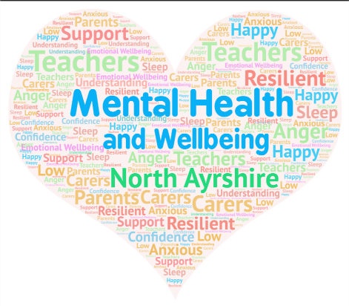

**Nurturing North Ayrshire’s recovery and return to school together!**