

# **Practical ways of talking to children at an age appropriate level without increasing any anxiety they may have**

Introduction

Talking to Children and Young People About the Coronavirus

News of the coronavirus COVID-19 is everywhere. Many parents and carers are wondering how to bring up the epidemic in a way that will be reassuring and not make kids more worried than they already may be. It is important that we do talk about COVID-19 to children for a number of reasons;

1.Children and young people are getting information -but we don’t know how much, from where and how well they understand it

2.Young people, no matter their support needs, are perceptive to changes in routine and changes in parents, carers and supporters

3.Parents and carers need to be trusted by their children to be open and honest

4.Personal responsibility is a big part of our fight against COVID-19

5.Anxiety can come from fear of the unknown

The most important factor is that we need to be **age and stage appropriate!**

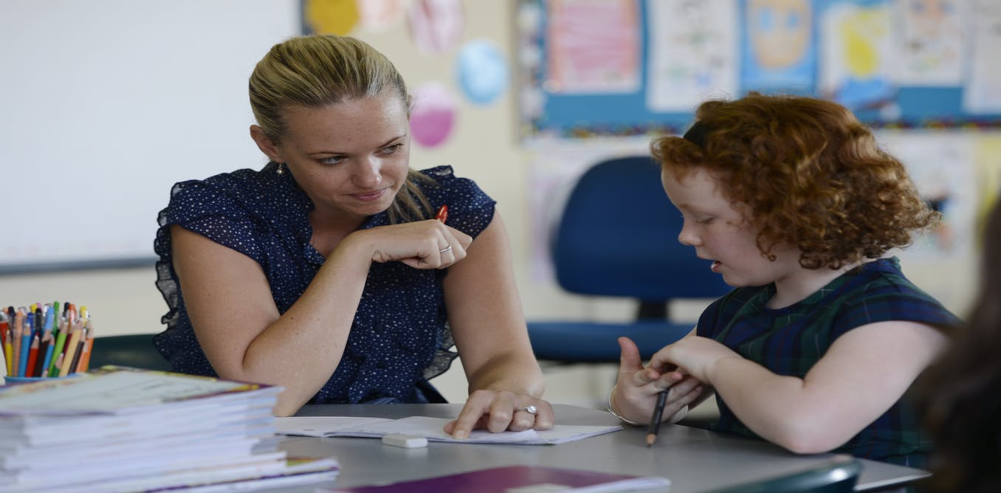

Where to Start

1.Find out what your child already knows (including misinformation, rumours etc)

2. Plan out what you think you should tell the child

3. Centre your conversation on the facts (not what ifs or maybes)

4.Prepare the child for what happens next (in relation to their immediate world)

**Do not rush this process!**

Key points

**Don’t be afraid to discuss the coronavirus.** Most children will have already heard

about the virus or seen people wearing face masks, so parents and carers shouldn’t avoid talking about it. Not talking about something can actually make children worry *more*. Look at the conversation as an opportunity to convey the facts and set the

emotional tone. Your goal is to help your children feel informed and get fact-based

information that is likely more reassuring than whatever they’re hearing from their

friends or on the news.

**Be developmentally appropriate.** Don’t volunteer too much information, as this

may be overwhelming. Instead, try to answer your child’s questions. Do your best

to answer honestly and clearly. It’s okay if you can’t answer everything; being

available to your child is what matters.

**Take your cues from your child.** Invite your child to tell you anything they may

have heard about the coronavirus, and how they feel. Give them ample

opportunity to ask questions. You want to be prepared to answer (but not prompt)

questions. Your goal is to avoid encouraging frightening fantasies.

**Deal with your own anxiety.** “When you’re feeling most anxious or panicked, that

isn’t the time to talk to your kids about what’s happening with the coronavirus” If you notice that you are feeling anxious, take some time to calm down before trying to have a conversation or answer your child’s questions. Remember taking care of yourself helps you to be that reassurance for your child. What can you build into your day that helps you to relax? Are there ways you can keep in contact with others who have children with similar needs to avoid feeling that you are the only one with these new challenges? The charity [Mind](https://www.mind.org.uk/information-support/coronavirus-and-your-wellbeing/#TakingCareOfYourMentalHealthAndWellbeing) offers helpful advice on how to look after your wellbeing during this period.

**Be reassuring.** Children are very egocentric, so hearing about the coronavirus on

the news may be enough to make them seriously worry that they’ll catch it. It’s

helpful to reassure your child that kids actually seem to have milder symptoms.

**Focus on what you’re doing to stay safe.** An important way to reassure kids is to

emphasize the safety precautions that you are taking. Children and young people can feel empowered when they know what to do to keep themselves safe. We know that the coronavirus is transmitted mostly by coughing and touching surfaces. The CDC recommends thoroughly washing your hands as the primary means of staying healthy. So remind children and young people that they are taking care of themselves by washing their hands with soap and water for 20 seconds (or the length of two “Happy Birthday” songs) when they come in from outside, before they eat, and after blowing their nose, coughing, sneezing or using the bathroom.

**Keep talking.** Tell your child that you will continue to keep them updated as you learn more. Let them know that the lines of communication are going to be open.

“You can say, ‘Even though we don’t have the answers to everything right now, know that once we know more, mum or dad will let you know, too.’”

**Create a sense of safety.** Children need reassurance and opportunities to explore their fears and worries. Many organisations have [created ways to help these conversations](http://www.autismtoolbox.co.uk/supporting-children-and-young-people-home-coronavirus). Your child may, however, be non-verbal but still sensitive to the changes around them. In this case, think about what normally reassures and calms your child. It’s helpful to know that many children and young people go back to behaviours from an earlier stage of development when they are going through loss and change so if this happens it is not unusual. Reassurance and acceptance helps your child’s anxieties to reduce.

Keep kids in the loop — but keep it simple

Talking to children in a clear, reasonable way about what’s going on is the best way to help them understand, however children don’t need to know every

little thing. Unless children ask specifically, there’s no reason to volunteer information that might worry them.

Some examples of explaining COVID-19- Key phrasing by age/stage



**Secondary age**:

“COVID-19, or Coronavirus is an illness that is like the flu. Most people who have the virus will stay home and get better. A very small number of people will need more help to get better. I can keep myself and other people safe by staying at home, washing my hands with soap and water and covering my mouth when I cough using my elbow. The grown ups I trust will help keep me safe.”

**Early Level (typically age 3-6):**

“Coronavirus is a germ that makes people sick. I can make sure the germs stay away by washing my hands with soap and water. The grown ups who love me will make sure I am safe.”

**First Level (typically age 6-8):**

# “Covid-19 is an illness like getting the flu. Some people call it Coronavirus. It is caused by germs that spread from person to person. I can make sure the germs stay away by washing my hands with soap and water. The grown ups who love me will make sure I am safe.”

**Second Level (typically 9-12):**

**“**COVID-19 is a virus also known as the Coronavirus. It is caused by germs that spread from person to person. Most people who have the virus will stay home and get better. A very small number of people will need more help to get better. I can make sure the germs stay away by washing my hands with soap and water. The grown ups I trust will help keep me safe.”

**Other useful guidance for explaining COVID 19**

For young people with ASN, it’s best to describe the situation by describing **what we are actually doing.** For example:

“Staying at home” and “Staying away from people who don’t live in this house”

“Staying at home, going to the park for 30 minutes”

# **Best practice:** “Andy stays at home and doesn’t go to school. Andy walks to the post box and back with mum once a day. If Andy needs to go to the doctor, Mum can take him”

# Reframing social distancing and self-isolation from things we are **not** doing to the things we **are** doing can make a difference. For example:

# “We are going to stay away from Granny’s house today even though its Tuesday. You can draw granny a picture of her instead. By doing this you are helping her to keep safe and stay strong. Well done!”

# “Washing our hands might feel weird, that’s because you're fighting all those millions of germs with your superhero skills”

# “By learning at home instead of at school, you’re making sure *favourite school staff member* is happy and healthy! That is really important!”

# The use of visuals and other means of representing each idea/ concept can also help support understanding at this time. For example, when explaining the concept of “social distancing” it may be useful to try some of the following:

●**Physically showing** what two meters looks like can help a child or young person understand how far away they need to be from other people

●Ask children and young people to guess what 2m looks like. This is a good way to test their proprioception

●Using a visual such as a broom, a 2m dog leash, or even identify the amount of steps the individual has to take to be two meters away can help visualise

●Remember to prompt it is not just 2 metres in front, it has to be **from every angle.** Asking what people can see of other people at 2 metres is a good indicator (can see someone’s glasses but not freckles on the face etc)

●Finding a **key prompt word** for public allows for quicker communication.

●Identifying that some people aren’t very good at social distancing, but we can help with that (i.e. moving further away with someone with mobility issues)